## http://t2.gstatic.com/images?q=tbn:ANd9GcRhhFY8-p4xT0WlmEQvbPdY51eSX1r-kud76BuSvyBvs5kyP0VoswThread Spool and Ribbon

## Pulley Experiment

OBJECTIVE: Investigate how pulleys can be used to change the amount of force needed to move an object.

MATERIALS:

* 12-inch string
  + empty thread spool
  + large paperclip
  + 36 inch ribbon (width of the thread spool groove)
  + masking tape
  + 1-lb. toy car or truck

PROCEDURE – Make the Pulley

1. Take 12-inch piece of string and thread it through the spool hole
2. Tie the ends of the string together
3. Slip a paperclip onto the string
4. Make a hook by pulling open one side of the paperclip

PROCEDURE – Experiment

1. Tape one end of the ribbon onto the edge of a desk or table. The other end of the ribbon should be wrapped around the groove of the thread spool.
2. One student should hold the ribbon, while another one attaches the toy car to the paperclip hook.
3. Predict whether the pulley will be able to lift the one pound car. Record your prediction
4. Pull up on the ribbon
5. Observe whether the car will move up
6. Record the steps and results of the experiment in their science journals

**Summary: (answer in science journals)**

1. When using a simple machine, why do you need less force? What do you have to do more of in exchange?
2. Why is a single fixed pulley with a wheel to turn (in this case the empty thread spool) more effective than a single fixed pulley without a wheel to turn? (Ex: rope over a tree; piñata)

**Fun Facts!**

* A pulley is also called a “sheave” or a “drum”
* A pulley is one of the “six simple machines”

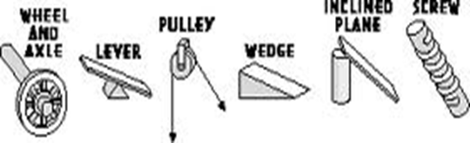

**History:**

Early peoples used the idea of a *single fixed pulley* to change the direction of a force. They threw vines or crude ropes over tree limbs to lift heavy objects. But since there was no wheel to turn, this use resulted in considerable friction. It is believed that by 1500 B.C.E. people in Mesopotamia used rope pulleys for hoisting water.

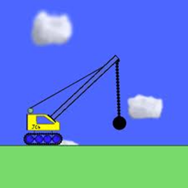

**Pulleys in Real Life!**

* + Curtains
  + Bikes
  + Elevators
  + Wrecking ball
  + Raising a flag up a pole
  + Can you think of another?