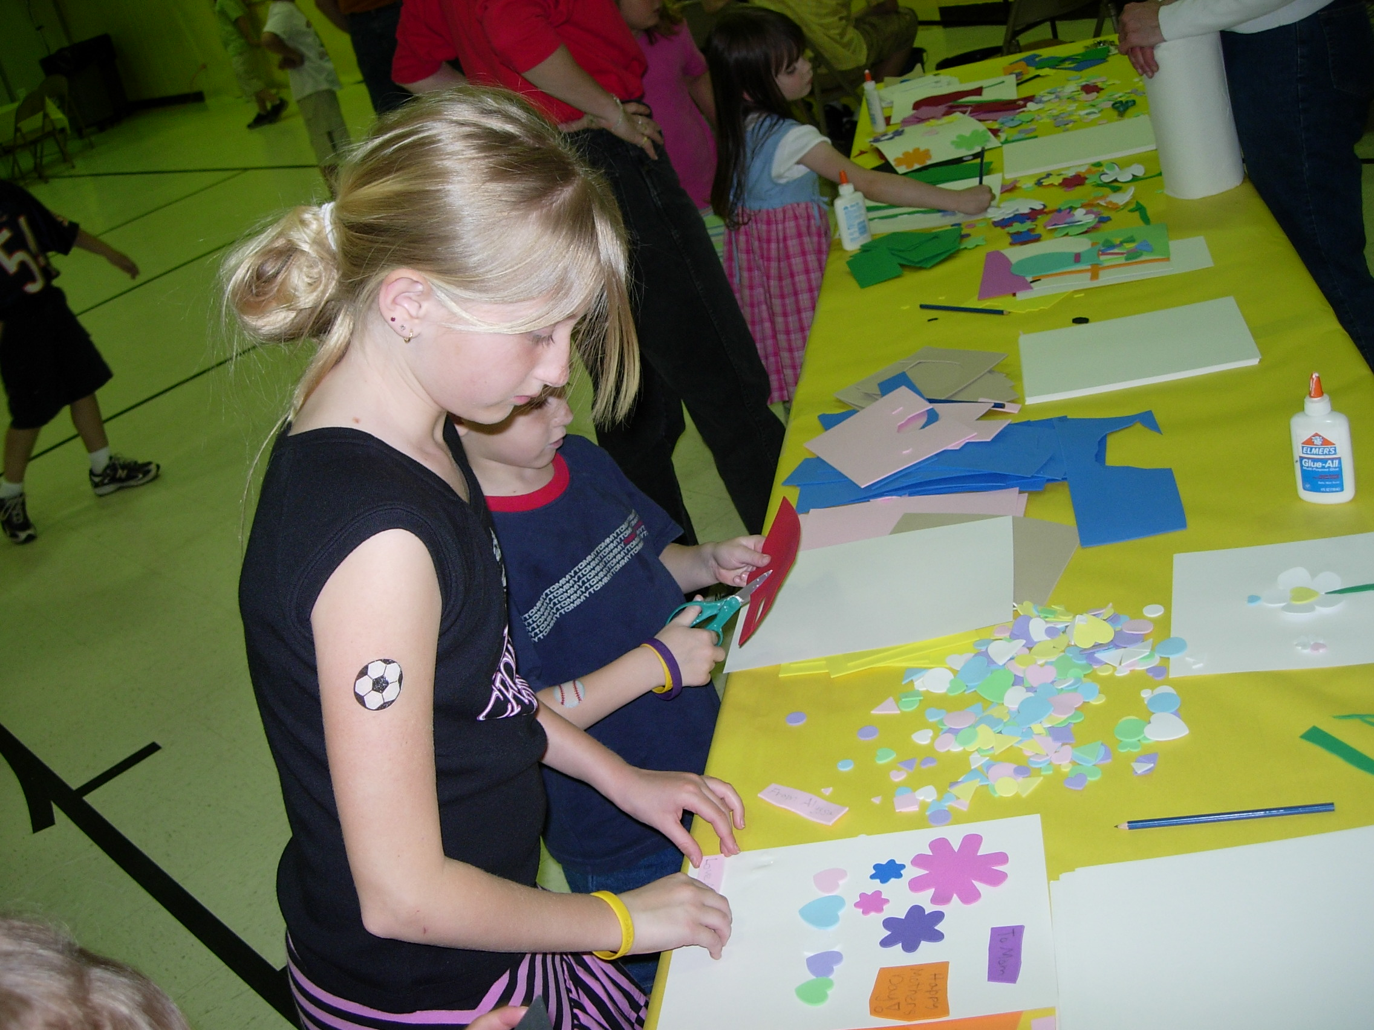
Community Activity:
Quilt Fundraiser

Activity Summary:

Students are to create a school-wide quilt contest, each grade level representing a different cause. The contest will raise money for the winning quilt’s cause while requiring the sponsoring class to use their writing, reading, communication, math, and researching skills.
Subject:
Math: Problem Solving, Connections, Representation
Science: Science in Personal and Social Perspectives
English: Effective Communication, Syntactical Knowledge and Uses, Student Research, English for Personal Purposes
Health: Health Promotion and Disease Prevention, Accessing Valid Health Information, Practicing Health-Enhancing Behaviors, Analyzing Influencing Factors on Health, Using Interpersonal Communication Skills, Enhancing Health through Goals and Decisions, Advocating for Personal Family and Community Health

Grade Level:
Target Grade: 7th grade
Upper Bound: 8th grade
Lower Bound: 6th grade


Time Required: one semester
Activity Team/Group Size: Class size
Reusable Activity Cost Per Group [in dollars]:
Scissors-$2.00 per student
Expendable Activity Cost Per Group [in dollars]:
Foam-$0.80 per sheet
Glue--$1.50 per bottle
Hot glue gun/sticks-$5.00
Yarn-$2.00-$4.00
Markers-$2.50
Tape-$1.00
(Cost depending on number of students and grade levels participating)
Authors:
Undergraduate Fellow Name: Diana Tran
Graduate Fellow Name: Marta Kobiela
Date Submitted: 02/05/2006
Date Last Edited: 02/05/2006
Activity Introduction / Motivation:
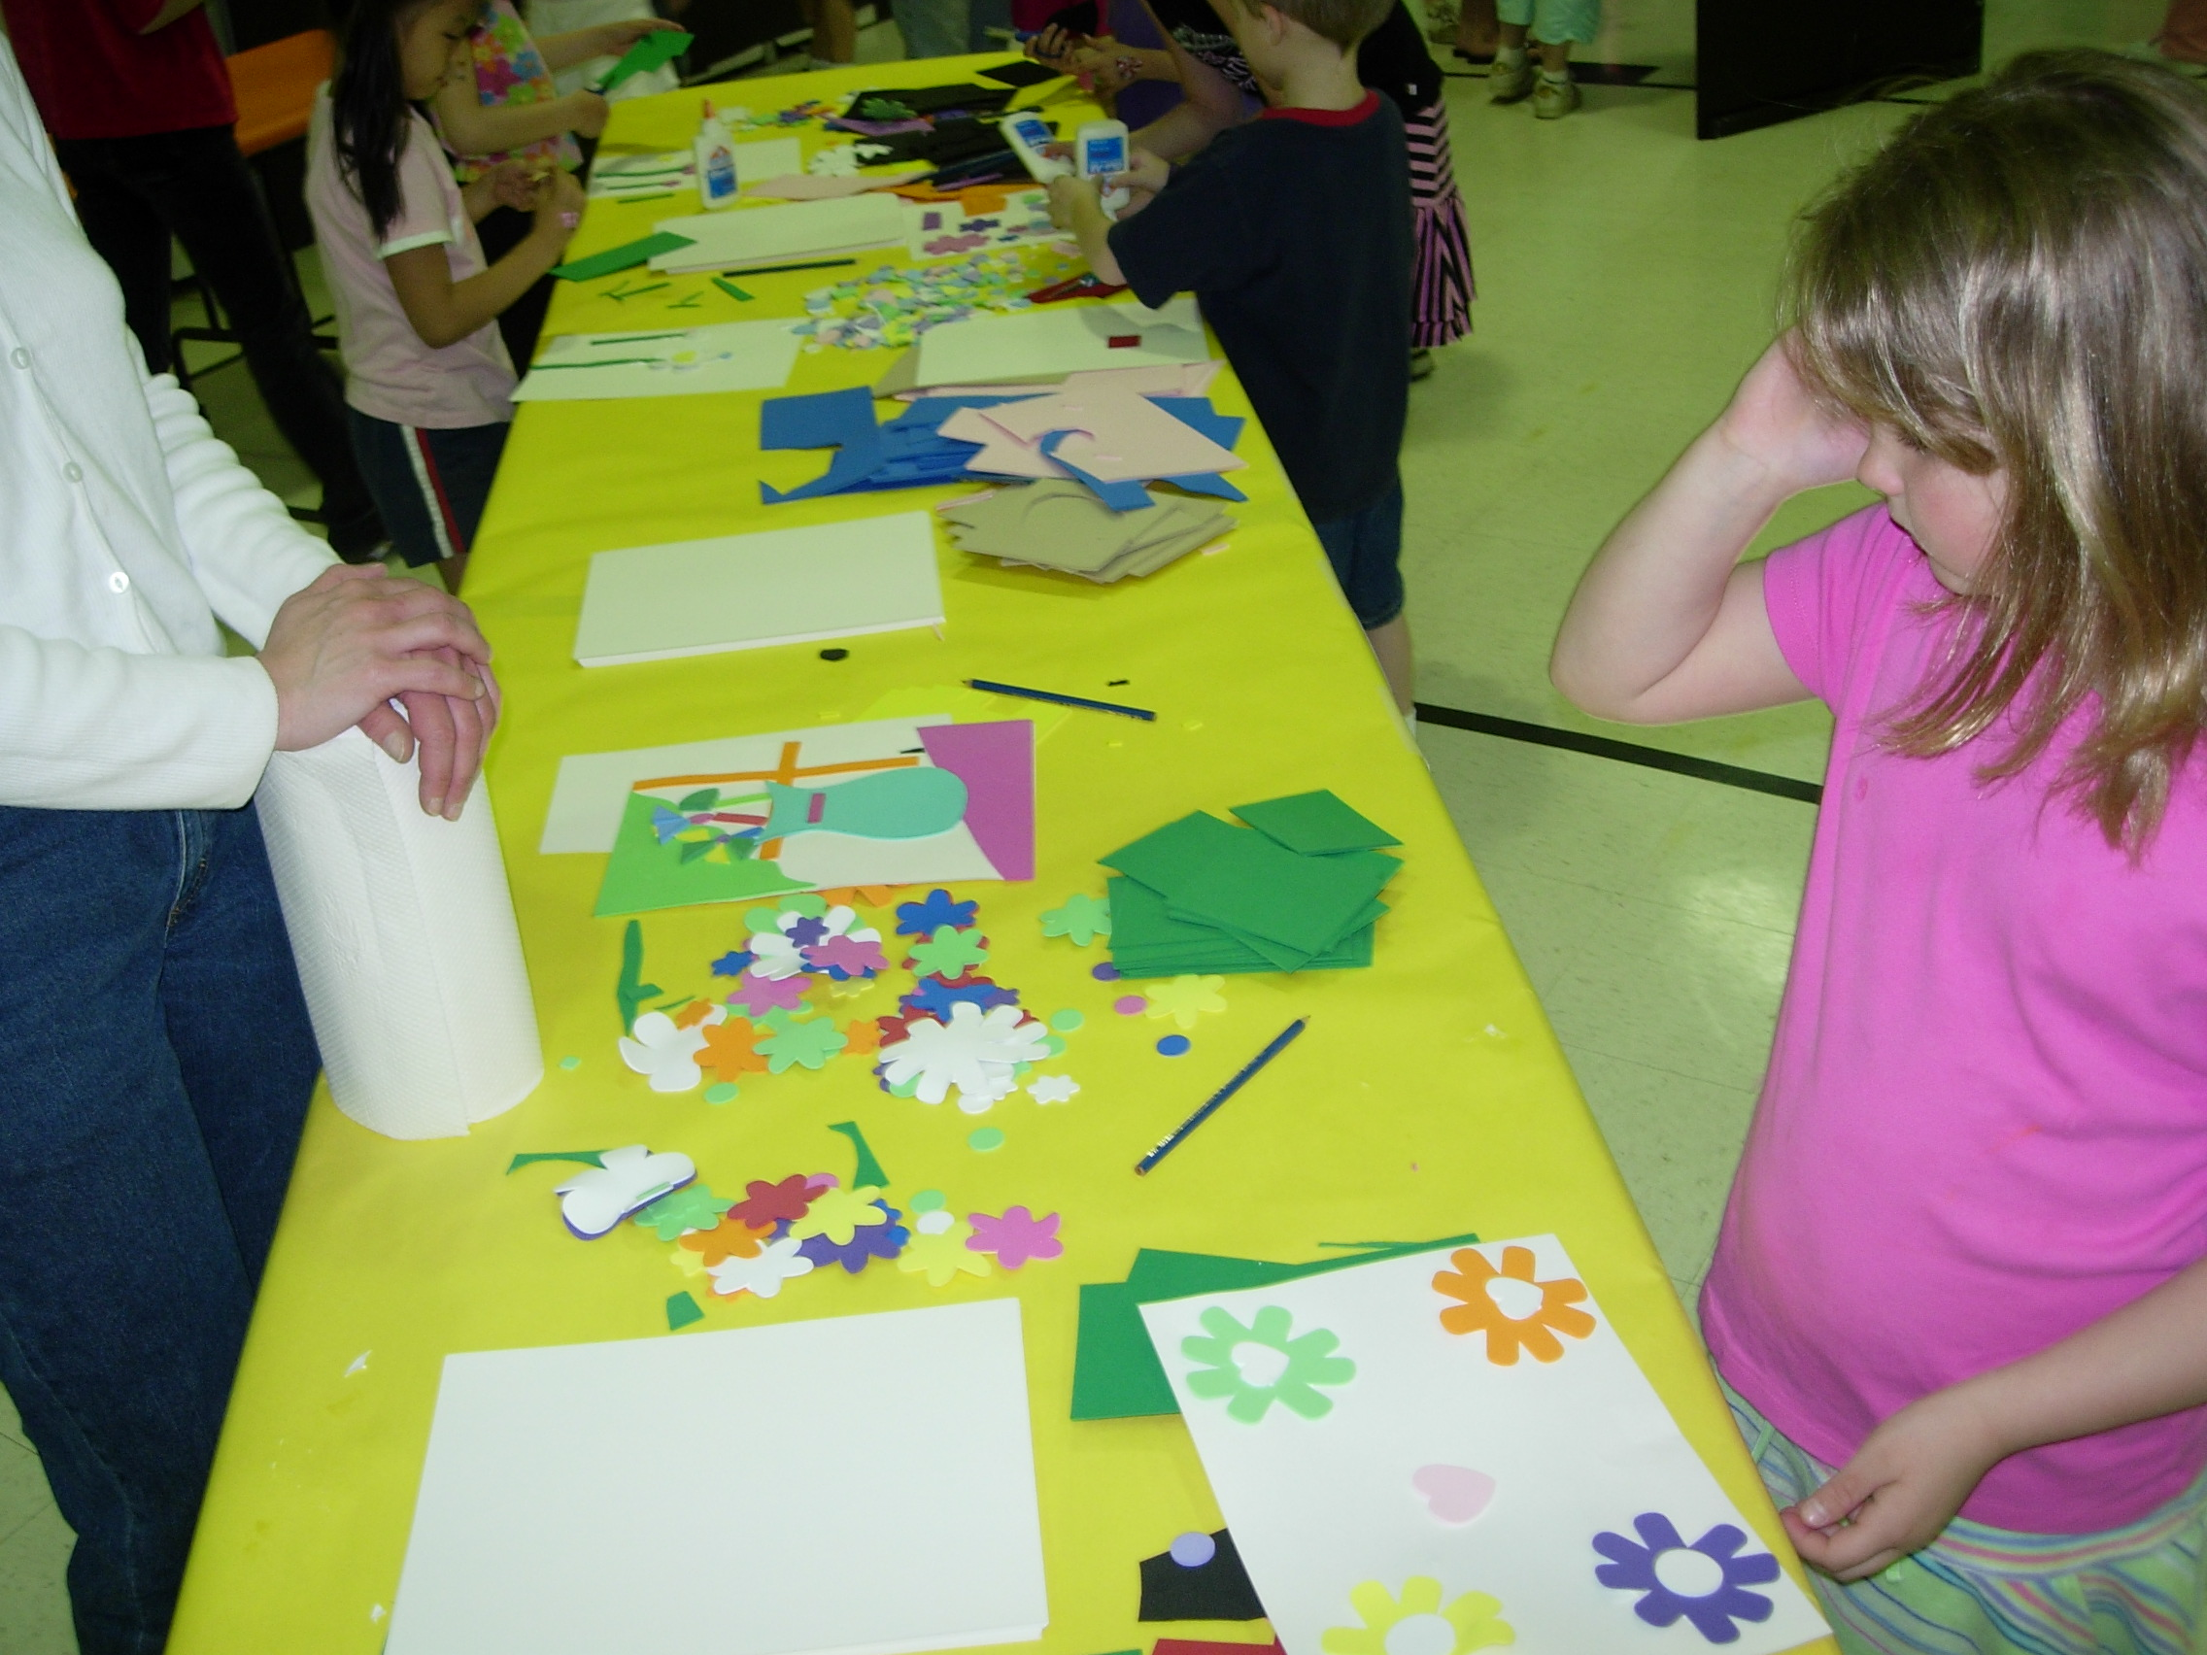
- Discuss examples of organizations that benefit others including American Cancer Association, AIDS Foundation, St. Judes, etc.
- Explain how community fundraisers help these organizations function.

Activity Plan:
  - Students will write a letter to each teacher in each grade level explaining the project and its goals. Allow each grade level or the sponsoring class to pick an organization to support.
  - Each sponsoring class may organize into two teams to divide up the objectives of the project. One team should be a communications team and the other a finance team.
  - The communication teams will each create a presentation for the students of each grade level explaining what the quilt will look like and the goals of the project. They will also hand out instructions and examples if needed.
  - The communication team will also write a letter to companies asking for donation of supplies. These include but are not limited to construction paper, foam parts, scissors, glue, etc.
  - The finance team will budget the allotted money to provide the supplies that could not be donated for the classes. They need to calculate the average amount each student should need to donate to create a profit. They also need to determine the effect of decreasing or increasing the number of quilts on their profits.
  - The finance team will keep track of the budget and supplies for each grade level. They need to create a box or can to collect change during lunch hours for each of the different quilts. The money needs to be counted at the end of each day.
  - The supplies are handed out, and the quilt pieces are collected after a designated time. The students need to thread these pieces together either with yarn and a hole punch or with tape. The quilts need to be displayed in a prime location.
  - The communication team needs to create a poster board to show the progress of each grade level.
  - Each student needs to create a newspaper article on the project. They may be posted throughout the halls as an advertisement.
  - The finance team will determine the winner after the allotted contest time and take care of communicating with the winning organization. They will explain the steps to donate the money.
  - The communication team can announce the results to the team.

Assessment:
- For each team, the teacher may assess on completion and on quality each step of the project.
- Additionally, the teacher may choose to assess the final, completed project.

Learning Objectives:
  - Students will practice correct grammar and vocabulary required in creating letters.
  - Students will practice correct grammar and formal language through creating newspaper articles.
  - Students will practice arithmetic by utilizing accounting techniques.
  - Students will practice presentation and verbal skills.
  - Students will learn marketing and advertising skills.
  - Students will learn or practice cost analysis (graphing inequalities).

Prerequisites for this Activity:
- An understanding of how to graph inequalities (this may or may not be used depending on the level of students)
- Basic writing skills (letter and article)

Materials List:
- yarn
- foam pieces
- construction paper
- glue
- tape
- hot glue
- other creative items (glitter, metallic pens, etc.)

Items Shared among the classes:
- scissors
- hot glue gun
- markers

Activity Extensions: This activity can be as large and as small as the class wants it to be. It can also be combined with can food drives and other charitable projects.

