In the Rainforest
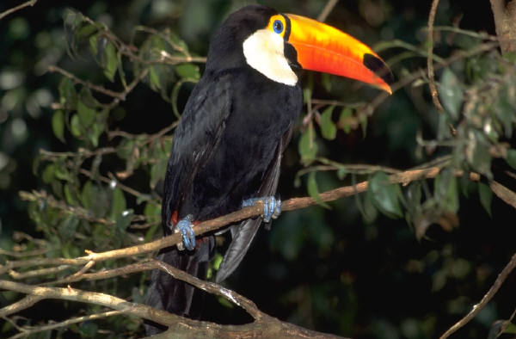

Activity Summary:
This PowerPoint presentation is intended to stimulate student’s interest in the rainforest, exploring the importance of the rainforest, endangered animals and the dangers of logging and farming.
Subject:
Science: Life Science

Grade Level:
Target Grade: 7th
Upper Bound: 8th
Lower Bound: 6th
Time Required: 20-30 minutes
Activity Team/Group Size: classroom

Activity Introduction / Motivation:
The presentation itself is meant to provide an interesting life science topic to make science fun, interesting, and relevant to everyday life.
Activity Plan:
Present the powerpoint presentation and let the students ask questions. Use the background information as a reference. Use the worksheet entitled, Worksheetforest to keep the students on task.
Activity Closure:
Allow the students to ask any questions they may have. If time permits, click on the link for the virtual rainforest tour to learn about the different animals or allow the students to explore this link and additional links at the bottom.

Learning Objectives:
The student should learn the difference between tropical and temperate rainforests. They should understand how the nutrients in the rainforest are not in the soil but in the vegetation. They should be able to brainstorm ways to help save the rainforest from destruction.

Vocabulary / Definitions:

indigenous people: natural to a country or region, native
greenhouse effect: The greenhouse effect is the rise in temperature experienced because certain gases in the atmosphere, like water vapor, carbon dioxide, nitrous oxide, and methane, trap energy from the sun. Without these gases, heat would escape back into space and Earth’s average temperature would be nearly freezing! Because of how they warm our world, these gases are referred to as greenhouse gases. The greenhouse effect is important. Without the greenhouse effect, the Earth would not be warm enough for humans to live. But if the greenhouse effect becomes too strong, it could make the Earth warmer than usual, which could devastate many natural habitats.

Activity Extensions:
Have the students form a recycling project and see how much paper they can save in a week or a month, to show how they can help save trees.

References:
http://www.enchantedlearning.com/subjects/rainforest/
http://www.spa3.k12.sc.us/WebQuests/Rainforests/
http://www.epa.gov/globalwarming/kids/greenhouse.html

Authors:
Graduate Fellow Name: Danielle Lewis
Undergraduate Fellow Name: Amanda Clauson

