**Prescription labels and inserts are important markers that describe and explain who, what, where, when, why and how of the drug.***How the drug is prescribed for*, *What is the drug, Where is the drug administered, When to administer the drug, Why is the drug used, How to administer the drug*

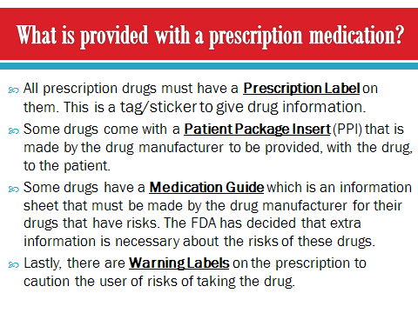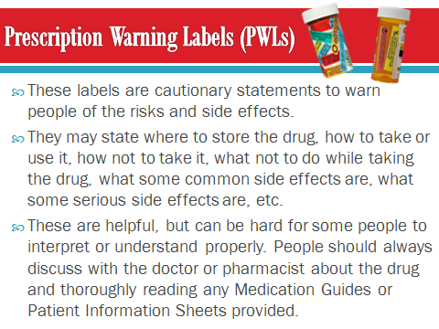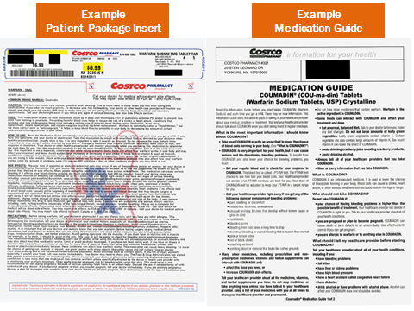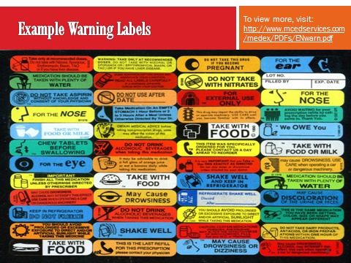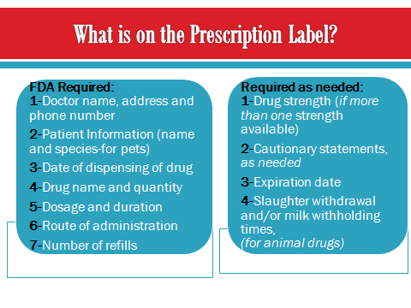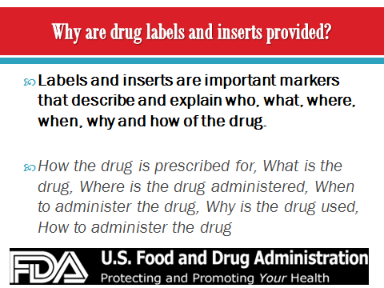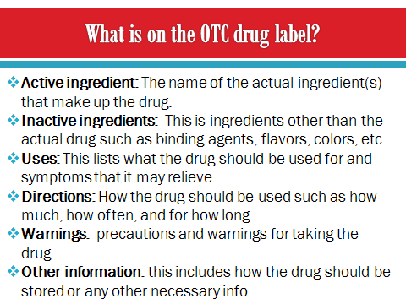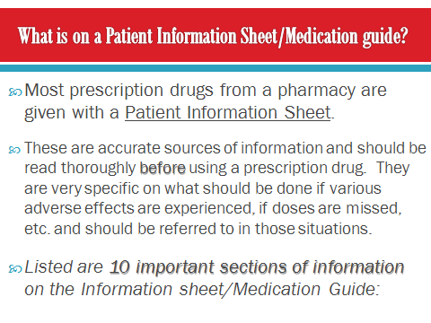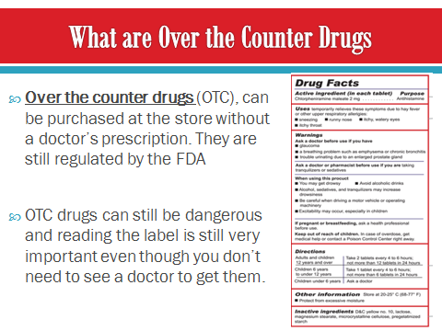

**In conclusion, when a prescription drug is used the label and any provided information documents should be read completely and should be referred to if any problems occur. The information given should be followed exactly and the medication should not be used in any way other than what is stated on the label and in the Medication Guide or Patient Information Sheet. For over the counter drugs, the label should be read completely and followed. Just like prescription drugs, they should only be used exactly how the label tells you to. *Remember*, if anything is confusing or problems occur such as side effects, you should call your doctor!**

