Reproduction Quiz (ANSWERS)

- Label which species to its correct penis type
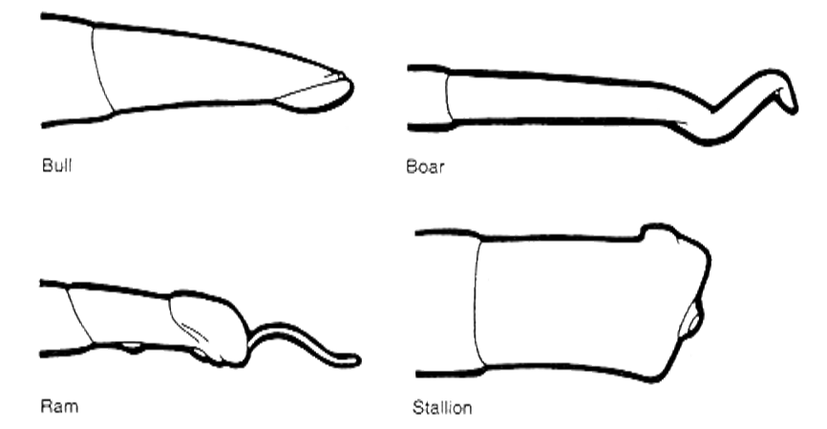
Stallion
Bull
Ram
Boar

- What is the difference between EstrOUS and EstrUS
Estrous: is the entire cycle the female will go through between heat and ovulation
Estrus: is the standing heat. One part of the Estrous cycle
- Name 1 of the 3 sterilization techniques in male.
Castration, Vasectomy, or Shortening of the spermatic cord
- Name 1 of the 3 types of Uterine Horns females can have.
Simple, Duplex, or Bicornuate
- Name any species difference in reproduction male or female.
Boars have a corkscrew shaped penis, rams have a filiform appendage, stallion has a vascular penis, sow has a corkscrew shaped cervix, mare only ovulates in one spot (ovulation fossa), boar has nonpendulous and inverted testicles, bull and ram deposit sperm in the vagina, stallion and boar deposit sperm in the cervix by the uterine body, mare has a specialized oviduct that only allows fertilized eggs to pass into the uterus.

