Reproduction Quiz

- Label which species to its correct penis type
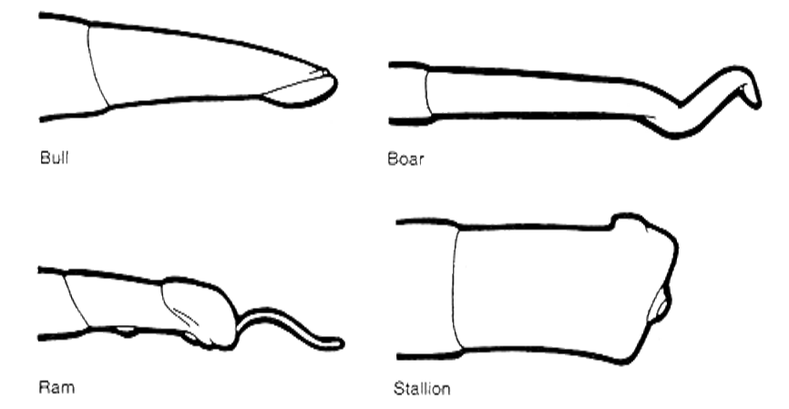

__________________________

- What is the difference between EstrOUS and EstrUS

- Name 1 of the 3 sterilization techniques in male.

- Name 1 of the 3 types of Uterine Horns females can have.

- Name any species difference in reproduction male or female.

