Instructions: The following worksheet is to see how well you have comprehended the topics we covered in class. For each of the pictures provided please answer if it is male or female; what species it is and then label the parts that are numbered. Not all the parts are labeled so look carefully to where the arrow is pointing!
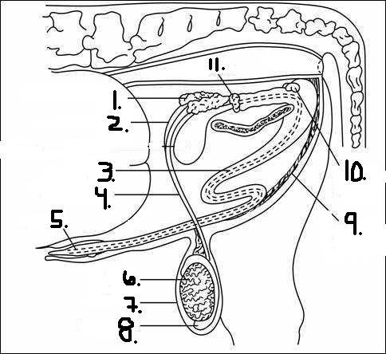
1.

Male or Female?_____Male________________
Species_______Bull_______________________
1. Seminal Vesicles 6. Testis
2. Ampullae 7. Scrotum
3. Urethra 8. Epididymis
4. Vas Deferens 9. Retractor muscle
5. Penis 10. Cowpers gland
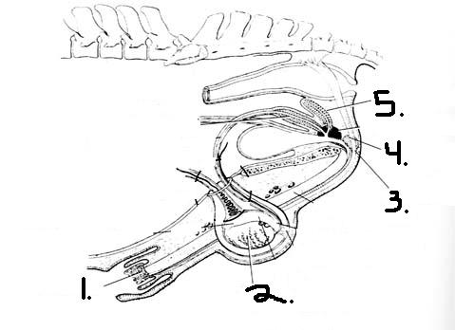
2.

Male or Female?______Male______________________
Species?________Stallion_______________________
1. Glans Penis
2. Testis
3. Retractor Penis Muscle
4. Bulbourethral gland
5. Vesicular Gland

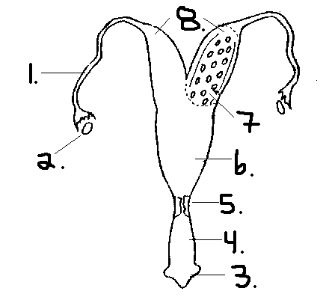
3.

Male of Female?________Female_____________
Species_____Ewe _______________________
1. Oviduct 5. Cervix
2. Ovary 6. Body of Uterus
3. Vulva 7. Caruncles
4. Vagina 8. Uterine Horns
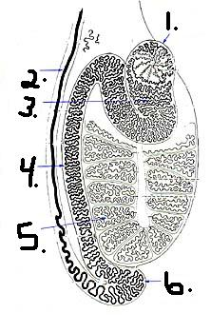
4.
1. Head of epididymis
2. Ductus deferens
3. rete tubule
4. body of epididymis
5. seminiferous tubules
6. tail of epididymis

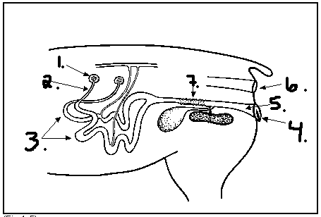
5.

Male or Female?__________Female___________________
Species_______________Pig_______________________
1. Ovary
2. Oviduct
3. Horns of uterus
4. Vulva
5. Vagina
6. Rectum
7. Cervix

