Name: ______________________________ Date: _____________ Class: ______
Instructions: For each of the pictures provided please determine the gender and species. Then label the parts that are numbered. Not all the parts are labeled so look carefully to where the arrow is pointing!
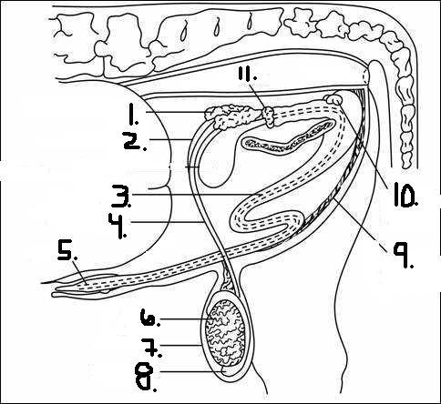
1.

Male or Female?_____________________
Species______________________________
1. 6.
2. 7.
3. 8.
4. 9.
5. 10.
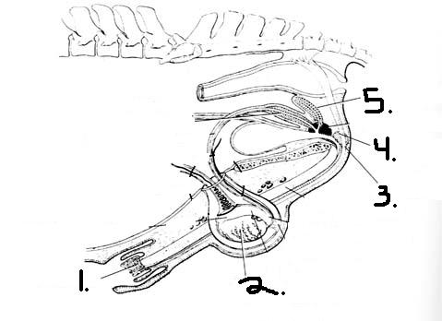
2.

Male or Female?____________________________
Species?_______________________________
1.
2.
3.
4.
5.

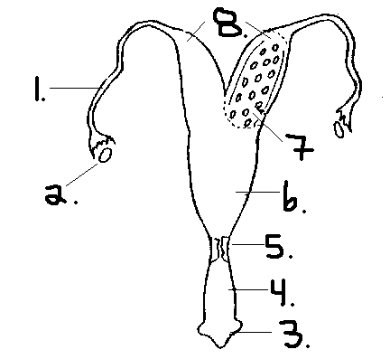
3.

Male of Female?_____________________
Species____________________________
1. 5.
2. 6.
3. 7.
4. 8.
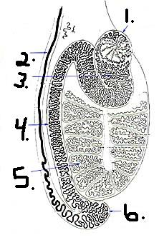
4.
1.
2.
3.
4.
5.
6.

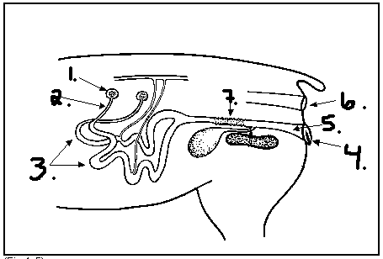
5.

Male or Female?_____________________________
Species______________________________________
1.
2.
3.
4.
5.
6.
7.

