Ruminant Digestion Activity Examples
Giraffe (ruminant) example: straws, pipe cleaner, markers, and clay
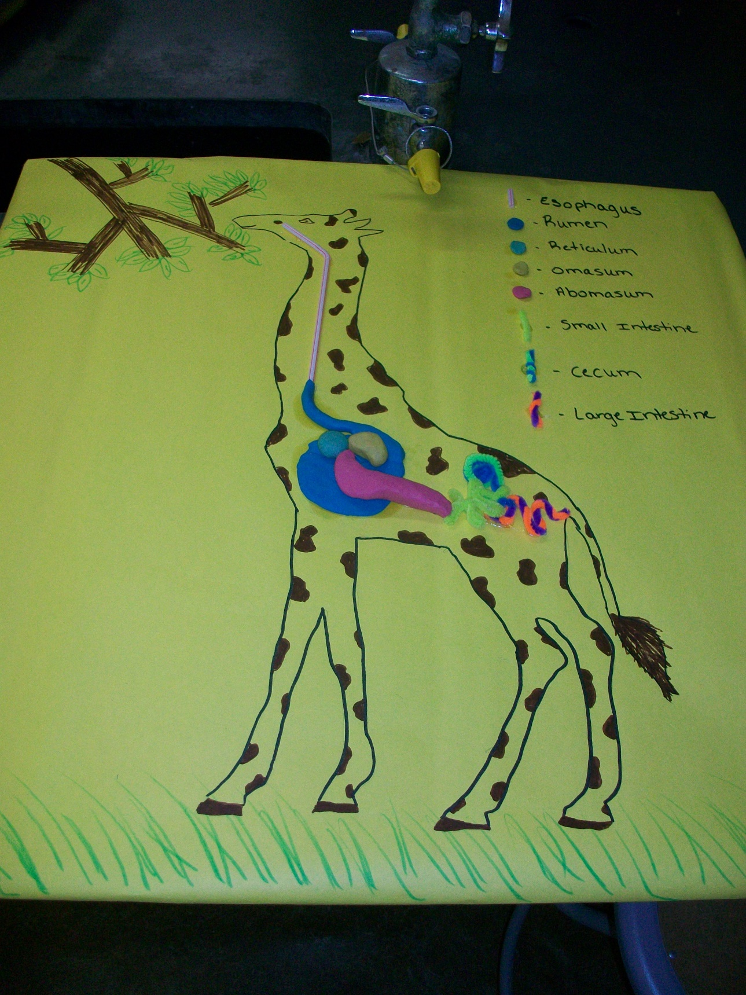

Cow (ruminant) example: finger-paining
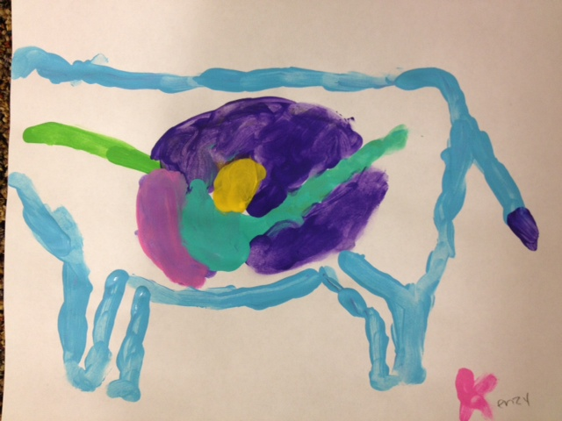
Bird (monogastric) example: pipe-cleaner, clay, and markers
