**Ruminant Digestion Worksheet**

1. Label the four compartments of the ruminant stomach in the following image:

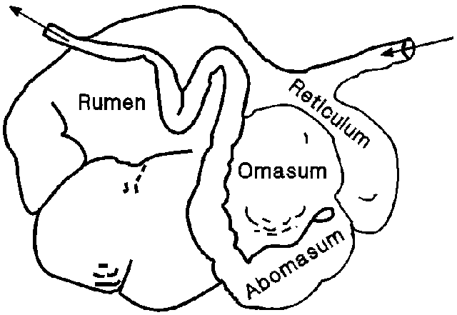

A

B

D

C

A: ___________Rumen________________

B: ___________Abomasum_____________

C: ___________Omasum_______________

D: ___________Reticulum______________

1. What are papillae and where are they located in the digestive tract of a ruminant animal?

Papillae are small, rounded projections. They can be found in the rumen and the omasum (if they say tongue too that is correct)

1. What are villi and where are they located in the digestive tract of a ruminant animal?

Villi are small finger-like projections located in the small intestine (more specifically – in the jejunum)

1. What is the difference between fermentation and enzymatic digestion?

Fermentation happens anaerobically (without oxygen present) when microbes breakdown nutrients. In ruminant animals this occurs in the rumen (majority), reticulum, omasum, and large intestine. Enzymatic digestion occurs through secretion of enzymes by the animal. This occurs in the abomasum and small intestine in the ruminant animal.

1. Which chamber of the ruminant stomach is glandular? What does it secrete?

The abomasum is glandular, this means that it secretes enzymes.

1. Which chamber of the ruminant stomach is honeycomb-like in appearance?

The reticulum

1. What are the three layers of nutrients in a ruminant animal’s largest compartment?

The top layer is the gas layer, the middle layer is the fiber mat, and the bottom layer is the liquid layer.

1. List three examples of a ruminant animal:

Answers will vary but some of the more common answers may be: cow, sheep, goat, giraffe, deer, buffalo, elk, etc.