**Ruminant Digestion Worksheet**

1. Label the four compartments of the ruminant stomach in the following image:

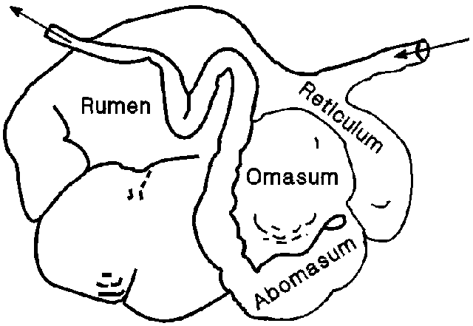

D

C

B

A

A: _________________________________

B: _________________________________

C: _________________________________

D: _________________________________

1. What are papillae and where are they located in the digestive tract of a ruminant animal?
2. What are villi and where are they located in the digestive tract of a ruminant animal?
3. What is the difference between fermentation and enzymatic digestion?
4. Which chamber of the ruminant stomach is glandular? What does it secrete?
5. Which chamber of the ruminant stomach is honeycomb-like in appearance?
6. What are the three layers of nutrients in a ruminant animal’s largest compartment?
7. List three examples of a ruminant animal: