Lesson Summary: The purpose of this lesson is for students to gain a basic understanding of Domains and Kingdoms in the Biological Taxonomic System. In this interactive activity, students will use their knowledge of these two taxonomic categories to complete a scavenger hunt of questions and answers in friendly competition with their classmates. A partnership or team of students will work together to answer each question and complete the scavenger hunt in a time race against the others. The first group to complete their scavenger hunt worksheet correctly (as checked by the teacher) will be the winner of this activity. (winners’ compensation is to be determined by the teacher).
Subject:
Science: Biology

Grade Level: 6th grade

Time Required: One class period.
Materials:
- Attached student Scavenger Hunt Activity Student worksheet
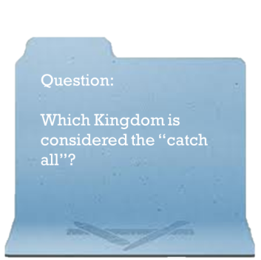
- Either a folder or a folded piece of paper with the answer to a question on the outside and a new question when you open to the inside
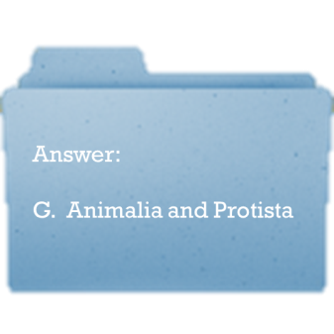
Activity Introduction/Preparation: The attached PowerPoint may be used as an introduction to the Domains and Kingdoms for the students before this activity takes place. Make and disperse the folders or folded papers of questions and answers around the room or hallway.

Activity Plan:
- Group the students into partnerships or teams.
- Explain that the student worksheet is for their question letters (which are assigned to the questions at random). There is only one correct order of letters that will appear on a completed worksheet (it does not matter which question you start with, the order makes a full circle)
- Create a competitive environment for the students. Start each group at a different question so that they do not have to interfere with each other’s progress.

Assessment: Monitor the activity. Periodically ask students how successful they are in matching the questions and answers. Let the students know that they can raise their hand to ask about Domain or Kingdom characteristics at any time. Allow all (or most) teams to complete the activity before the correct answers are given. Allow the winning team to read the answers in order as you read the questions in order for them.

Lesson Extensions:
- Assign the teams each a different Domain or Kingdom. Have them create a 1-2 minute presentation to give to the class about what they have learned.
- Assign a homework project where each student must bring back a list of 3 organisms they have run into in each of the 4 Kingdoms.
References: Here are some websites that may be helpful
- http://www.cals.ncsu.edu/course/zo150/mozley/domkingd.html
- http://animaldiversity.ummz.umich.edu/accounts/Animalia/

TEKS: Science-
- (6) 12.A, 12.B, 12.C

Authors:
Undergraduate Fellow: Kristen Bowen
Graduate Fellow: Jennifer Graham
Please email us your comments on this lesson:
E-mail to ljohnson@cvm.tamu.edu
Please include the title of the lesson, whether you are a teacher, resident scientist or college faculty and what grade you used it for.

