Answer on the Top of the Folder from Last Question/ Next Question’s Question on Inside of Folder
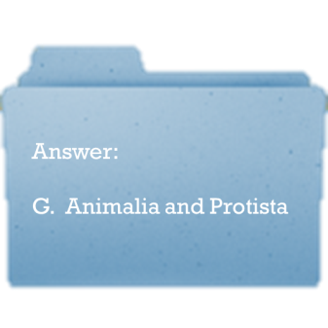

M. Fungi/ Which Kingdom has the greatest number of species?
B. Animalia/ What species has the greatest number by far within the Kingdom Animalia?
L. Insects/ Which Kingdoms are mobile?
G. Animalia and Protista/ Which Kingdom is the “catch all”?
K. Protista/ Which Kingdom is the first step in many food chains?
F. Plantae/ Salmonella belongs to which Domain?
E. Bacteria/ Which taxonomic category groups all living things together by similar DNA sequences?
A. Domain/ Which Kingdoms are immobile?
C. Fungi and Plant/ The organisms from which domain tolerate harsher environments such as hot water and landfills and produce methane?
H. Archaea/ Which taxonomic category is of the second highest rank?
D. Kingdom/ The bodies of most animals (except sponges) are composed of cells that make up what?
J. Tissues/ The organisms in this Domain are set apart by their nuclei
I. Eukarya/ Which Kingdom is the most closely related people in the Animal Kingdom?
M. Fungi (Wrapping back to the first question).

