Science Fair: TOPIC
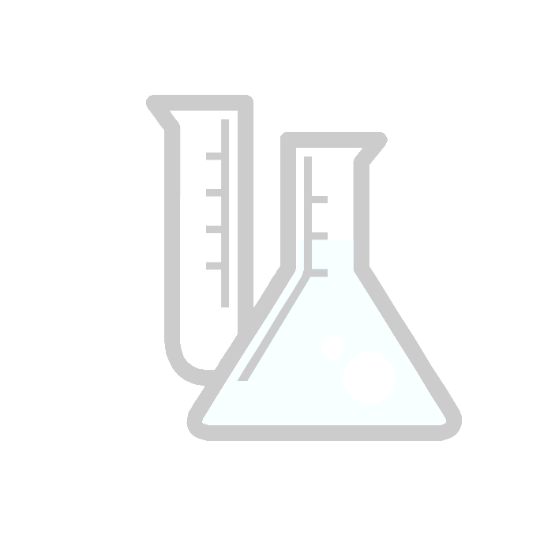
Name: ______________ Class Period: ____ Due: ___________
Things I am Interested in | Questions/Problems I Have | Science Fair Topic
Ex) Dropping things from high places | I don’t know why some objects drop faster than others | What affects the speed at which objects drop: the mass or the shape?

Put a star by your top 2 topics.

Can they be answered by a yes or no? (If so, re-work them! Good science fair projects are not yes or no questions.)

Can you design an experiment to test this question?

Write the best topic, phrased as a question, below:
________________________________________________________________________________________________________________________________________________
________________________________________________________________________
Now start thinking about an experiment to test this question!
Science Fair: TITLE & QUESTION
Name: ____________ Class Period: ____ Due: _____________

The question is what you will answer with your experiment. It might be something like “What is the optimum popping time for microwave popcorn?” or “What kind of lipstick stays on the longest?” or “What kind of fertilizer makes plants grow the tallest?”. The question should not be able to be answered with a yes or no. It should be specific and testable.

Write out your question below.

________________________________________________________________________

________________________________________________________________________

The title of your science fair project should be something fun and catchy. Write out your working title below. (You can change the title if you think of a better one before you make your board.)

________________________________________________________________________

________________________________________________________________________

Science Fair: MATERIALS & PROCEDURE
Name: ____________ Class Period: ____ Due: _____________

The materials list should include all materials used, the quantity of each item, and be as specific as possible.

Ex) 2 measuring sticks, marked with both centimeters and inches ← GOOD
Something to measure with ← NOT GOOD

Materials:
________________________________________________________________________________________________________________________________________________________________________________________________________________________
_______________________________________________________________________________________________________________________________________________________________________________________________________________________

Your procedure should be written so that a student 2 years younger than you could repeat the experiment exactly. Number each step.

Procedure:
________________________________________________________________________________________________________________________________________________________________________________________________________________________________________________________________________________________________
________________________________________________________________________________________________________________________________________________________________________________________________________________________________________________________________________________________________________________________________________________________________________
________________________________________________________________________________________________________________________________________________

Science Fair: HYPOTHESIS
Name: ____________ Class Period: ____ Due: _____________

The hypothesis is an educated guess in which you predict the result of your experiment. A hypothesis is based on research and experience. In your hypothesis you must do 2 things:

- Answer your question by telling what you think will happen
- Explain why you think that will happen

Ex) I predict that the popping time listed on the popcorn box, 3:30 minutes, will be the optimum popping time. I assume that the popcorn manufacturer has tested to find the popping time that will work the best for their popcorn.

Write your hypothesis below.

________________________________________________________________________

________________________________________________________________________

________________________________________________________________________

________________________________________________________________________

________________________________________________________________________

________________________________________________________________________

Science Fair: DATA & RESULTS
Name: ______________ Class Period: ____ Due: ___________

Display your data in a way that is easily understood. You must have a minimum of one chart/table and one graph, but you can use as many as you like. Choose whatever type of graph best displays your data: line, bar, or circle.

Graph checklist:
- Title the graph clearly.
- All axes should be properly labeled (including units).
- Make your charts/tables and graphs in a computer program (like excel) or neatly on paper. If you use paper, make sure your lines are neat and use colors. Graph paper can be very helpful!

The results section should be about a paragraph in length and summarize what you found out in the experiment. Tell what the experimental results are. Now is not the time to say which product is best or why! (Save this for the conclusion.)

Ex) The 3 minute popping time resulted in the fewest percentage unpopped (7%) and burnt (3%) kernels and the highest percentage of perfect kernels (90%). All other times gave a smaller percentage of perfect kernels.

Write out your results below.
________________________________________________________________________________________________________________________________________________________________________________________________________________________________________________________________________________________________________________________________________________________________________
Science Fair: CONCLUSIONS
Name: ______________ Class Period: ____ Due: ___________

Your conclusions should be a paragraph long. They should elaborate on and explain your results. First say whether you proved or disproved your hypothesis. Then explain why and what implications this may have. You can use words like “best” in the conclusion.

Ex) The 3 minute popping time was best because it resulted in the highest percentage of perfect kernels. This result disproves my hypothesis. I suspect that the microwave I used was slightly higher powered than the microwave on which the suggested popping time was based.

Write your conclusion below.

________________________________________________________________________________________________________________________________________________________________________________________________________________________________________________________________________________________________________________________________________________________________________
________________________________________________________________________________________________________________________________________________________________________________________________________________________

Science Fair: REFERENCES
Name: ____________ Class Period: ____ Due: _____________

When you do research, it’s important to gather information from many different types of sources. You need to reference the sources; that is, give credit to the people whose information you are using.
For your science fair project, you should have at least 5 references. Only two of these may be internet sources.
Record the information from each reference source below. Later, we’ll put this information in the proper format and make a bibliography.

Book/web site/journal title: _______________________________________________________________
Article title: __________________________________________ Journal volume and issue: ___________
Web address: __________________________________________________________________________
Author(s)/editor(s): _____________________________________________________________________
Publisher: _________________________________ Place of publishing: __________________________
Date viewed/read: __________ Date written/created: ___________Page # & chapters read: ___________
Book/web site/journal title: _______________________________________________________________
Article title: __________________________________________ Journal volume and issue: ___________
Web address: __________________________________________________________________________
Author(s)/editor(s): _____________________________________________________________________
Publisher: _________________________________ Place of publishing: __________________________
Date viewed/read: __________ Date written/created: ___________Page # & chapters read: ___________
Book/web site/journal title: _______________________________________________________________
Article title: __________________________________________ Journal volume and issue: ___________
Web address: __________________________________________________________________________
Author(s)/editor(s): _____________________________________________________________________
Publisher: _________________________________ Place of publishing: __________________________
Date viewed/read: __________ Date written/created: ___________Page # & chapters read: ___________
Book/web site/journal title: _______________________________________________________________
Article title: __________________________________________ Journal volume and issue: ___________
Web address: __________________________________________________________________________
Author(s)/editor(s): _____________________________________________________________________
Publisher: _________________________________ Place of publishing: __________________________
Date viewed/read: __________ Date written/created: ___________Page # & chapters read: ___________

Science Fair: Research Notes
Name: ______________ Class Period: ____

________________________________________________________________________________________________________________________________________________
________________________________________________________________________
________________________________________________________________________________________________________________________________________________
________________________________________________________________________
________________________________________________________________________________________________________________________________________________
________________________________________________________________________
________________________________________________________________________________________________________________________________________________
________________________________________________________________________
________________________________________________________________________________________________________________________________________________
________________________________________________________________________
________________________________________________________________________________________________________________________________________________
________________________________________________________________________
________________________________________________________________________

Science Fair: REFERENCES Bibliography Guidelines

Books:
One author:
Last name, First name. Title of Book. Place of publication: Publisher, year of
publication.
Jones, Royce. Anatomy of Criticism: Four Essays. Chicago: MacMillan, 1988.

More than two authors (et al. means "and others" in Latin):
Last name of 1st author, First name, et al. Title of Book. Place of publication:
Publisher, year of publication.
Ottoman, James, et al. Exploring Architecture. New York: Bantam, 1998.

Encyclopedia Articles:
An encyclopedia article or entry with no author indicated:
"Title of article/entry." Title of Encyclopedia. Edition. Year of publication.
"The Dinner Party." Masterplots. 10th ed. 1976.

An encyclopedia article with an author:
Last name, First name. " Title of article/entry." Title of Encyclopedia.
Edition. Year of publication.
McKay, Nellie Y. "Angelou, Maya." The World Book Encyclopedia. 2nd ed.
2006.

Internet Sources:
An article from an online encyclopedia:
"Title of Article/Entry." Title of Online Encyclopedia. Date article was
accessed <URL>.
"Zygotes." Britannica Online. 14 Mar. 1999 <http://www.eb.com:180>.

An article from an online magazine, newspaper, or journal:
Last name of author, First name. "Title of Article." Title of Online
Publication. Date of publication. Date of access <URL>.
Sklaroff, Sara. "E-mail Nation." U. S. News Online. 22 Mar. 1999. 31 Mar. 1999
<http://www2.USNews.com/usnews/issue/990322/22emai.htm>.

A website with an author's name listed:
Last name of author, First name. Title of Website. Date of website. Date
website was accessed <URL>.
Carroll, Robert Todd. The Skeptic's Dictionary: Witches. 21 Dec. 2004. 7 Mar.
2005 <http://www.skepdic.com/witches.html>.

