Skateboard Science

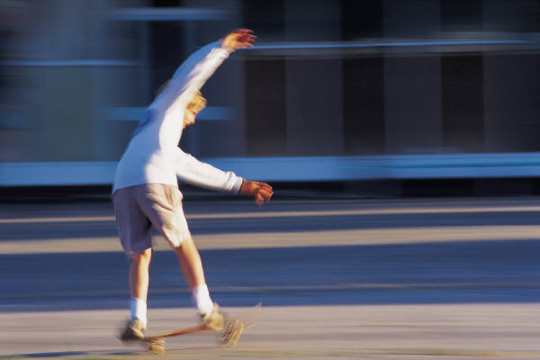

Activity Summary:
Students will use skateboards, stop watches, and Newton spring scales to discover the relationship between force and acceleration. Students will also be doing various calculations involving speed and acceleration.
Subject:
Science: Science as Inquiry, Physics, Newton’s Laws

Grade Level:
Target Grade: 7th
Upper Bound: 8th
Lower Bound: 6th

Time Required: 1-2 50-minute class periods
Activity Team/Group Size: 4-5
Reusable Activity Cost Per Group [in dollars]: $10
Expendable Activity Cost Per Group [in dollars]: $0

Materials List (per group):
- 1 skateboard (ask the students to bring their skateboards from home)
- Meter stick
- 1 Newton spring scale (You can purchase these at http://www.sciencelab.com/page/S/CTGY/20848 )

- String
- Masking tape
- 1 stopwatch
- Several bricks (or other large masses)

Activity Plan:
- Attach a loop of string to one of the skateboard axles. Place the bricks on top of the skateboard.
- Using masking tape, mark off a 1-meter distance on a level floor. Label one end “start” and the other “finish.”
- Attach a spring scale to the loop of string. Pull it so that you maintain a force of 2.0 N. Be sure to pull with the scale straight out in front. Practice applying a steady force to the skateboard as it moves. This may take a while to practice!
- On a sheet of paper make a table like this:

Force (N) | Trial 1 Time (s) | Trial 2 Time (s) | Trial 3 Time (s) | Average Time (s) | Average Speed (m/s) | Final Speed (m/s) | Acceleration (m/s²)
 | ------ | ------- | ------ | ------ | ------ | ------ | -------

- Find the smallest force needed to pull the skateboard at a slow, constant speed. Do not accelerate the skateboard. Record this force on the first line of the table.
- Add 0.5 N to the force in step 5. This will be enough to accelerate the skateboard. Record this force on the second line of the table.
- Have one of your partners hold the front edge of the skateboard at the starting line. Then pull on the spring scale with the force you found in Step 6.
- Have another partner set a stopwatch to time how long it takes for the skateboard to cross the finish line. When your partner signals to start and lets go of the skateboard, maintain a constant force until the skateboard reaches the finish line. Record the time and force in the table.
- Repeat steps 7 and 8 two more times, and record the data in time trial 2 column.
- Repeat steps 7, 8, and 9, using a force that is 1.0 N greater than the force you found in step 5.
- Repeat steps 7, 8, and 9 two more times. Use forces that are 1.5 N and 2.0 N greater than the force in step 5.
- For each force, find the average time of the 3 trials. Record this number as the average time in the data table.
- Find the average speed of the skateboard for each force and record this as the average speed. HINT: average speed = 1meter / average time.
- Final speed = average speed X 2
- Acceleration = Final speed / Average time.
- Make a graph of your data and connect your data point with a line. HINT: acceleration on the y-axis and force on the x-axis.

Assessment:
The teacher may check a students’ understanding of the material by checking giving students the following questions:
- What does your first data point on your graph represent? (the force required for an acceleration of zero)
- According to your graph, how is the acceleration of the skateboard related to the pulling force?
- Which variable is the manipulated variable? Which is the responding variable?

Learning Objectives:
TEKS 7th Grade Science Objectives:
  - (A) Demonstrating basic relationships between force and motion using simple machines

Activity Scaling:
If you would prefer an even more inquiry based lab for use after the above experiment, have the students design their own experiment to test how the acceleration of the loaded skateboard depends on its mass.
Questions to ask:
- How would you vary the mass of the skateboard?
- What quantity would you need to measure that you did not measure in the previous experiment?
- Do you have the equipment to make the measurement? If not, what other equipment would you need?

