The Whole Truth (Not the Fibula) About the Skeletal System
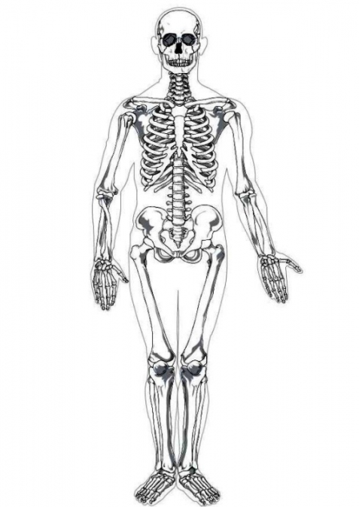
Summary:
This lesson is designed to help the students learn the bones in the skeletal system. The students will further their understanding through the quiz Prezi and attached worksheets.
Subject:
- Science: Grade 7(12B): identify the main functions of the systems of the human organism, including the circulatory, respiratory, skeletal, muscular, digestive, excretory, reproductive, integumentary, nervous, and endocrine systems.
Grade Level:
- Target Grade: 7
- Upper Bound: 8
- Lower Bound: 6
Time Required: 1 and a half class periods
Activity Team/Group Size: Small groups of 2 or 3 students

Materials:
- Prezi lesson
- Prezi quiz
- Prezi quiz worksheet
- Prezi quiz fill in the blank skeleton worksheet
- Dancing skeleton and box for dancing skeleton
Reusable Activity Cost Per Group [in dollars]: $0
Expendable Activity Cost Per Group [in dollars]: $0

Learning Objectives:
- Knowledge of the bones in the skeletal system
Lesson Introduction / Motivation:
The skeletal system is the frame and structure of the human body. It provides protection for the organs and produces more white and red blood cells. Each organism has a unique skeleton. Showing the lesson Prezi will help the students learn the bones in the body.
Lesson Plan:
The students will first watch the skeletal lesson Prezi. After they finish that they will break up into teams for the skeletal quiz Prezi. Each team will fill out the Prezi quiz worksheet to be turned in. At the end of the lesson the students can build the dancing skeleton and its box to take home (perfect around Halloween).
Lesson Closure:
Collect the group worksheets and discuss the lesson and quiz with the students. Each student will fill out the Skeleton fill in the blank worksheet individually (it is more for the students to write down the answers to the quiz for them to study later).
Assessment:
Maybe give the winners of the quiz candy or extra credit on an assignment. Since the only way to get a 100 is to get the bonus points it is not advisable to use as a grade unless prorated.

Background and Concepts for Teachers:
- Basic knowledge and understanding of the skeletal system.
Lesson Scaling:

Instead of listing the answers to the quiz, teachers can have the students fill out the skeleton fill in the blank. This is useful if the student has a learning disability and needs a visual to answer the questions.

Lesson Extensions:
Teachers can show the students different videos on the skeletal system. Students can be shown the Hannah Montana Bone Dance to stimulate interest.

Safety Issues: None

Multimedia Support and Attachments:
- https://prezi.com/secure/c1141bee8b3ee7f73328f05c8bb1fde16d3af431/ for the lesson Prezi
- http://prezi.com/fyg7cch87djs/the-skeletal-system-katie-clark/ for the quiz Prezi
- http://www.thetoymaker.com/Holidays/Halloween/BigSkelly.pdf for the dancing skeleton
- http://www.thetoymaker.com/Holidays/Halloween/Dancingskellies.pdf for the dancing skeleton box

References:
- http://www.edupics.com/coloring-page-human-skeleton-i7622.html
- https://homes.bio.psu.edu/faculty/strauss/anatomy/skel/skeletal.htm
- http://yucky.discovery.com/noflash/body/pg000124.html

Keywords:
- Skeletal System
- Skeleton
Authors:
Graduate Fellow Name: ___
Teacher Mentor Name: ___
Undergraduate Fellow Name: Katie Clark
Date Submitted: ___
Date Last Edited: ___
Please email us your comments on this lesson:
E-mail to ljohnson@cvm.tamu.edu
Please include the title of the lesson, whether you are a teacher, resident scientist or college faculty and what grade you used it for.

Teacher’s Comments:

