The horse was domesticated in ___4000____ BCE.

The horse was estimated to be pulling the cart in ______3000_______BCE.

The war chariot was invented in ______1800____ BCE.

The Draft Horses: large thick horses that can carry large loads
- Main Work: is on a farm or pulling heavy rail cars
- Breeds: Clydesdale, Shire, Belgian
The Light Carriages Horses: light boned horses good for long distance travel
- Main Work: Pleasure Driving
- Breeds: Hackney Horse, Quarter Horse, Standardbred Horse
The Pony Carriage Horses: pony sized horses
- Main Work: Pleasure and competition driving
- Breeds: Welsh Pony, Haflinger, Miniature Pony

Multiple Hitch:
- Four in Hand: 4 horses (2 in the back and 2 in the front)
- Unicorn: 2 horses in the back and 1 in the front
- Tandem: 1 horse or pony in front of another
- Pair: 2 horses side by side
Driving Competitions:
- Harness Racing used which breed?: Standardbred Horses
- True or False?: Carriage Pleasure Driving is only open to certain breeds.
- 3 Day Driving Trials Includes:
  - Dressage
  - Marathon
  - Cone Driving
List some Do’s and Don’ts:
- DO: The harness and cart fit your horse or pony properly, know what to do in case of an accident, emergency, or the unexpected, drive safely, make sure your horse or pony is properly trained to pull a cart.
- DON”T: Forget to check harness, cart, and most important horse or pony soundness, work our equine if they are unfit to work, sick, or lame, drive in the dark or poor visibility areas on public roads, take unnecessary risks, get careless about safety.

Head Pieces

Brow Band
Crown Piece
Blinder

Noseband

_Bit__

Throatlatch

Body Pieces
Neck Strap
Saddle
Reins

Breast Collar
Girth
Traces
Over Girth

Rump Pieces

Reins
Hip Strap

Crupper

Breeching

Traces

How to Harness a Horse:
- Separate Harness into 3 sections
  - Saddle Pad, Girth, Crupper, Hip Strap, and Breeching
  - Neck Strap, Breast Collar, and Traces
  - Bridle and Reins
Common Bits:
- Liverpool: Most common of all driving bits and very versatile bit that rein placement can be adjusted for minimum or maximum pressure on the mouth.
- Butterfly: Common Bit type because of varying mouth pieces. Not as popular because it is not as adjustable for rein placement.
Common Types of Carts:
- Meadowbrook: 2 wheels
  - Light weight, inexpensive and most comfortable cart for daily use.
- Road Cart: 2 wheels
  - Light weight, inexpensive, and is considered a common utilitarian cart.
- Dog Cart: 2 or 4 wheels
  - Carries up to 4 people and used for country driving, driving tandem or four in hand. Were thought of as utilitarian carts now used as show carts.

Label the Cart Parts
Seat
Tug Dee
Tree

Breeching Dee
Shaft Tips
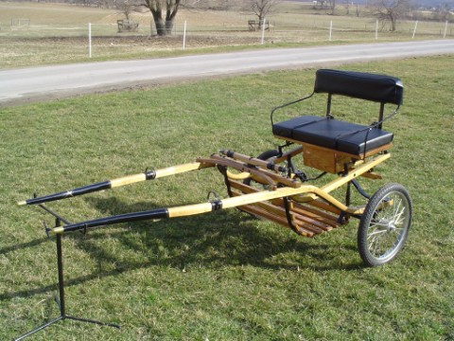
Shaft
Step and Footrest
Wheel
Felloes (silver)
Spoke
Common Harness Functions:
- Bridle, Headpieces, and Reins: Help direct and turn the horse and cart.
- Body Pieces:
  - Saddle: Helps support the shafts
  - Breast Collar: what the animal pushed against to pull the cart foreword
  - Girth: Holds the saddle in place
  - Traces: Connect the breast collar to the cart
- Rump Pieces:
  - Crupper: Restricts the saddle from sliding up on the horses neck
  - Breeching: When stopping, it keeps the cart from bumping the horse in the rump
When training your horse how to drive Safety is number 1!!!
1st step in training your horse how to drive is: Ground Driving
- Ground Driving is walking a distance
behind them so that they begin to learn walking foreword without you next to them leading them.
- It’s important to work both the Walk and Trot gait.
Recommended cues are:
- Walk Foreword: “Walk” Halt: “Whoa”
- Turn Right: “Ha” Turn Left: “Ge”
What is the second step in training your horse how to drive: Full Harness and Training Tools
- Once you are comfortable working in the harness, begin hooking them up to training tools.
  - Examples are: Log, Small Tire, PVC Pipe
What is the third step in training your horse how to drive: Ground Driving while Hooked to the Cart
- Before initially hooking the cart to the horse you can help get them used to the shafts by placing two PVC Pipes where the shafts would go.
- Do NOT immediately get into the cart on your first hook up.
What is the fourth step in training your horse how to drive: Drive while in the Cart
- Make sure you are NOT Alone when getting in the cart for the first time.
Do NOT be afraid To Ask for Help!!!!!
Driving can be VERY dangerous to you and your horse so it is important to work Slowly, Carefully, and most importantly SAFELY.

