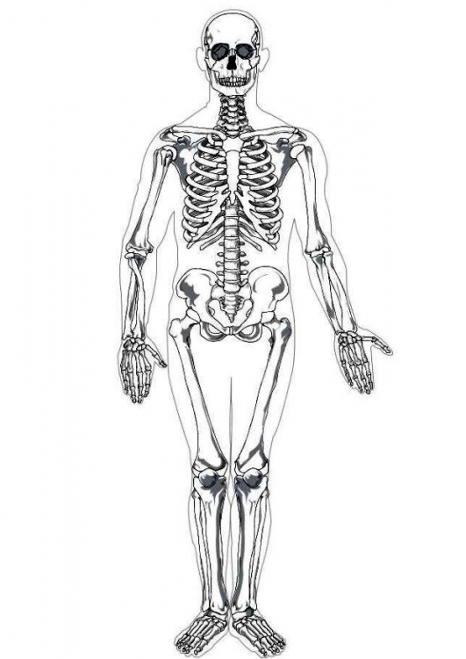

Metatarsal Bones

Phalanges of Fingers

Metacarpal Bones

Carpal Bones

Ulna

Radius

Phalanges of Toes

Tarsal Bones

Os Coxa

Fibula

Tibia

Patella

Femur

Sacrum

Lumbar Vertebra

Thoracic Vertebra

Ribs

Scapula

Humerus

Cervical Vertebra

Clavicle

Sternum

Mandible

Skull

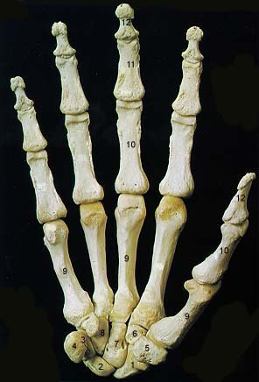

Distal Phalange

Middle Phalange

Proximal Phalange

Trapezoid

Hamate

Metacarpal

Triquetral

Trapezium

Pisiform

Navicular (Scaphoid)

Lunate

Capitate

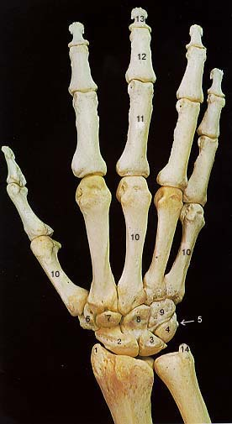

1. Styloid Process of Radius

2. Navicular

3. Lunate

4. Triquetral

5. Pisiform

6. Trapezium

7. Trapezoid

8. Capitate

9. Hamate

10. Metacarpal

11. Proximal Phalange

12. Middle Phalange

13. Distal Phalange

14. Styloid Process of Ulna