Slime and Polymers
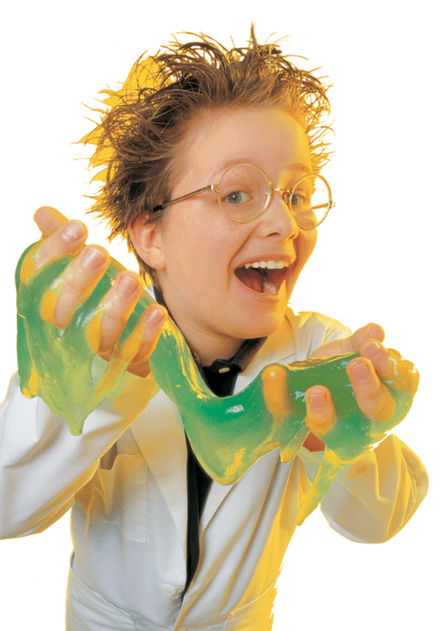
Follow the directions in the order they are given, and answer the questions as you go, do not wait until the end of the lab.
Using the graduate cylinders provided, measure out 30mL of the 50/50 glue/water solution.
1. Record your observations about this mixture. ______________________________________________________________________________
______________________________________________________________________________
To this solution add 2-3 drops of food coloring. ONLY ADD 2-3 DROPS (any more and you wind up dyeing your hands and anything else the slime touches.) Stir until the color is uniform.
At the next station, measure 10mL of borax solution into a graduate cylinder.
2. Record your observations about this mixture.
______________________________________________________________________________
______________________________________________________________________________
Add the borax solution to the glue mixture in your cup. Stir hard with the provided popsicle sticks to make sure borax can interact with the glue—forming a gooey slime.
3. Record your observations about this new mixture.
______________________________________________________________________________
______________________________________________________________________________
Remove the slime from the cup and keep your slime in the plastic bag provided when you are not playing with it to ensure it will stay good for a long time.
4. Thinking back to what you learned from the powerpoint about how polymers gain the ability for different textures/hardness, why (or how) do you think that when you add the borax solution to the glue mixture the glue changes and becomes “slime”.
______________________________________________________________________________
______________________________________________________________________________

5. If you wanted to make different kinds of slime (such as more runny slime, or more hard slime) what would you change to make those?
______________________________________________________________________________
______________________________________________________________________________

