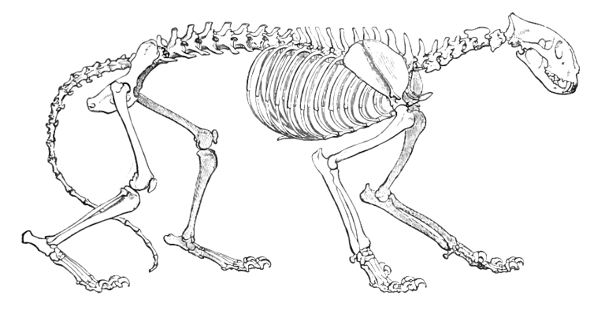
Using your knowledge of small animal skeletal systems, follow all directions and correctly answer each question.
1. Circle the Pectoral Skeleton of this cat. (1 POINT)
2. Label the following bones: Sternum, Radius, Ulna, Tibia, Maxilla, Ilium, Patella, Scapula, Femur, and Phalange (10 POINTS) refer to PowerPoint presentation with bone diagrams.
3. Match the correct word with its definition: (3 POINTS)
A. Joints _B_tissue that holds bones together
B. ligaments _D__hard tissue that supports and protects
C. cartilage _A__where bones meet and allows for movement
D. bone
4. The __Yellow Marrow_ part of the bone stores fat and energy. The _Compact Bone_ is made of Calcium and gives bones strength. (2 POINTS)
5. Name two types of joints. (2 POINTS) Hinge, Plane, Saddle, Pivot, Ball and Socket or Ellipsoid

6. What are the four functions of the skeletal system? (1/2 POINT EACH= 2 POINTS)
Form, Protection, Support, Strength

