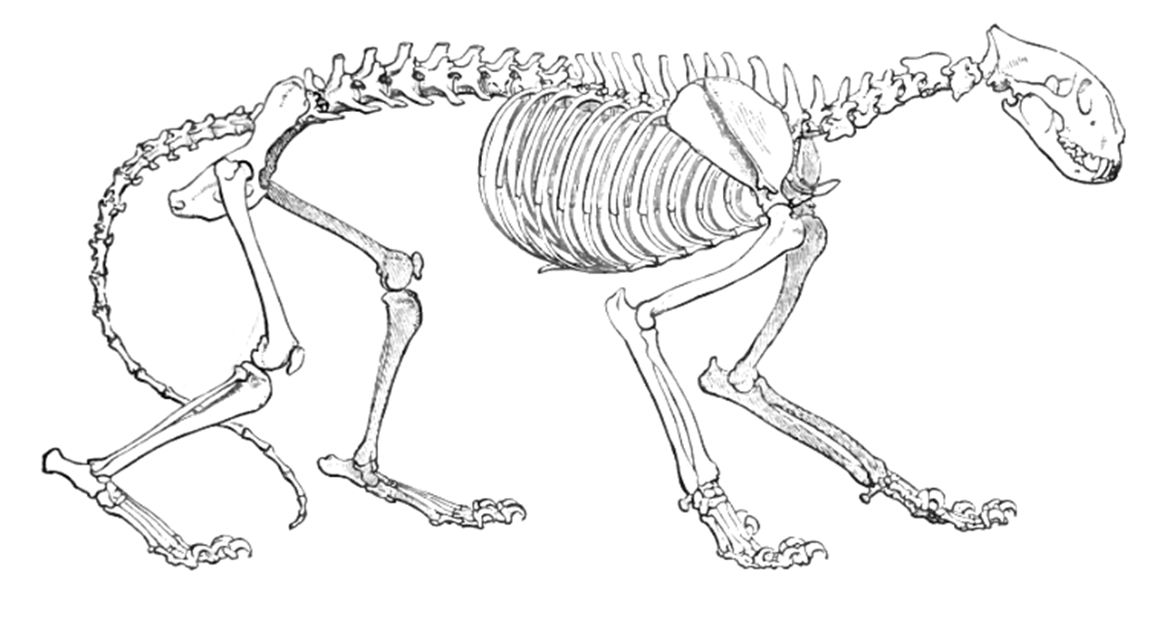
Using your knowledge of small animal skeletal systems, follow all directions and correctly answer each question.
1. Circle the Pectoral Skeleton of this cat.
2. Label the following bones: Xiphoid Process, Radius, Ulna, Axis, Maxilla, Ilium, Patella, Scapula, Femur, and Phalange
3. Match the correct word with its definition:
A. Joints _____tissue that holds bones together
B. ligaments _____hard tissue that supports and protects
C. cartilage _____where bones meet and allows for movement
D. bone
4. The _____________ part of the bone stores fat and energy. The _____________ is made of Calcium and gives bones strength.
5. Name two types of joints. _____________________ ________________________
6. What are the four functions of the skeletal system?
___________________ ____________________ ____________________ __________________

