Soil Microbes and Their Role

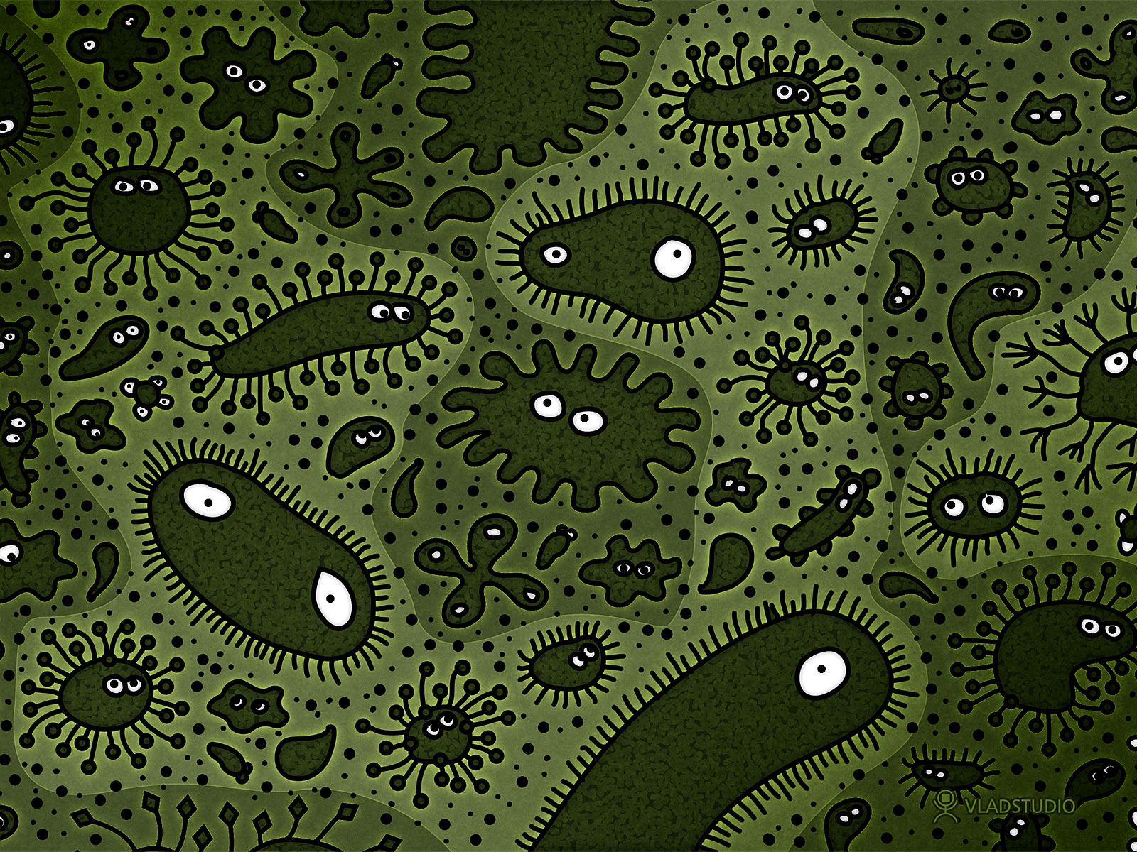

Download all Associated Files for this lesson from our Website

Summary:
In this lesson, students will learn about soil microbes and their role in the ecosystem of decomposing dead material and recycling nutrients back into the soil. They will apply these concepts by using the scientific method to make a mini compost bin in the classroom and observing decomposition by soil microbes.
Keywords: soil, microbes, bacteria, fungi, plants, gardening, protozoa, decomposition, compost, environment

TEKS: Science-
6.1 (B) / 7.1 (B) / 8.1 (B) Practice appropriate use and conservation of resources, including disposal, reuse, or recycling of materials.
6.2 (C) / 7.2 (B) / 8.2 (B) Collect and record data using the International System of Units (SI) and qualitative means such as labeled drawings, writing, and graphic organizers.
6.3 (C) / 7.3 (C) / 8.3 (C) Identify advantages and limitations of models such as size, scale, properties, and materials.
7.5 (B) Demonstrate and explain the cycling of matter within living systems such as the decay of biomass in a compost bin.
7.6 (A) Identify that organic compound contain carbon and other elements such as hydrogen, oxygen, phosphorus, nitrogen, and sulfur.

Grade Level: 6th-8th

Learning Objectives:
The learner will:
- Understand the role of soil microbes in the ecosystem
- Define decomposer
- Know how nutrients are recycled in the soil
- Recognize the nutrients microbes recycle
- Place soil microbes’ role in the nitrogen cycle
- Recognize the different types of soil microbes and their specific roles
- Understand a food web
- Identify components of compost and its uses

Time Required: Lecture Time: 30 minutes
Observation of compost pile time: 2-5 weeks
Materials:
- 5 Gallon Plastic Container
- Soil
- Drill
- Spray Bottle
- Stirring Utensil

Reusable Activity Cost Per Group [in dollars]: $45
Expendable Activity Cost Per Group [in dollars]: $10

Background and Concepts for Teachers:
Soil microbes are microscopic organisms that live in the soil. Every living thing in the ecosystem has a role. It is either a:
1) Producer, meaning it produces its own food energy from light, carbon dioxide, and water; these include plants and some bacteria.
2) Consumer, meaning it eats producers or other consumers for food; e.g. animals.
3) Decomposer, meaning it eats dead material, recycling nutrients back into the surroundings. Bacteria, Fungi, Protozoa, Earthworms.
Soil microbes are decomposers. They are beneficial to the soil by providing nutrients plants need. Types of soil microbes include bacteria, protozoa, nematodes, and fungi. Bacteria recycle nitrogen by a process known as nitrogen fixation. Bacteria convert nitrogen from animal waste into free nitrogen in the air that plants absorb. Bacteria also convert this nitrogen in the soil into a form plants can use and get from the soil. Composting is an environmentally friendly way to fertilize a garden. The bacteria break down organic matter placed in the compost pile to create humus. This material is rich in nutrients and is good for plants.

Vocabulary / Definitions:
- Organic Matter – Carbon containing matter derived from a once-living source
- Microbe – Microscopic organism
- Decomposer – Organisms that consume dead material to recycle nutrients back into the ecosystem
- Nutrient – A substance that provides nourishment essential for growth and the maintenance of life
- Bacteria – microscopic unicellular organisms that aid in decomposition
- Protozoa – single-celled microscopic organism that eat other microbes
- Nematodes –microscopic not segmented worms with bodies that taper to each end
- Fungi – A group of unicellular or multicellular organisms feeding on organic matter
- Food Web – A graphic of interconnecting food chains showing how energy moves throughout an ecosystem.
- Compost -The decayed remains of organic matter that has rotted into a natural fertilizer
- Humus – The organic component of soil, formed by decomposition of organic matter by microbes, found in compost piles
Lesson Introduction / Motivation:
Use soil microbes in the news to explain their importance and the wide variety of roles that microbes play. Explain the Gulf oil spill of 2010. Then explain that a strain of bacteria that lives in the soil was found that can help to break up the toxic compounds from the oil spill.
Presentation/Explanation:
Present the PowerPoint on Soil Microbes and Their Role.
Activity/Application:
Make a mini compost bin in the classroom. See Activity Page on the PEER website.

Lesson Closure:
Have students take out a piece of paper or pass out note cards. Have them write 3 things they learned today, 2 questions they have, and 1 thing they want the teacher to know. If time permits, have them tell a classmate.
Assessment/Evaluation:
Give the students the handout provided, where they can record their observations of the compost pile over a few weeks. The students will draw pictures to represent the decomposition of the food and touch and smell the compost. If you use laboratory notebooks in your classroom, have the student record their observations and write down the answers there.

Lesson Extensions:
Perform an experiment to see how the presence of organic matter for soil microbes to decompose effects the growth of a plant. For the control variable, plant a plant in soil with no leaves, worms, pill bugs, or food added. Plant an identical plant in the compost pin. Observe the plant growth over a few weeks. What conclusions can be drawn about the role of soil microbes and how this affects plants?

Safety Issues:
Do not add any food or leaves to the compost bin that a student has allergies to. Make sure students do not get dirt in their eyes have them wash their hands after handling the compost bin. Be careful when using the drill on the bin.

References:
- http://www.tgdaily.com/sustainability-features/50193-new-bacteria-could-help-clean-up-oil-spill
- http://www.ehow.com/how_5566061_make-classroom-compost-bins.html
- http://www.bioflora.com/soil-microbes

Authors:
Undergraduate Fellow: Megan Landon
Graduate Fellow: Jennifer Graham

