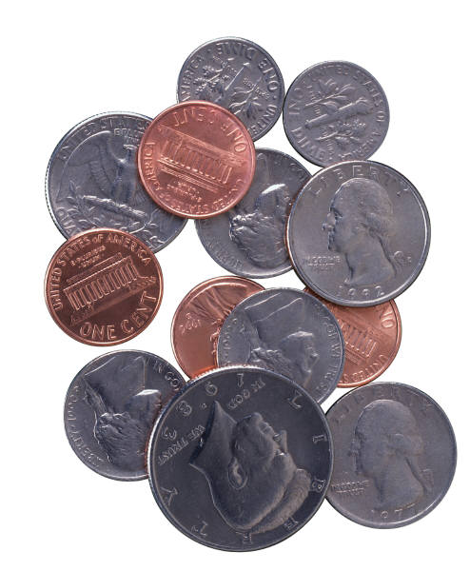

Spare Change: Adding and Subtracting Fractions
Worksheet

Do you have a pile of loose change at home? Maybe your family keeps change in a jar or maybe you save it up in a piggy bank. Spare change can really add up!

How much money do you have saved up in all that spare change? How many cents is a dime worth? How about a quarter? Count out how many of each type of coin you have and fill in the second column. How much are all your pennies worth? Fill out the third column with the total value of each type of coin:

Type of Coin | Value of Coin | Number of Coins | Total Value
Penny | 1¢
Nickel | 5¢
Dime
Quarter
Other:

How many coins do you have altogether? | How much money is all of your change worth?

Now, using the circles drawn below, make and label a pie chart that represents
- The fraction of each type of coin out of the total amount of coins
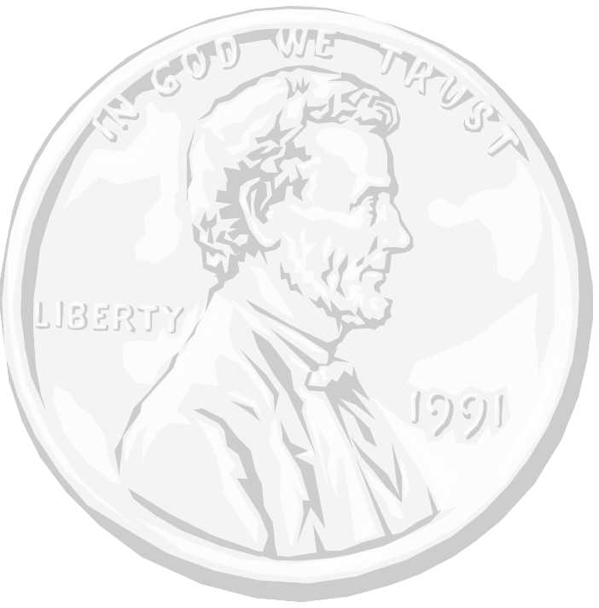
- The fraction of the total value of each type of coin out of the total value of all the coins
A)
B)

