Bridge Building!
Testing Structural Stability of Bridges
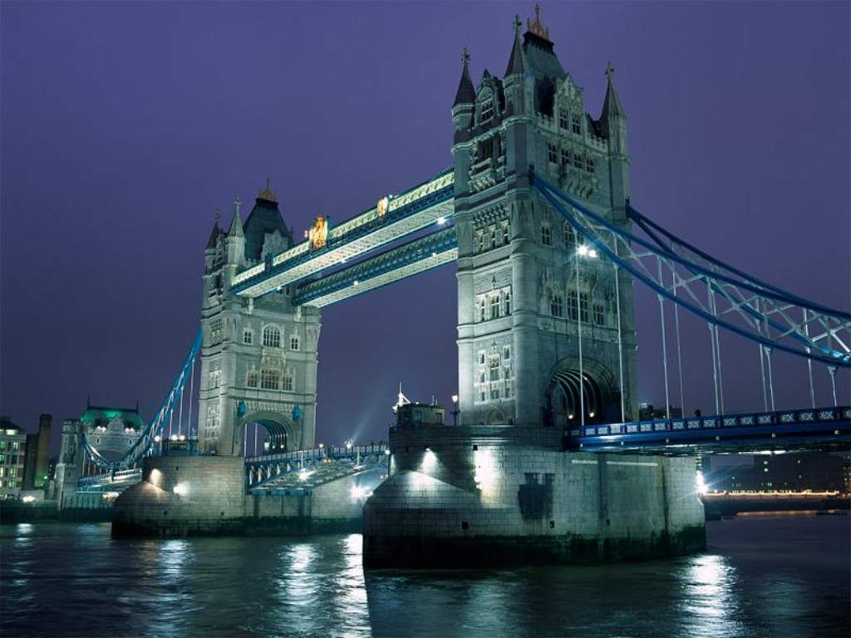

Activity Summary:
In this activity, groups of students will use visual aids of bridges around the world and their creativity to build various bridges of spaghetti and marshmallows. Each group will then test the strengths of their bridges to come to conclusions on the characteristics of strong and stable bridges.
Subject:
Math: Numbers and Operations, Geometry, Measurement, Problem Solving, Connections, Representation.
Science: Unifying Concepts and Processes, Science as Inquiry, Physical Science.

Grade Level:
Target Grade: 6
Upper Bound: 8
Lower Bound: 4

Time Required: 1.5 hours
Activity Team/Group Size: Split class into 5 groups
Reusable Activity Cost Per Group [in dollars]: $0
Expendable Activity Cost Per Group [in dollars]: $5 (Spaghetti and marshmallows)
Authors:
Undergraduate Fellow Name: Ekta Saheba
Graduate Fellow Name: Sarah Davis
Date Submitted: April 12, 2005
Date Last Edited: April 12, 2005
Parent Lesson Plan(s):
This activity was created as a supplement to the PEER 6th grade curriculum module “The Kiss of the Assassin,” but can easily stand alone. (http://peer.tamu.edu/IntegratedCur.shtml)

Activity Introduction / Motivation:
Present to students the various pictures of bridges around the world. Explain that there are many different designs that can be used to construct bridges but the most important thing about them is that they are stable, and they last for a long time. (Keep the pictures of bridges around so students can use them for the activity).
Activity Plan:
Preparations:
- Open up bags of marshmallows about 1-2 days before activity will be done to allow the marshmallows to ‘air out’ and harden up a little. This will allow them to be more useful during the activity.
- Before presenting this activity to the students, break or cut spaghetti into 45 sets of the following lengths: 3”, 5”, 6”, and 8” pieces. Also keep 45 pieces of spaghetti at full length. It is easier to distribute material if each group of spaghetti is bundled together using a rubber band.
- Collect various objects from around the classroom that can be placed on the bridges, once built, to determine how much weight each bridge can hold. Objects used can include text books, thin chapter books, spiral notebooks, Kleenex boxes, etc. Objects used should have flat edges, making it easier for students to stack the weighted objects on top of their bridges. Once objects are collected, record each one’s weight for use later in the procedure.
- Open either StructuralStabilityWorksheet.doc (Word) or StructuralStabilityWorksheet.xls (Excel) and make any changes you see fit for your students. Print a copy for each student in the class.

Procedure:
- Split students into 5 groups.
- Each group is designated a specific spaghetti size (choose from 3”, 5”, 6”, 8”, and full-length). Students are not allowed to break their spaghetti into smaller parts. Each group must use the lengths of spaghetti given to them only.
- Using their creativity, ideas, and information gained from the pictures of bridges around the world, each group will build their own bridge using the spaghetti.
- Each bridge must span 8.5” (the short length of a piece of paper), and must be 3” wide. Though the bridge can be as tall as wanted, each bridge will have 4 ‘legs’ and no legs can be attached before and after the 8.5” span.
- Remind each group the objective is to make the strongest bridge possible. Marshmallows will be used to join ends of spaghetti pieces to construct the bridge. However, marshmallows may not be used to attach the bridge to the desk, table, floor, etc. The bridge must be free-standing.
- Before beginning the bridge building, each group must first brainstorm structures for the bridges (use Bridge Pictures). On a clean sheet of paper, the students will sketch a rough drawing of what the bridge will look like, and write in measurements (height, length, span, etc.). They could use the back of the worksheet for this sketch.
- Show the teacher the sketch, and only begin building if the sketch is approved.
- Build the bridge carefully, and remember to follow the measurements required in step 4.
- This part can only be started once all groups are finished constructing their bridge. Using the pre-weighed books, slowly place the first book on top of the bridge. Continue placing books on top of bridge until the bridge breaks.
- Record the amount of weight piled on the bridge at this point in the Group Weight Totals Table (StructuralStabilityWorksheet.doc or StructuralStabilityWorksheet.xls)
- Repeat this procedure for each bridge and record all total weight amounts in Group Weight Totals Table. (StructuralStabilityWorksheet.doc or StructuralStabilityWorksheet.xls)
- Each student will individually answer the questions at the bottom of the worksheet then construct a line graph comparing the lengths of the spaghetti used to the amount of weight the bridge held.

Assessment:
Students should compare and discuss their results and come to conclusions about structural stability. Questions to discuss include ‘What size spaghetti was the strongest and most stable?’ ‘What type of designs are the strongest?’ ‘What could have been done differently to hold even more weight?’ ‘Does the bridge that held the most weight have a similar design to any of the pictures of bridges?’
Students should come to the conclusion that shorter pieces of spaghetti and triangular designs were the most stable and strongest in holding weight.

Learning Objectives:
Math:
6.8 (A) Estimate measurements and evaluate reasonableness of results
6.10 (D) Collect, organize, display, and interpret data to solve problems
6.11 (B) Use problem-solving model to answer questions
6.12 (A) Communicate mathematical ideas using words, graphs, models
6.13 (A) Make conjectures from patterns or sets of examples and non-examples
6.13 (B) Validate conclusions using mathematical properties and relationships
Science:
6.1 (B) Make wise choices in the use and conservation of resources
6.2 (B) Collect data by observing and measuring
6.2 (C) Analyze and interpret information to construct reasonable explanations
6.2 (D) Communicate valid conclusions
6.2 (E) Construct graphs, tables, maps, and charts to evaluate data
6.3 (C) Represent the natural world using models and identify their limitations
6.4 (B) Identify patterns in collected information

Materials List:
Each group will need:
10 pre-weighed books (ranging in weight from 1oz. to 1lbs.)
A set of 45 sticks of spaghetti (broken to the appropriate length – each set should be broken into one of the following lengths: 3”, 5”, 6”, 8” and one kept at full-length).
35 marshmallows
Worksheet (StructuralStabilityWorksheet.doc or StructuralStabilityWorksheet.xls)

Multimedia Support and Attachments:
Pictures of Bridges: StructuralStabilityBridgePictures.doc
Group Weight Totals Table (Worksheet): StructuralStabilityWorksheet.doc or StructuralStabilityWorksheet.xls This is the same sheet, just in two different formats for ease of modification of table.

