- Order the taxonomic system 1-7 (biggest to smallest) : (DKPCOFGS)
  - __3__Phylum
  - __5__Order
  - __7__Species
  - __2__Kingdom
  - __1__Domain
  - __4__Class
  - __6__Family
- Answer a question about the taxonomic system
  - Ex: which level of the taxonomic system divides all living things into three categories according to similar DNA sequences? (Domain)
  - Ex: which level of the taxonomic system divides living things up into 4 categories according to similar fundamental characteristics? (Kingdom)
  - Ex: True or False? Domains divide all living things into 4 categories according to similar fundamental characteristics (false)
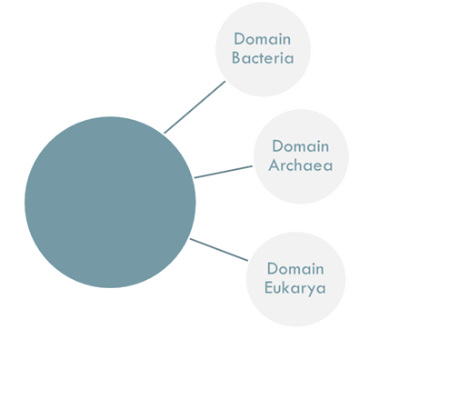
- Handed a worksheet with the names of all the Domains and Kingdoms and a Diagram to fill in

Empty diagram word box
- Bacteria
- Archaea
- Plantae
- Animalia
- Eukarya
- Protista
- Fungi
