Student Skeleton Notes
- What are Enzymes? ______________________________________________________
- Lipids:___________________
- Glucose is: ______________________________________________________________
- What is the function of the digestive system? ________________________________________________________________________________________________________________________________________________
- The Mouth:
  - Consists of: __________, ____________, and ____________
  - Function of the mouth: _______________________________________________
  - Saliva acts as a: _______________________________
- Name some species differences in the mouth
  - Poultry: ___________________________________________________________
  - Aquatic Birds:______________________________________________________
  - Livestock: _________________________________________________________
- The Esophagus:
  - Function: _________________________________________________________
- The Crop:
  - Connects with the ___________________________
  - Function: _________________________________________________________
  - Species difference: ____________________________________________________________________________________________________________________________________
- The Stomach:
  - The two stomachs in a bird are: _______________ and ________________ or “_____________________”
- ______________________ is a glandular stomach and is like the ____________ stomach
  - ________________ are digested here
- _______________________ is the muscular stomach
  - Function: ________________________________________________
- The Pancreas:
  - Digestive Function: ____________________________________________________________________________________________________________________________________
  - ________________ Function: Produce Insulin
- The Liver:
  - The most important thing the liver does is: _________________________
    - What does bile do?: ______________________________________
- The Gall Bladder:
  - _______________ excess __________ produced by the liver
- The Small Intestine:
  - Completes the _______________ and ________________ process
  - ____ feet in length
  - Consists of:
- _________________________:
  - Extends from the ________________ to the ___________________
  - What 3 things branch off?
    - ________________________
    - __________________________
    - __________________________
- ____________________________:
  - Extends from the __________________ to the __________________
  - Receives __________ to break down __________
- ____________________________:
  - Extends from the ____________________ to the _________________
  - ______________________ ends here
- The Ceca:
  - Joins the ______________ with the ___________________
  - Like the cattle rumen because: _________________________________________
  - _______________________ is found here
- The Large Intestine:
  - Connects with ___________________ and ends at the _________________
  - ______ inches in length
  - Digestive Function: ____________________________________________________________________________________________________________________________________
- The Cloaca:
  - Connects with ____________________ and ends at the _________________
  - Function: _________________________________________________________
- The Vent:
  - Connects with the _______________________
  - Function: _________________________________________________________

- Label the Digestive System:
13._____
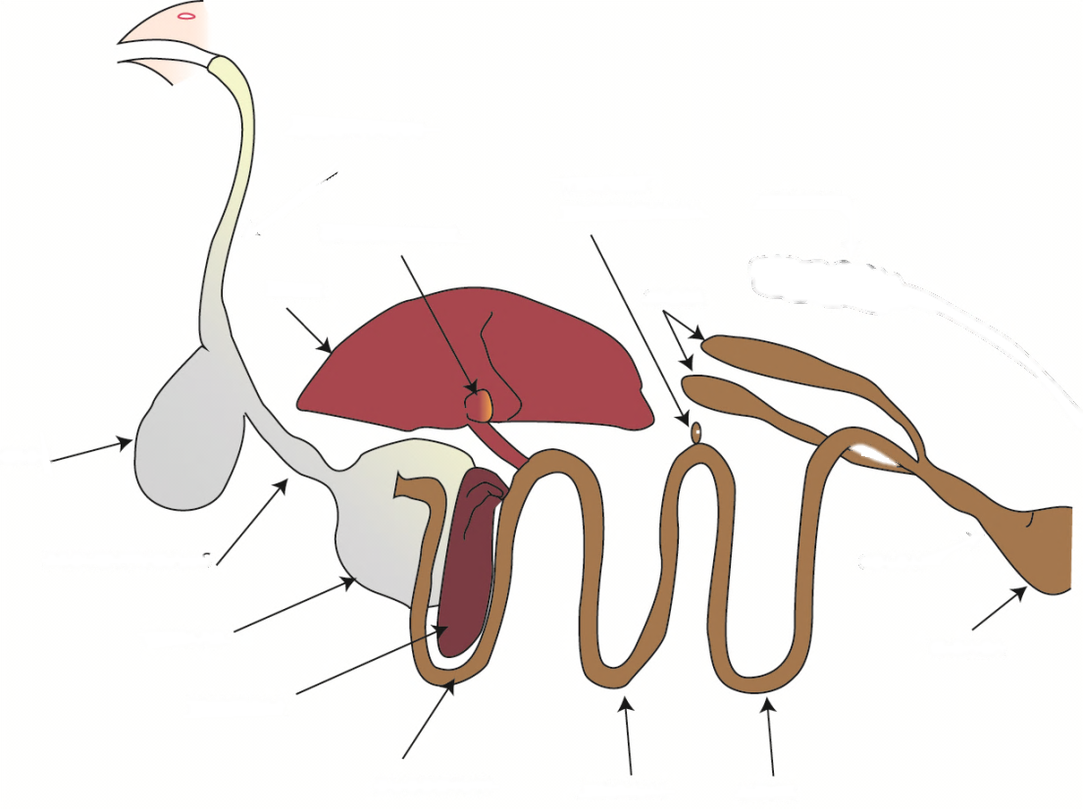
2.________
14._______
13._________
12._______
11.__________
10._____
8. __________
7. __________________
6. ____________
4._______________
5. ____________
9. _________
3._______
1. _________

- Required Nutrients:
- __________________________________: (___________________)
  - When broken down it turns into: ________________
  - It is used for: _____________________
  - Some examples are: ________________________________________
- __________________________________: (___________________)
  - Are NOT _____________________
  - _________________ specifically breaks down
  - Used as an ________________________
  - Some examples are: ________________________________________
- ___________________________________: (______________________)
  - Broken down in the ____________________________
  - Used for _____________________________________
  - Some examples are: ________________________________________

