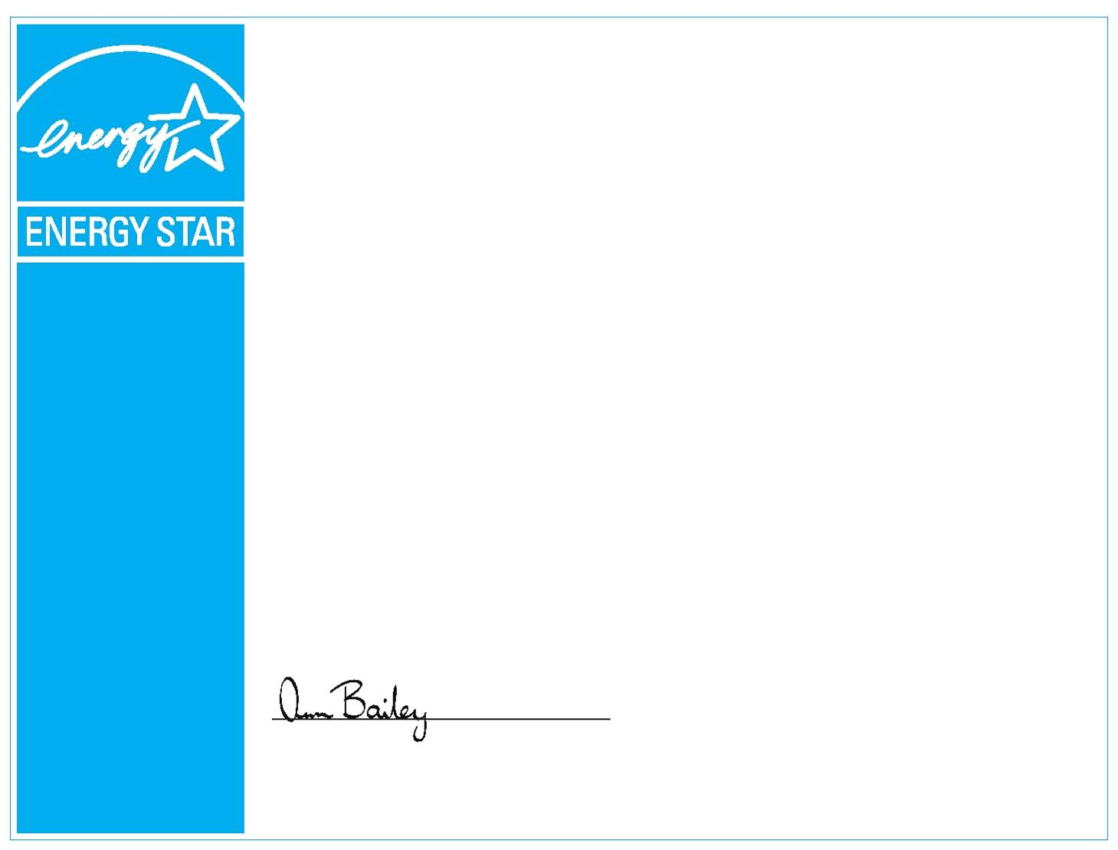
ENERGY STAR CHANGE THE WORLD PLEDGE LEADER ®

The U.S. Department of Energy and
The U.S. Environmental Protection Agency congratulate

Student Name Here

for saving energy and helping reduce greenhouse gas
emissions by participating in the 2011/2012 ENERGY STAR
Change the World, Start with ENERGY STAR Campaign.

Ann Bailey
U.S. Environmental Protection Agency
ENERGY STAR

