Answer the following questions using your knowledge of veterinary sutures.
Sutures in Veterinary Medicine
- Explain what a suture is and why it is important in veterinary medicine.

- Define the following types of sutures and explain why you might use each one.
  - Continuous Suture:
  - Interrupted Suture:
  - Purse String Suture:
Compare and contrast the different types of sutures and suture materials using the charts below:
3.
Continuous |  | Interrupted
Pros |  | Pros
Cons |  | Cons

4. Absorbable All Suture Materials Non-Absorbable

- Describe the proper procedures for removing an animal’s sutures.

Practicing Sutures Activity
Name: __________________ Date: ____________ Class: _________
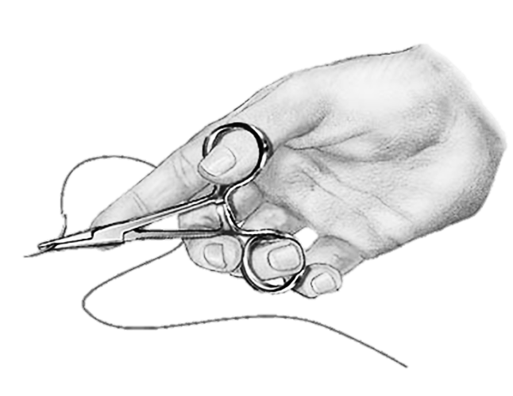
Follow the below steps to complete a suture on your model incision site.
- Collect the needed materials:
  - 1 half banana with 2 incision sites, Needle, Needle Holders,
Suture Material, Surgical Scissors, and Forceps

- Prepare your suture needle
  - Thread your needle with suture material.
  - Tie a square knot, as shown by your teacher.
- Practice Interrupted Sutures
  - Begin by threading the suture material onto the needle. Tie securely with a square knot.
  - Next, use your forceps to lift the skin the banana enough to begin your suture.
  - Beginning from the outside of the banana on one side of the incision site,
insert the needle through the skin but not into the below tissues.
  - Pull the needle out from under the skin through the incision site.
  - Next insert the needle through the skin on the other side of the incision site.
(Insert the needle from the bottom of the skin coming out the top).
  - Pull the needle up and out, gently closing the incision.
  - Tie a square knot and trim the suture material ends.
  - Repeat Steps 1-5 along the incision site until the incision is completely closed.
- Practice Continuous Sutures
- Begin this suture practice just as steps 1-6 are described for interrupted sutures.
- Tie a square knot and DO NOT trim the suture material ends YET.
- Repeat steps 2-6 as described for interrupted until the entire incision site is closed.
- Tie end off with a square knot and trim suture material.
Answer the following questions based on your experience practicing sutures.
- What tasks did you find easy in this activity? Explain why.

- What tasks did you find challenging in this activity? Explain why.

