Adaptation Island Board Game
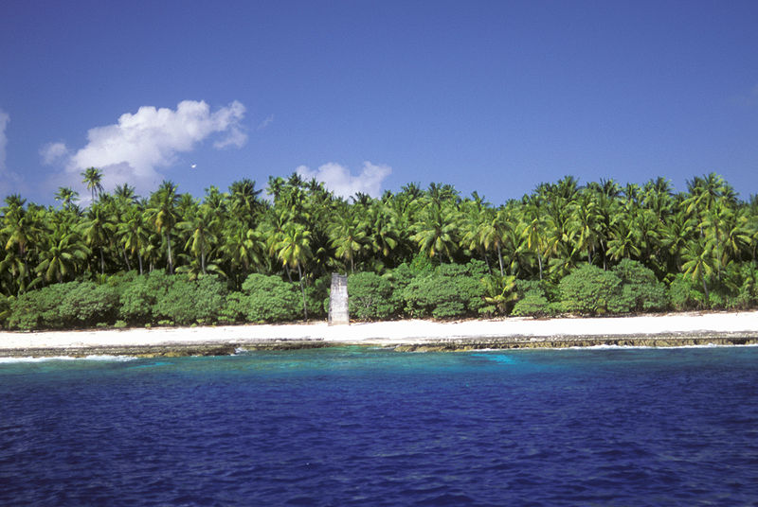
Summary:
Using a homemade game board and cards, students will play Adaptation Island, a board game that will help reinforce their knowledge of DNA, genes, mutations, and natural disasters, and how each of these effects populations in an ecosystem.
Subject:
- Science:
  - New TEKS –
    - 7.8A The student knows that natural events and human activity can impact Earth systems
    - 7.12A,F - The student knows that living systems at all levels of organization demonstrate the complementary nature of structure and function
    - 7.14A,C - The student knows that reproduction is a characteristic of living organisms and that the instructions for traits are governed in the genetic material
  - Old TEKS –
    - 7.5B - The student knows that an equilibrium of a system may change
    - 7.10B,C - The student knows that species can change through generations and that the instructions for traits are contained in the genetic material of the organisms
    - 7.12A,B,C,D - The student knows that there is a relationship between organisms and the environment
    - 7.14A - The student knows that natural events and human activity can alter Earth systems
Grade Level:
- Target Grade: 7
- Upper Bound: 8
- Lower Bound: 5
Time Required: 1 class period
Activity Team/Group Size: 4-6 children per game board
Materials:
- Adaptation game board (1 for every 4-6 students)
- Mutation, Catastrophe, and Test Your Knowledge cards (1 set of each for each game board)
- Animal, plant, bird, and insect game pieces (at least 2 of each type for each game board)
- Dice (1 per game board)
- Play money (about $70 per game board)
- Instructions (one set for each game board)
Reusable Activity Cost Per Group [in dollars]: $30
Learning Objectives:
- Students will be able to relate interactions in the game to real life interactions between organisms in a population and their ecosystem.
- Students will understand how organisms can adapt and change over time and how this relates to genes, DNA, and chromosomes.
Before the Lesson:
Game boards, game pieces, money, cards and dice need to be printed/obtained prior to class. You will need a full set of the game (board, pieces, money, cards and die) for every 4-6 students in your class.
Game boards can be printed as a poster at Kinko’s. This is the most expensive part of the activity. Printing the game board is around $20.
Dice can be purchased at Wal-Mart or another store that sells games. Only one die per game is needed. Game pieces can be small toys or decorations from a craft store. For example, you can purchase small plastic animal & insect toys and plastic birds that are for decorating wedding cakes at the dollar store for game pieces. For plant game pieces, you can use plastic fruit found at a craft store.
There are 3 types of cards to print—the different types may be printed on different colors of cardstock. The titles of the cards should be printed on the back of cards to differentiate between the different types of cards. Another option if colored cardstock is not available is to print the titles of the different types of card on different colored mailing labels and then stick these to the back of the cards. Money and game instructions just need to be printed out. Set up each game in different spots around the room.
Lesson Introduction / Motivation:
Tell your students the class period before that they will be playing a fun game next class period. Be mysterious about what the game will entail and tell them to use their imagination. They will enter the classroom excited about what they will be doing.
Lesson Plan:
Go over the directions of the game with the students making sure to explain why each type of card is included and how it can affect organisms and populations in an ecosystem. Also remind the students that adaptations are dependent on the environment. Adaptations may be helpful in some environments while being detrimental in other environments, or (as in the game) adaptations can help populations of organisms survive catastrophes. Answer any questions, and then instruct students to pick their game piece. Make sure each type of organism is represented in each group. Then have students begin playing the game. Walk around the classroom and make sure students are on task and understanding the game.
Lesson Closure:
Have students discuss what they learned while playing the game. Ask them if they thought it made sense and why. Encourage explanations rather than yes or no answers.
Assessment:
Assessment should be informal. Judge whether or not students understood the implications of the game during your observation of the groups and during the end of class discussion.
Vocabulary / Definitions:
- Adaptation
- Mutation
- Catastrophe
- DNA
- Gene
- Chromosomes
Prerequisites for this Lesson:
- Students should have already had prior lessons over genetics, reproduction, and adaptation. This activity should be a way to review or reinforce the concepts listed in the TEKS.

Multimedia Support and Attachments: (see attachments for all files)
- Adaptation Island Instructions
- Adaptation Island Catastrophe, Mutation, and Test Your Knowledge Cards
- Adaptation Island Game Board
- Play Money
- Adaptation Island Card Labels
Authors:
Graduate Fellow Name: ___
Teacher Mentor Name: ___
Undergraduate Fellow Name: Jillian Van Zandt
Date Submitted: ___
Date Last Edited: ___
Please email us your comments on this lesson:
E-mail to ljohnson@cvm.tamu.edu
Please include the title of the lesson, whether you are a teacher, resident scientist or college faculty and what grade you used it for.

Teacher’s Comments:

