Subterranean Termite Behavior
It is not known exactly how subterranean termites locate sources of food. It is thought that the termites forage by digging a network of tunnels and come in contact with food sources in the process. The foraging range of a single termite colony is difficult to predict. Some larger colonies may forage over areas the size of a football field. However, depending on the season or weather, they may not forage over their entire range at all times. Also, several smaller colonies may cover a greater foraging distance than one large colony.
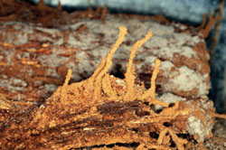
Swarm Tubes
Foraging termites produce a variety of chemicals called pheromones that influence their behavior. These pheromones are basically odors that send messages to other termites in the colony. While tunneling underground, the foraging termites lay down a trail of pheromone which they secrete from glands on their abdomen. When a food source is located, the odor trail is intensified to recruit other termites to the feeding site. However, the intensity of the recruitment effort (odor trail) is influenced by soil temperature, moisture and compaction as well as the size and quality of the food source.
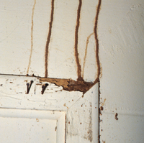
Utility Tubes
Subterranean termites also forage above ground for sources of cellulosic food like wood in homes and other structures. In order to protect themselves from predation by ants and maintain their connection to the soil while searching for food above ground, termites build long tubes out of mud and fecal material. These mud tubes are called exploratory tubes. Termite exploratory tubes are very easy to see and are one of the best ways to identify a potential termite infestation. Once a source of wood has been located, the termites establish more permanent utility or working tubes. The utility tubes are highways running from the underground termite galleries directly to the food source. Utility tubes can cover long distances over the foundation of a building or along exterior walls to reach the wood inside. Sometimes subterranean termites build another tube that runs from the structural wood back down to the ground. These tubes are called drop or suspended tubes. Drop tubes are often lighter in color than the utility tubes because they contain more of the wood fiber taken from the structure. Subterranean termites construct a fourth type of mud tube in addition to those that facilitate foraging. These are called swarming tubes. Swarming tubes are built seasonally extending only 4-8 inches above ground. These tubes provide the exit port for winged swarmers leaving the colony.

http://www.ext.vt.edu/pubs/entomology/444-502/444-502.html#L4

Reticulitermes
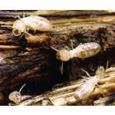
This subterranean termite is smaller than Zootermopsis, but it has distinct castes with workers, soldiers, winged reproductive forms, and occasionally secondary reproductive forms that develop in the event of the queen’s death. They will also follow a pen trail.

http://wardsci.com/product.asp?pn=IG0017244&name=Reticulitermes+(Termite)+Living+Specimen&bhcd2=1223497190

.

Eastern subterranean termite
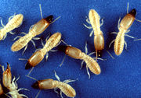
Eastern subterranean termite (Reticulitermes flavipes) is the most widely distributed subterranean termite, and it is the most common termite found in the eastern United States and Canada. It is also an invasive species in Europe^{[1]}.
Eastern Subterranean termites feed on cellulose materials including structural wood, wood fixtures, paper, books and cotton, and will occasionally attack the roots of shrubs and trees. A mature colony of Eastern Subterranean termites can range from a low of 20,000 workers to a high of five million, with an average of 300,000. The colony's queen can lay 5,000 to 10,000 eggs per year making colony growth slow. It may take four to 10 years before swarmers are produce by the colony.
Colonies are largely located in the ground below the frost line, but secondary colonies can exist above ground. These colonies must have access to a moisture source, such as a drainage spout or plumbing leak. Eastern Subterranean termites will often build shelter tubes for travel between their colonies and their food sources. Shelter tubes are a common sign of Eastern Subterraneans as well as translucent wings shed by the kings and queens during swarming.

http://en.wikipedia.org/wiki/Eastern_subterranean_termite

Reticulitermes flavipes (eastern subterranean termite)
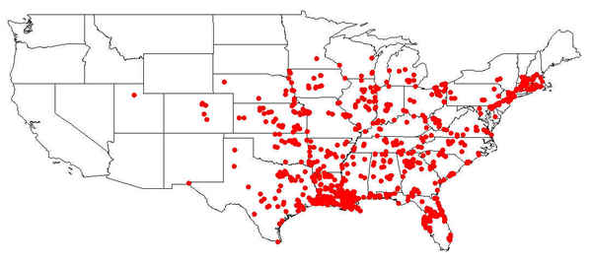

(Current U.S. distribution based on samples received from survey participants)
LOCATIONS IN TEXAS

Alvin
Amarillo
Arlington
Austin
Bacliff
Beaumont
Benbrook
Brownsville
Burleson
Cedar Hill
Clute
Colleyville
Corpus Christi
Crystal City
Daingerfield
Dallas
Edna
Fort Worth
Fredericksburg
Galveston
Garland
Gonzales
Grand Prairie
Houston
Keller
Kemp
Kerrville
Kountze
La Grange
Lake Jackson
La Rue
League City
Lindale
Live Oak
Livingston
Lubbock
Lufkin
Mabank
Mason
Mesquite
Missouri City
Nederland
Plano
Port Neches
Rockport
San Angelo
San Antonio
Schulenburg
Seven Points
Spring
Sugar Land
Temple
Trinidad
Troup
Vidor
Waco
The Woodlands

PHOTOGRAPHS
Alate | Alate (close-up) | Soldier | Soldier Mandibles
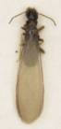 | 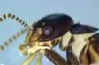 | 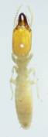 | 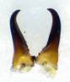
Primary King and Queen |  | Secondary Reproductive Queen
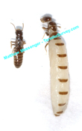 |  | 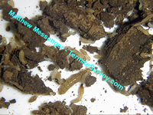

http://www.termitesurvey.com/distribution/reticulitermes_flavipes.shtml

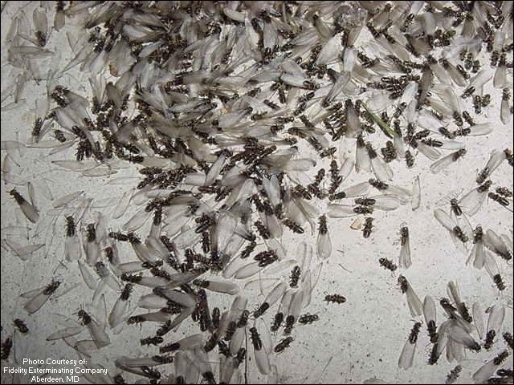

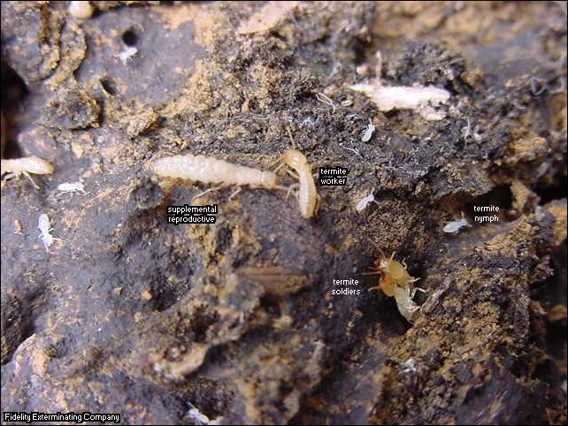

http://www.fcps.edu/islandcreekes/ecology/eastern_subterranean_termi.htm

