You only need to cut out the TOP white picture. The bottom gray picture just shows you how to number the backside of the top white picture that you just cut out.

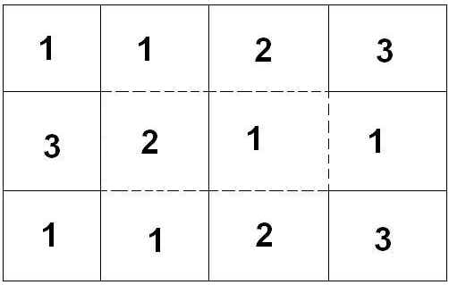

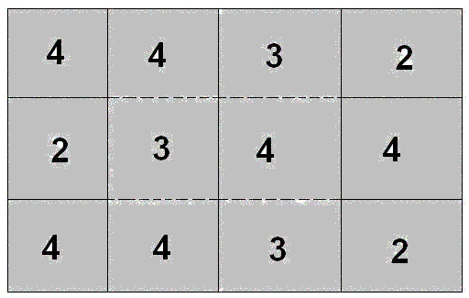

Source: http://www.mathemagic.org/MathsAndArt/flexagon.htm

