Dishes for your Thanksgiving Feast

Food | Pricing Info | Calculated Cost
Turkey | Turkey costs $3.00 per pound.  You can buy an 18 lb turkey, or a 21 lb turkey.
Rolls  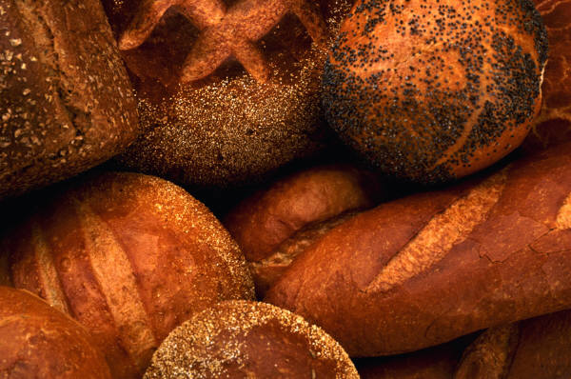 | Rolls cost 59 cents each, and there are 12 rolls in one bag.
Mashed Potatoes | It takes 7 potatoes to make mashed potatoes, and they cost 87 cents each.
Gravy | Gravy costs 45 cents per ounce, and you need to buy 17 ounces to fill this cup.
Peas  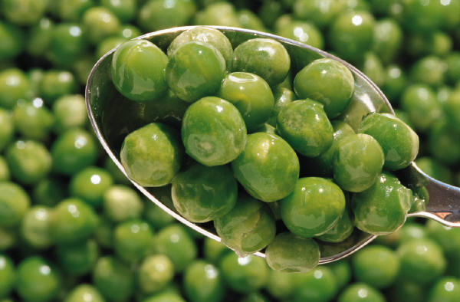 | Peas cost 19 cents per ounce, and you would buy 24 ounces of them for your dinner.
Corn | Each cob of corn costs $3.34. They come in packs of three, so add:  3.34 + 3.34 +3.34
Ham | Ham costs $4.00 per pound, and you can buy the small size at 13 pounds, or the large size at 19 pounds.
Cornbread  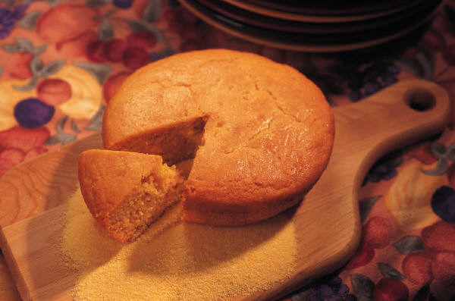 | 250 loafs of cornbread cost $750. You want to buy one loaf of cornbread
Regular Salad | Regular salad costs $3.25 per person in your group.
Gourmet Salad  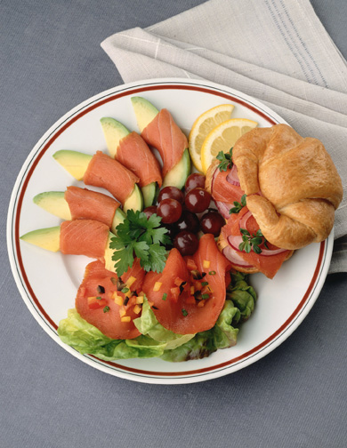 | Gourmet salad costs $5.30 per person in your group.
Strawberries  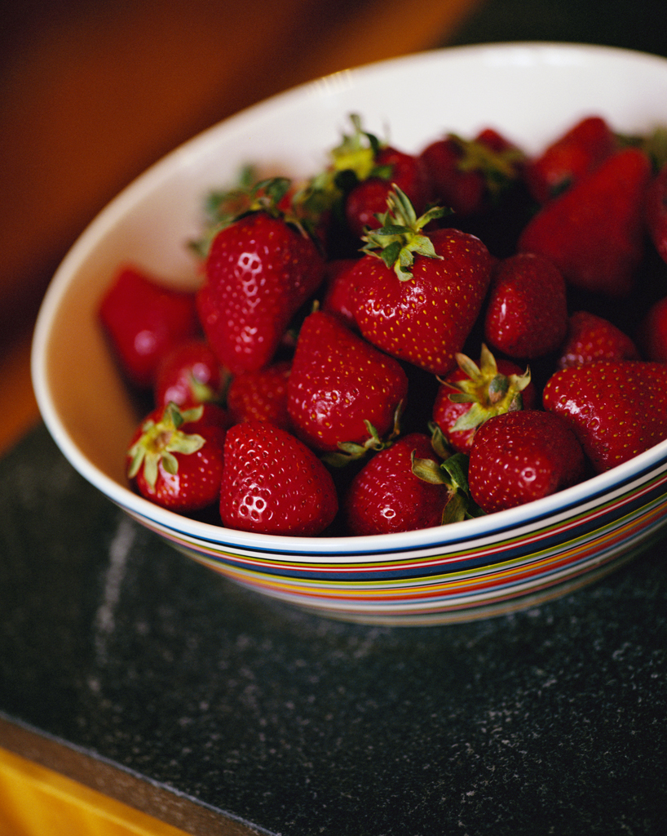 | Strawberries cost 12 cents each, and 20 strawberries make up this bowl.
Pumpkin Pie 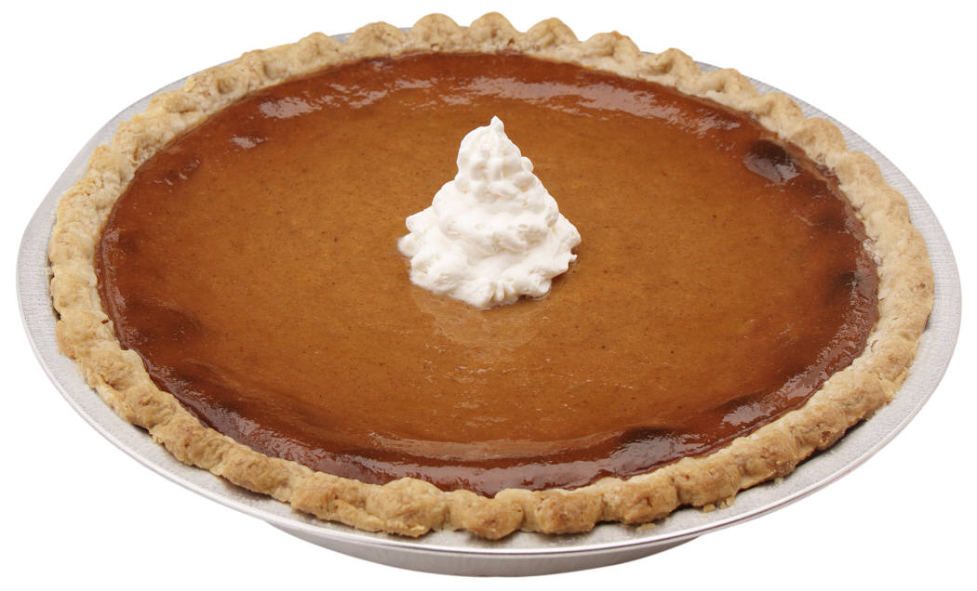 | Pumpkin pie costs $400 for 20 pies. You want to buy one pie.
Apple Pie  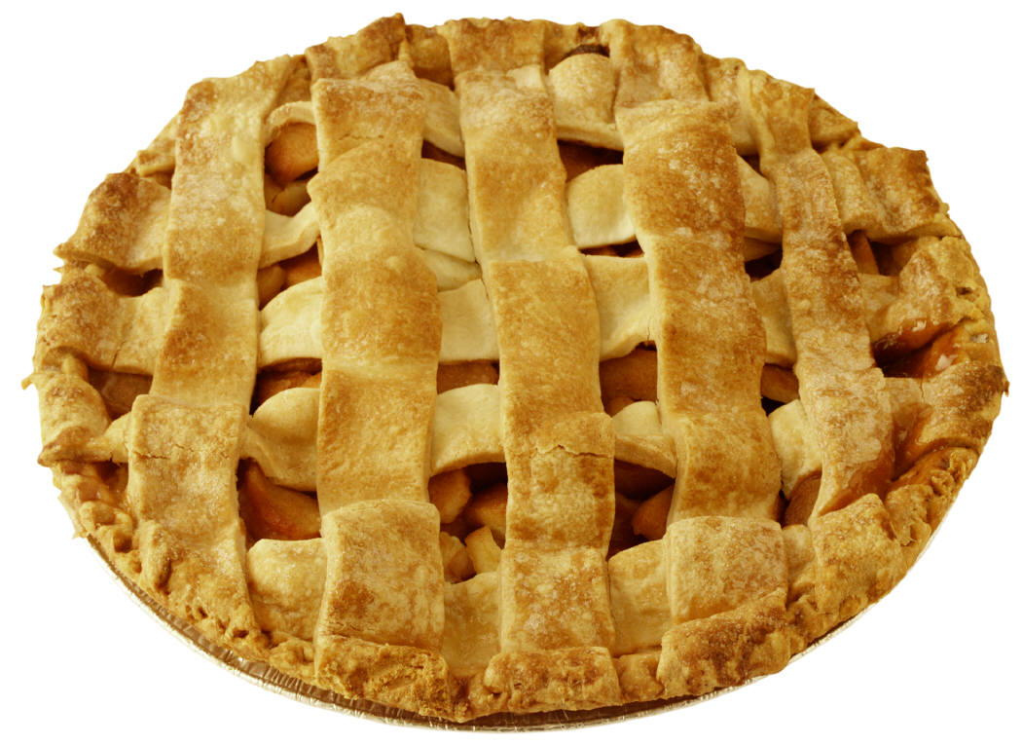 | Apple pie costs 34 cents per ounce. One pie is 36 ounces.
Blueberry Muffins  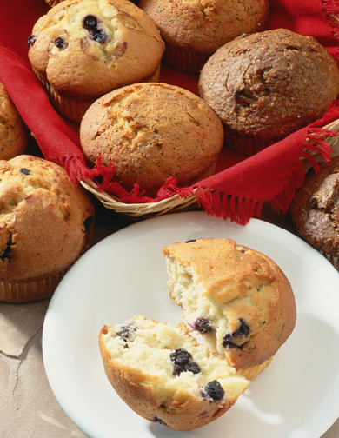 | Blueberry muffins cost 22 cents per muffin, and there are 12 muffins on a tray.
Gingerbread Cookies | Gingerbread cookies cost 45 cents each, and you want to buy a tray of 15.
Gourmet Desserts  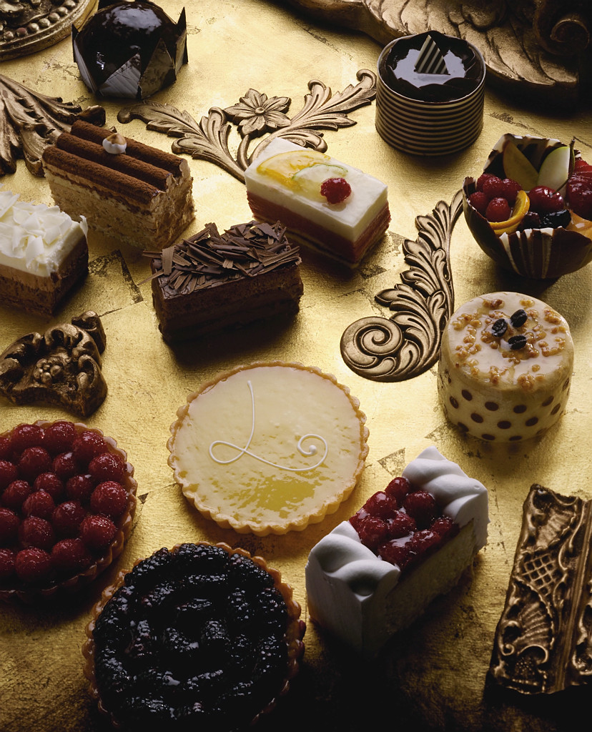 | A gourmet dessert platter costs 87 cents per ounce. One platter is 13 ounces.
Fruitcake | 25 fruitcakes cost $500. You want to buy one fruitcake.
Water  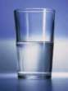 | Glasses of water are free.
Milk  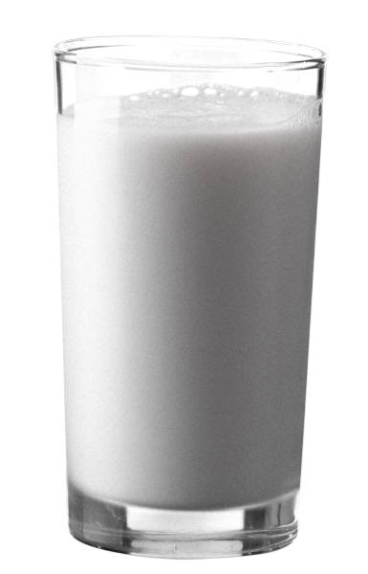 | Milk costs 85 cents per glass. Add the decimals for each glass you want to buy.
Apple Cider  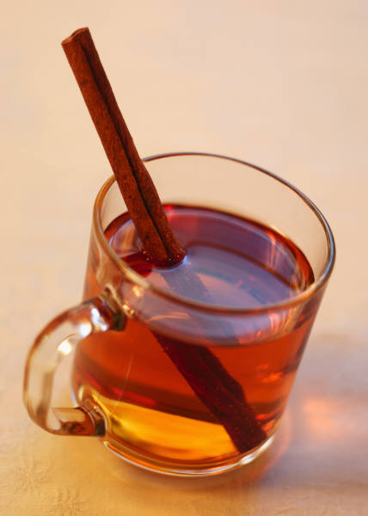 | Cinnamon apple cider costs $2.99 per cup. Add the decimals for each glass you want to buy.
Hot Chocolate  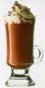 | Hot chocolate costs $1.99 per cup. Add the decimals for each glass you want to buy.

How much did your whole meal cost? ______________________

