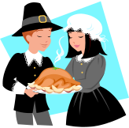
Dishes for your Thanksgiving Feast

Food | Pricing Info | Calculated Cost
Turkey  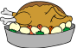 | Turkey costs $3.00 per pound.  You can buy an 18 lb turkey, or a 21 lb turkey. | 18 lb: $54.00  21 lb: $63.00
Rolls  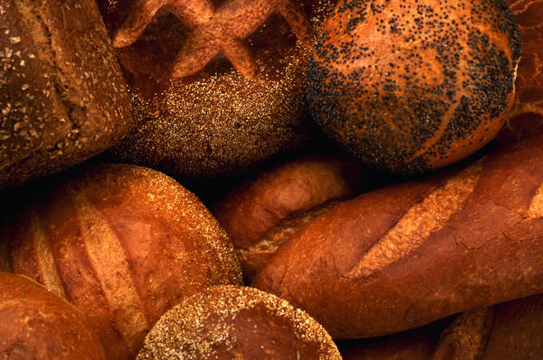 | Rolls cost 59 cents each, and there are 12 rolls in one bag. | $7.08
Mashed Potatoes   | It takes 7 potatoes to make mashed potatoes, and they cost 87 cents each. | $6.09
Gravy   | Gravy costs 45 cents per ounce, and you need to buy 17 ounces to fill this cup. | $7.65
Peas  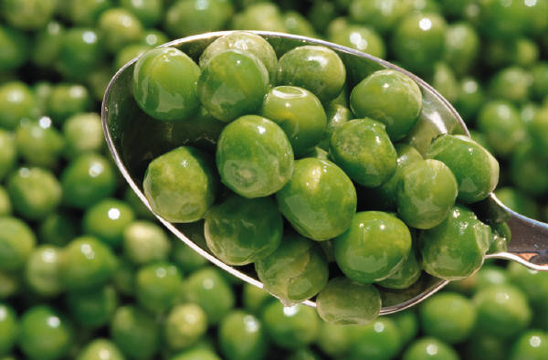 | Peas cost 19 cents per ounce, and you would buy 24 ounces of them for your dinner. | $4.56
Corn   | Each cob of corn costs $3.34. They come in packs of three, so add:  3.34 + 3.34 +3.34 | $10.02
Ham  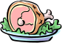 | Ham costs $4.00 per pound, and you can buy the small size at 13 pounds, or the large size at 19 pounds. | 13 lb: $52.00  19 lb: $76.00
Cornbread  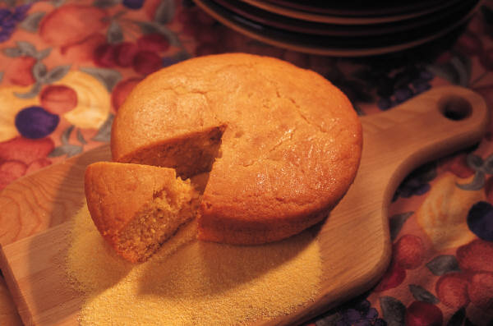 | 250 loafs of cornbread cost $750. You want to buy one loaf of cornbread | $3.00
Regular Salad  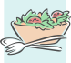 | Regular salad costs $3.25 per person in your group. | One person: $3.25  Two people: $6.50  Three people: $9.75
Gourmet Salad  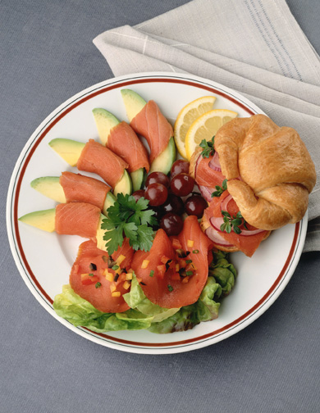 | Gourmet salad costs $5.30 per person in your group. | One person: $5.30  Two people: $10.60  Three people: $15.90
Strawberries  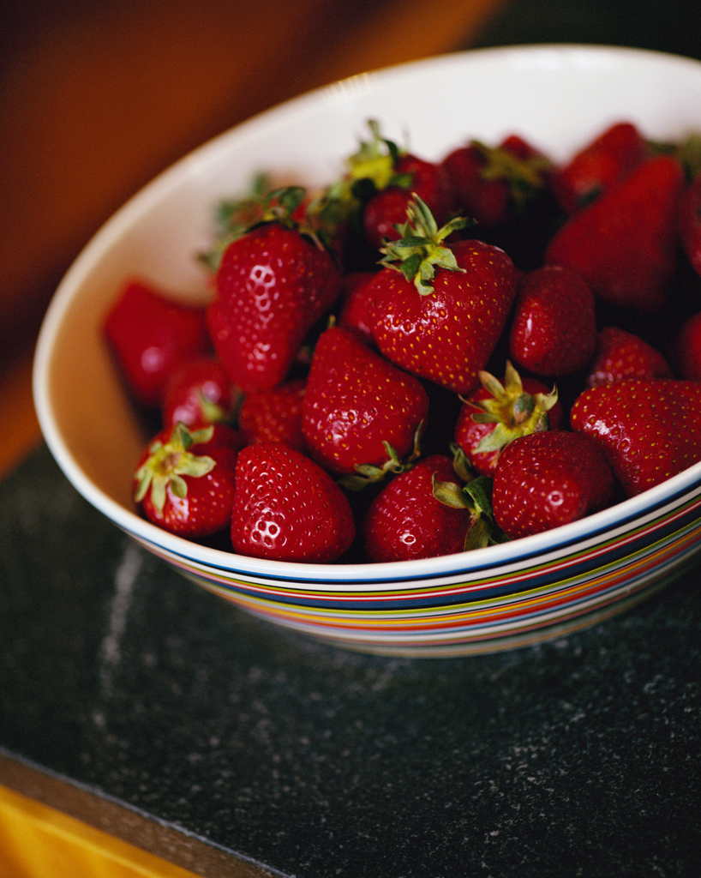 | Strawberries cost 12 cents each, and 20 strawberries make up this bowl. | $2.40
Pumpkin Pie 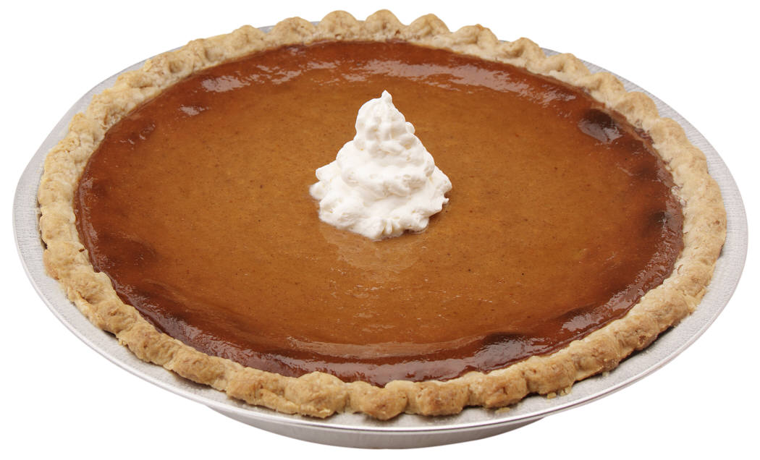 | Pumpkin pie costs $400 for 20 pies. You want to buy one pie. | $20.00
Apple Pie  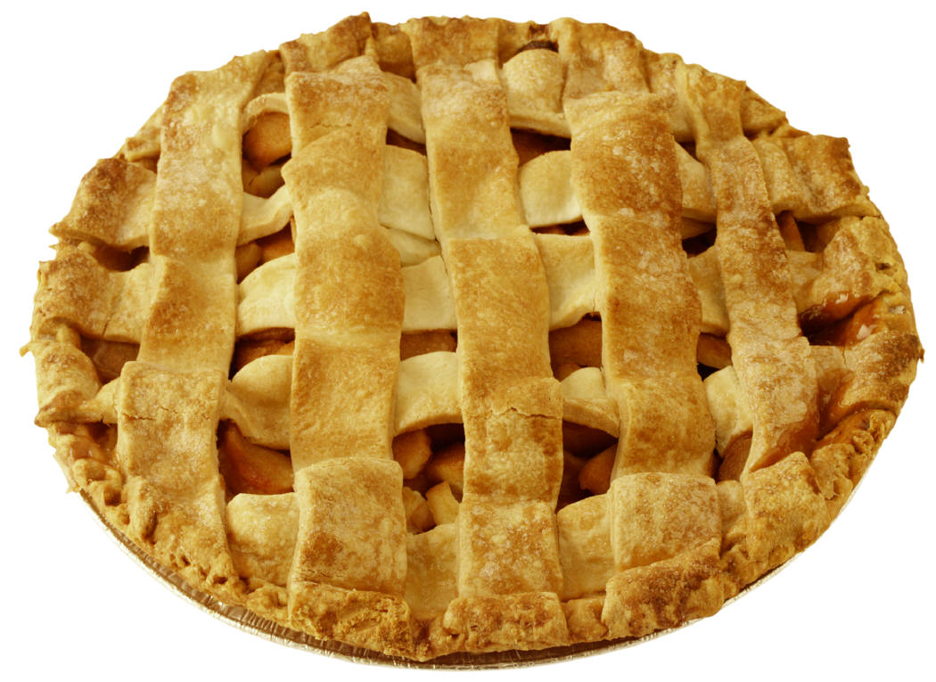 | Apple pie costs 34 cents per ounce. One pie is 36 ounces. | $12.24
Blueberry Muffins  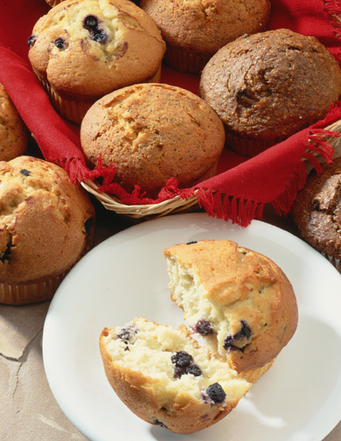 | Blueberry muffins cost 22 cents per muffin, and there are 12 muffins on a tray. | $2.64
Gingerbread Cookies   | Gingerbread cookies cost 45 cents each, and you want to buy a tray of 15. | $6.75
Gourmet Desserts  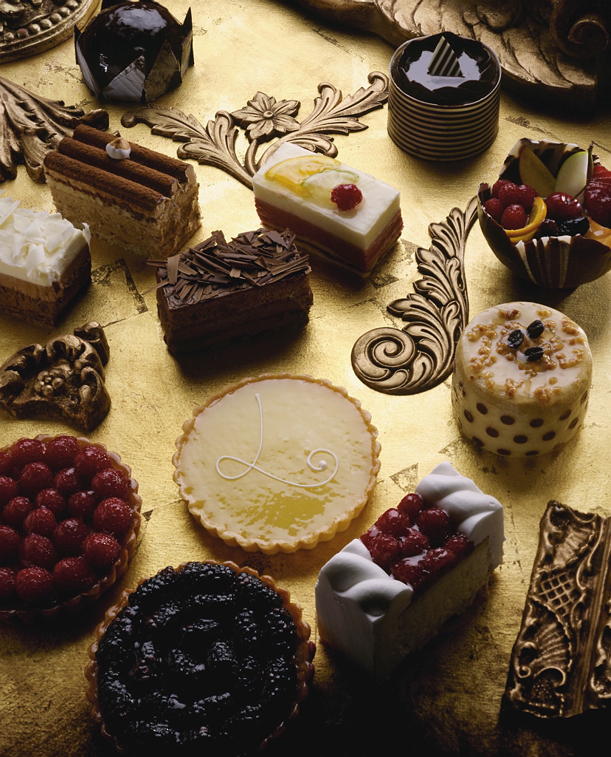 | A gourmet dessert platter costs 87 cents per ounce. One platter is 13 ounces. | $11.31
Fruitcake   | 25 fruitcakes cost $500. You want to buy one fruitcake. | $20.00
Water  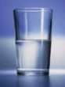 | Glasses of water are free. | $0
Milk  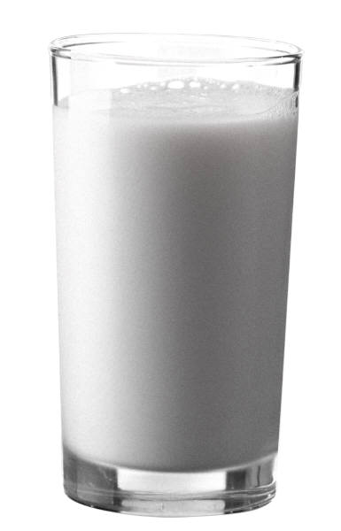 | Milk costs 85 cents per glass. Add the decimals for each glass you want to buy. | One glass: $.85  Two glasses: $1.70  Three glasses: $2.55
Apple Cider  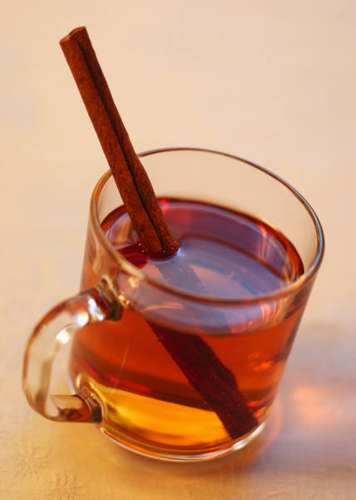 | Cinnamon apple cider costs $2.99 per cup. Add the decimals for each glass you want to buy. | One cup: $2.99  Two cups: $5.98  Three cups: $8.97
Hot Chocolate  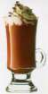 | Hot chocolate costs $1.99 per cup. Add the decimals for each glass you want to buy. | One cup: $1.99  Two cups: : $3.98  Three cups: $5.97

How much did your whole meal cost? ______________________

