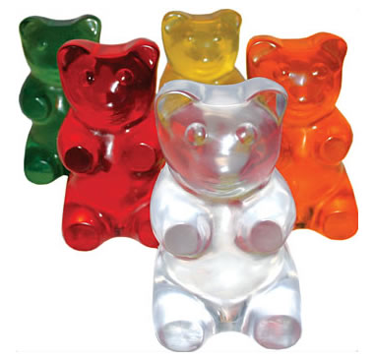
The Gummy Bear Metric Challenge
Observation and Analysis Worksheet
Day 1

For this activity, your group is going to take measurements of a gummy bear. You will record your observations on this worksheet and then put your gummy bear in a cup of water. We will leave the gummy bears in their water over night and then tomorrow see what changes might have occurred! Make sure to follow all directions in this worksheet carefully and don’t forget to write everything down.

1. Describe your gummy bear:
- What color is the bear? __________
- What does the bear feel like? ________________________________________________
2. Using the metric ruler, measure the length of your bear and record it in mm.
- Length _______

3. Using the triple beam balance, measure the mass of your gummy bear. Make sure to record your data in g.
- Mass ________
4. Using a graduated cylinder, measure 50mL of water and pour it into the cup. If your cup is labeled “Room Temperature”, use the room temperature water. If your cup is labeled “Cold Temperature” use the cold water.

5. What number is written on your cup? _______

6. Using a thermometer, measure the temperature of the water in your cup. Make sure to record the temperature in °C.
- Temperature of water _______
7. Put your gummy bear in the cup of water.
8. Let’s think of some hypotheses! (Which bear do you think will weigh more—one that has been in cold water all night or one that has been at room temp. all night? Which will be longer? Will the different water temperatures have any effect on these outcomes?)
- What do you think is going to happen your bear? __________________________________________________________________________________________________________________________________________________________________

