Name: ________________________ Class: _____ Date:___________

Label each diagram with the correct types of teeth discussed in the presentation. Identify each diagram as herbivore, carnivore, or omnivore.

Carnivore

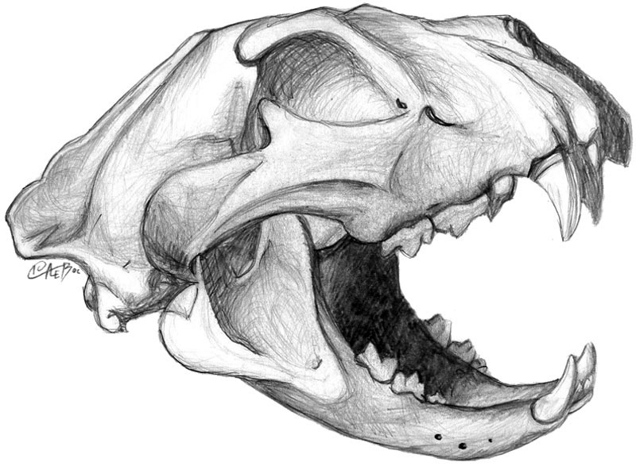

1. Incisor
2. premolar
3. Canine
4. molar

Herbivore

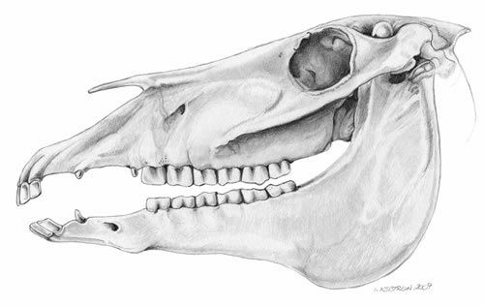

1. __premolar__________________
2. _molar___________________
3. _Canine___________________
4. incisor

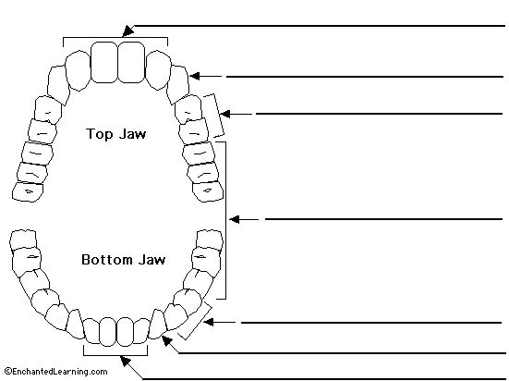

Incisor

premolar

molar

Omnivore

Canine

**Bonus**

What class of animal does this jaw represent?

Omnivore

