Name: ________________________ Class: _____ Date:___________
Label each diagram with the correct types of teeth discussed in the presentation. Identify each diagram as herbivore, carnivore, or omnivore.

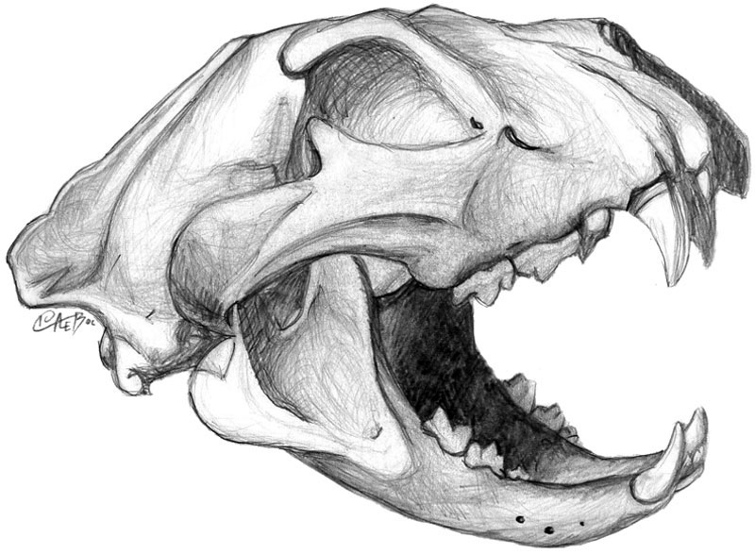

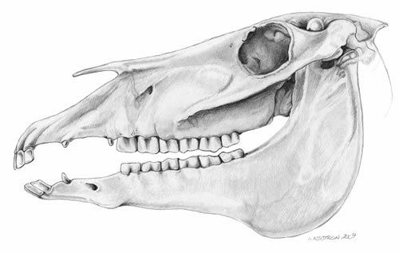
- ____________________
- ____________________
- ____________________

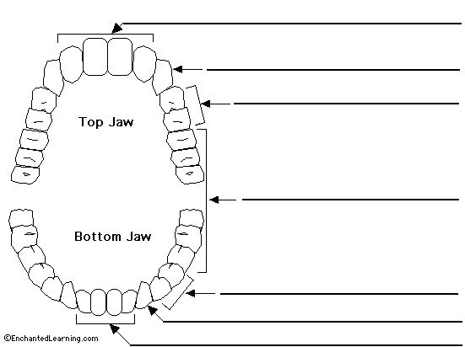

Bonus
What class of animal does this jaw represent?
