Thermal Energy Worksheet – Answer Key
1. Label the diagram with the following words: Conduction, Convection, and Radiation
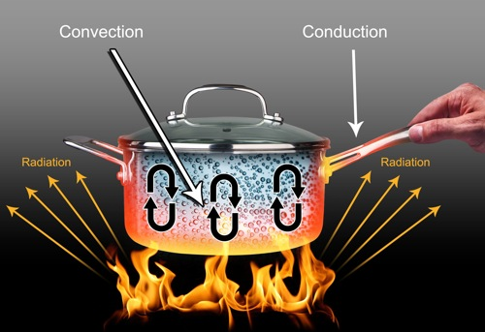
Radiation
Radiation
Conduction
Convection
2. Draw an arrow indicating the flow of heat between the two objects:
a) Santa’s hand and cold milk b) bare feet and hot sidewalk c) pan and food
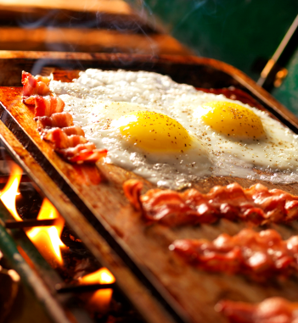
3. Circle the correct answer:
During the experiment today, the temperature of the water (increased/decreased) and the temperature of the ice cube (increased/decreased).
The water (gained/lost) heat and the ice cube (gained/lost) heat.
The heat traveled from the (ice cube/water) to the (ice cube/water).
The transfer of thermal energy through objects is (conduction/convection).
The transfer of thermal energy by waves is (conduction/radiation).
The transfer of thermal energy with currents is (convection/radiation).
Warm air and warm water (rises/falls) while cool air and cool water (rises/falls).
Thermal energy always travels from the (hotter/colder) object to the (hotter/colder) object.
The hotter object has (more/less) thermal energy than the colder object.

4. What would the graph of time vs. temperature of the water for the experiment in class today look like?
a) b)

c)

