You just need ONE of these strips to build your tri-hexaflexagon. Cut one of the strips out, and then pass the paper to your partner!

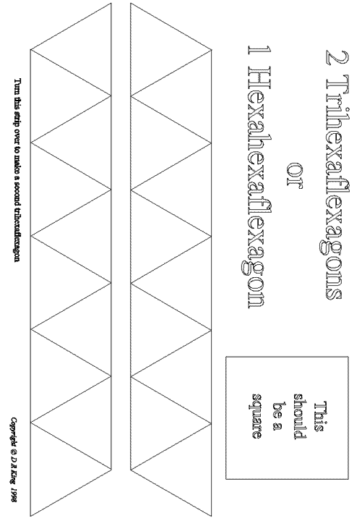

Source: http://math.dartmouth.edu/~leejstem/mathematrix/flex3.gif

