Tropism Notes

- What are we talking about?
  - Tropism - directional growth of a plant, or part of a plant, in response to an external stimulus
    - Stimulus – an action or condition that causes a response
    - Response – an action or condition that is a reaction to a stimulus
      - Negative response – when the growth of a plant is away from the stimulus
      - Positive response – when the growth of the plant is towards the stimulus

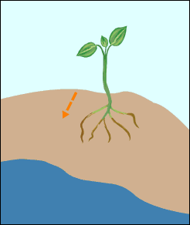
- Types of Tropism
  - Hydrotropism
    - Stimulus – water
    - Response – a plant’s roots grow towards a water source
    - What type of response is this? Positive

  - Thermotropism
    - Stimulus – temperature
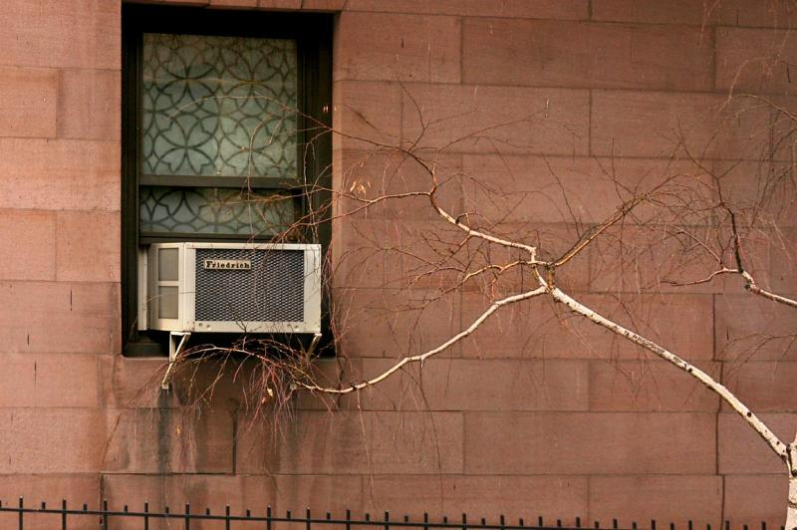
    - Response – a plant grows in the direction of/away from a source of heat or cold
      - Example: In the picture, this tree has a positive response to the cold.
      - Example: A plant called a Rhododendron curls its leaves away when it experiences cold weather.

  - Gravitropism
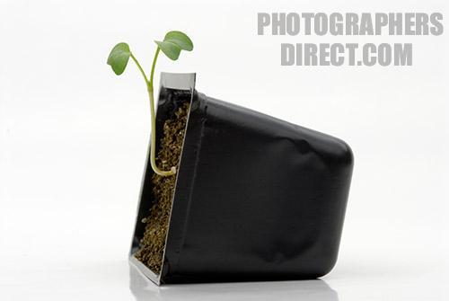
    - Stimulus – gravity
    - Response –
      - Negative – the stalk grows upwards, against gravity
      - Positive – the roots grow downwards, towards gravity

  - Thigmotropism
    - Stimulus – touch
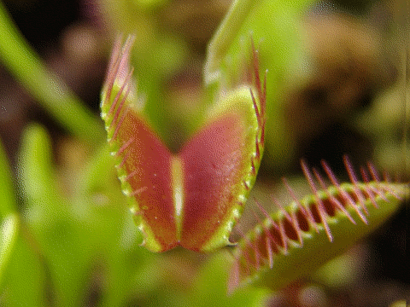
    - Response – the leaves or part of the plant that is touched move or coil away from the touch, or trigger some other action
      - Example: The Venus Fly Trap is a plant that shows thigmotropism. It closes when a bug or some other object touches it.

  - Phototropism
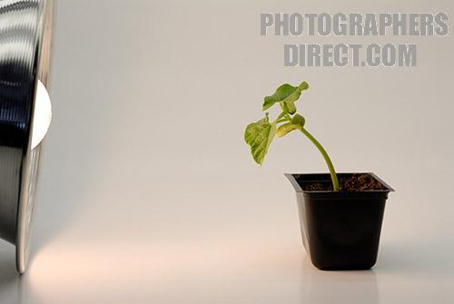
    - Stimulus – light
    - Response – the plant grows in the direction of a unidirectional light (it only comes from one direction)
      - What type of response is this? Positive

  - Heliotropism
    - Stimulus – sunlight
    - Response – a plant grows or turns to face the direction of the sun
      - Example: Young Sunflowers face the sun all day long. As the sun goes across the sky, the sunflower turns so that it is always facing it.
      - Is a Sunflower growing towards the sun an example of Phototropism or Heliotropism? Both
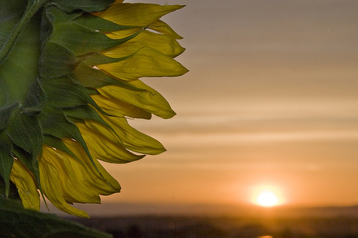
References
- Pictures:
- http://virtualastronaut.tietronix.com/textonly/act25/images/hydrotropism.gif
- http://k53.pbase.com/u48/roving_rube/large/30489110.a.c.birch.jpg
- http://www2.brevard.edu/jefrick/rhod.htm
- http://www.xtec.cat/~mherna23/summer03/amspot/picture/gravitropism.gif
- http://img1.photographersdirect.com/img/17231/wm/pd1198793.jpg
- http://wpcontent.answers.com/wikipedia/commons/9/9d/Dionaea_muscipula_closing_trap_animation.gif
- http://img1.photographersdirect.com/img/17231/wm/pd1198796.jpg
- http://farm2.static.flickr.com/1423/1402179998_4e1712d584.jpg
- Information:
- http://www.hasc.qld.edu.au/csnotes06/biowedGG/Notes%20for%20Sandra/Plant%20Tropisms.doc
- www.wikipedia.org

