Pharmacology for Veterinary Assistants
What is pharmacology?
The branch of veterinary medicine concerned with the
___________, ____________ and _____________ of drugs; the study of drugs.

- What is a drug classification?
Characterized by a drug’s _____________ in
the body or on the target tissues.
Emetics-
Antiemetics-
Antidiarrheal agents-
Cathartics-
Antacids
Diuretics-
Antibiotics-
Anti-inflammatories-
Analgesics-
Anesthetics-
Anticonvulsants-
Stimulants-
Tranquilizers-
- What is a drug form?
Characterized by a drug’s __________ or
__________________ such as:
Solid tablet, syrup, lotion, ointment, extract, injectable, etc…
Solid-
Solution-
Suspension-
Extract-
Topical-
Semisolid-
Injectable-
- What is a drug route?
The drug’s _________________ of entering
the patient’s body.
Intravenous (IV) -
Intramuscular (IM) -
Intradermal-
Subcutaneous (Sub-Q, SQ, SC
Oral-
Inhalation-
What are methods of administration?
The _______________ used to give the drug
to the patient.
Injection
Oral
Topical
Aerosol
What are controlled substances?
Substances that have the potential for
_______________, ______________
and/or __________________.
Controlled Substances Act of 1970 states:
_______________________________
_______________________________
_______________________________
C-I—
C-II—
C-III—
C-IV—
C-V—
Controlled substances should:
Be kept in a _______________________
_____________ any controlled drug that
was used.
Records must state: _______, _________
and ____________ of each drug used.
Records must include ____________ of
purchase and sale of drugs.
Log must be kept for at least ______ years.

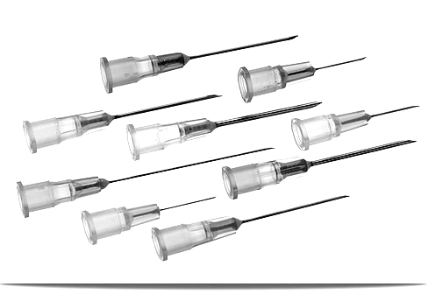
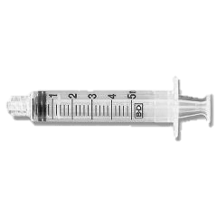
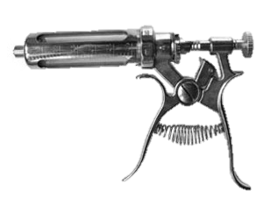
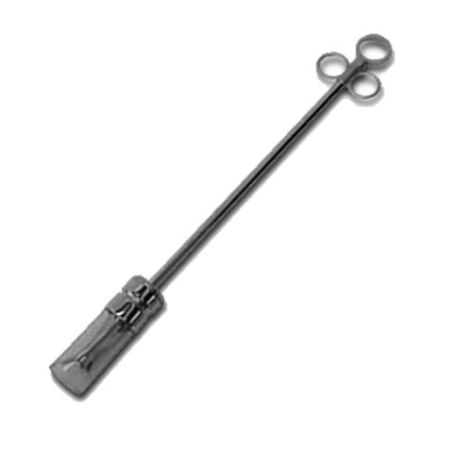
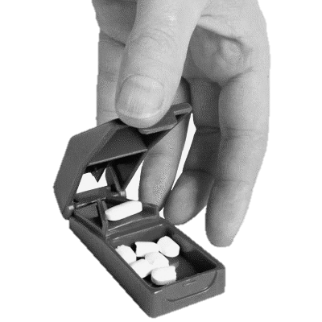
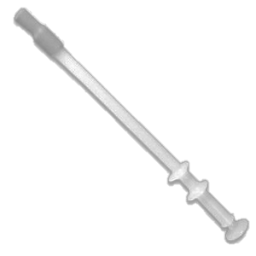
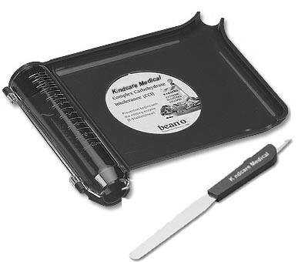
Label the following tools and describe what they are used for.
___________________________
___________________________
___________________________
___________________________
___________________________
___________________________
Pharmacy Equipment
Assisting in the Veterinary Pharmacy

- How do veterinary assistants help in the pharmacy?

- What is a prescription?

- Why is it important for a veterinary assistant to
calculate a CORRECT dosage?

- What three factors are important to know to be
able to calculate an accurate dosage? Define each.

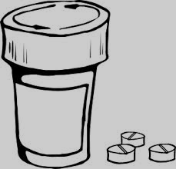
- Make the following conversions:
Calculating Dosages
20 lb = ______ kg
14 cc = ______ ml
0.00043 kg = ______ mg
111,208 mg = ______ gr
2 g = ______ mg
14 lb = ______ kg
800 cc = ______ L
.25 ml = ______ L
- How much of a drug does a 20 kg dog need if the dosage is 10 mg drug/kg of body weight?

- A 6 lb cat, Luna, will be receiving a prescription that recommends
5 mg/ kg of body weight. If the concentration of the drug is
50 mg of drug/ ml liquid, what volume of this injection should be administered to Luna?

- How much of a drug does a 150 lb pig need if the dosage is 10 ml drug/50 lb of body weight?

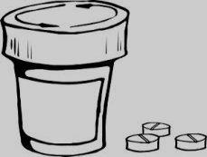
Calculating Dosages
- Your patient, Reveille- the dog, will be receiving a prescription that recommends
.5 cc/ 1.5 kg of body weight. If the concentration of the drug is .5 cc of drug/ .2 ml liquid, what volume of this injection should be administered to the 36 lb patient?

- You are filling a prescription for a 1014 lb quarter horse. The veterinarian recommends this drug be administered 600 mg/ 200 kg of body weight. If the concentration of the pills in your pharmacy contains 600 mg of drug/ pill, how many pills should the patient be administered for each dosage? (with this particular drug, you may round your calculation up or down to a whole pill)

- The doctor asks you to prepare a dose of ketamine sufficient to restrain a 15 lb cat. It is recommended to use 15 mg/kg IV or IM. The concentration of ketamine in the vial is 100 mg/ml. What volume of ketamine is the required dosage for this cat?

1. What is a prescription label?
Completing Prescription Labels

The FDA requires certain identifiers be on each prescription label:
- Veterinarian name, address, phone number
- Owner and patient name and animal/species
- Date of dispensing of drug
- Drug name and quantity
- Dosage and duration
- Route of administration
- Number of refills
Information that should be on each label, if appropriate or needed:
- Drug strength (if more than one strength available)
- Cautionary statements, as needed
- Expiration date if applicable
- Slaughter withdrawal and/or milk withholding times, if applicable

2. Why are the listed identifiers important to have on a prescription? Why would it be dangerous to omit or delete one or more of the identifiers?

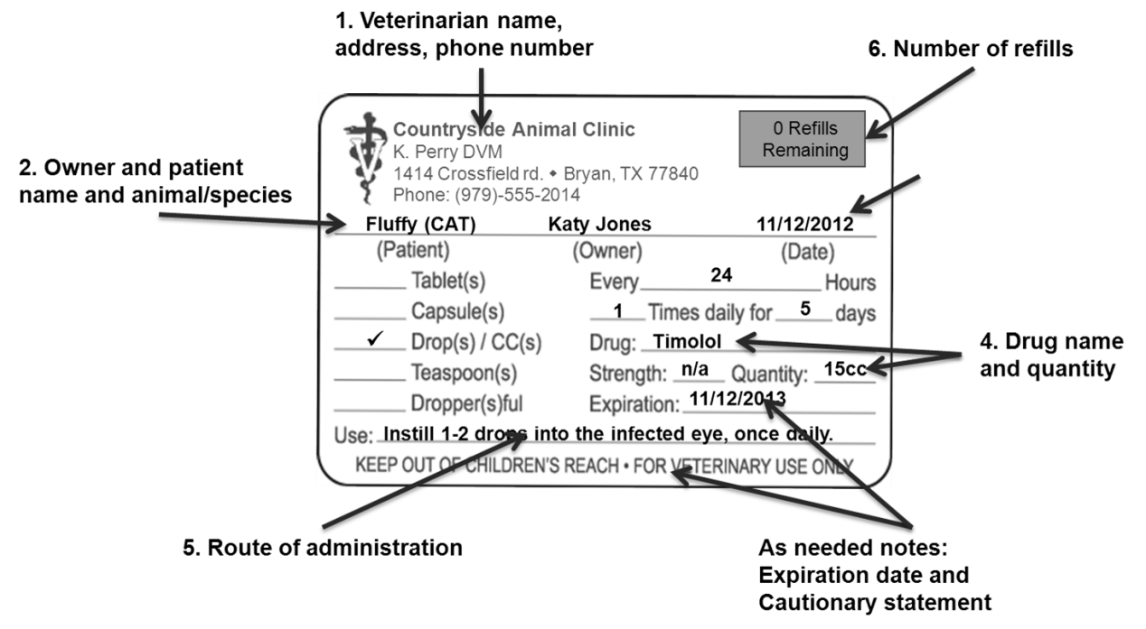
Fig. 1 Prescription labels and FDA identifiers

Complete the following prescription labels:
Today, Dr. Jennifer Graham (123 Main St, Wallis, TX (979)-114-5555) has written a prescription for an anti-inflammatory drug called Rimadyl. The owner’s name is Bob and his dog’s name is Spot. The Prescription calls for Spot to take 1 pill each day for 2 weeks. Bob may refill Spot’s prescription one more time, if he would like. This drug can cause appetite loss, vomiting and diarrhea and should only be used for dogs.
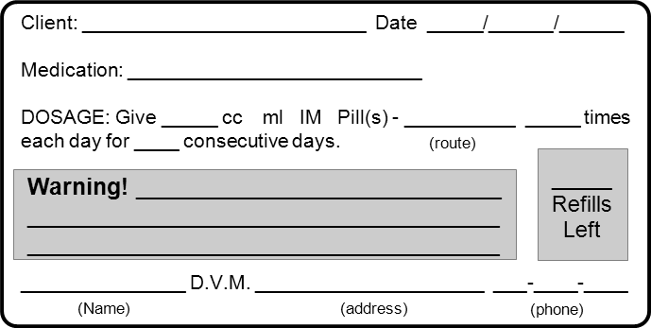
On March 21, 2013, Dr. Leslie Wagner (11 Vet Rd. College Station, TX (979)-555-5505) has prescribed Pirsue, a bovine mastitis drug, to Mr. Wayne to give to his dairy cattle. 10 ml should be administered into each affected teat every 24 hours for 8 days. Mr. Wayne may not refill this prescription. Milk may not be used for food for 36 hours. Animal may not be slaughtered for food for 21 days.

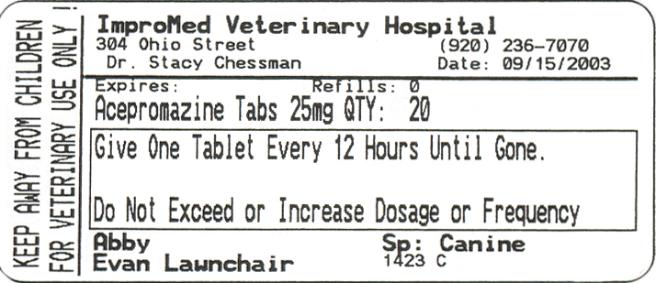
Label the FDA required identifiers. List any that may be missing.

