Name: _________________________________ ____ Date: _______________________
Class: ____________
Virus Quiz - KEY
- Label the parts of the virus below.
Envelope (membrane)
Protein spikes
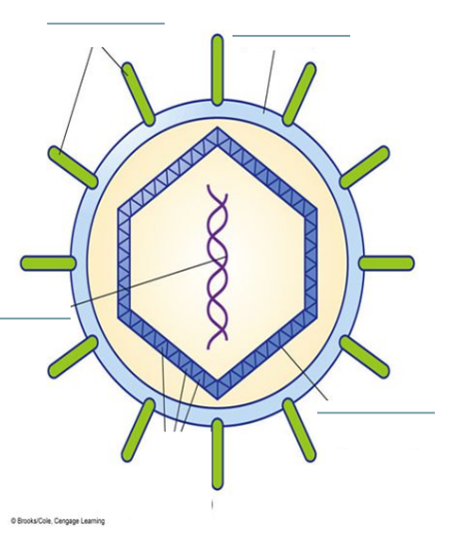
Capsid (protein coat)
Nucleic Acid

- Which one of these is not a way to prevent yourself from contracting the flu virus:
  - Being around an infected person
  - Washing your hands
  - Disinfecting surfaces
  - Sneezing into a tissue

- Which is more common the flu virus or Ebola?
Flu
- What is the capsid?
A protein coat surrounding the virus genetic material
- A virus has genetic material of either___DNA______ or ___RNA______ but never both.

- True or False: Viruses can replicate on their own.

- An active virus is in the ____________Lytic_________________ cycle.

- A latent virus is in the ________Lysogenic________________________ cycle.

- Give an example of a lytic virus.
Influenza, Rabies, Common Cold, Ebola

- Name three symptoms that flu and Ebola have in common.
Fever, muscle pain, fatigue, headaches.

