Weather Maps
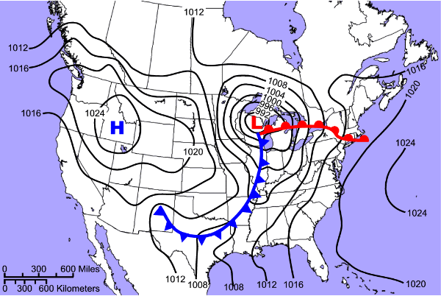

This activity has weather maps with questions that will test your knowledge of air masses, fronts, air pressure and more. The following question will need to be matched with the corresponding maps on page 2.

Where would you expect the warmest temperatures to occur? __________________

Where would you expect to find the highest atmospheric pressure? __________________

Where would you expect precipitation to occur? __________________

Where would you expect to find the lowest atmospheric pressure? __________________

Where would you expect the coolest temperatures to occur? __________________

Where would you expect the highest wind speeds to occur? __________________

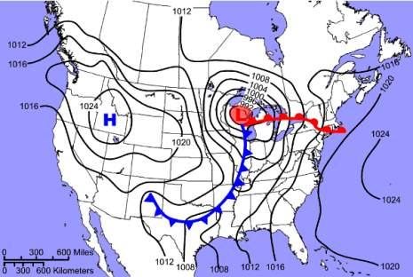
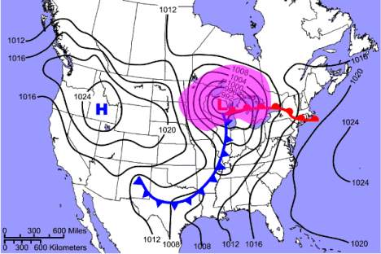

B
A

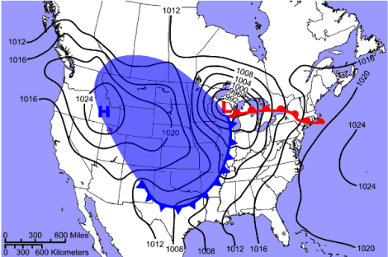
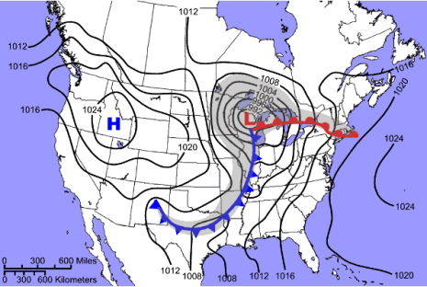

C
D

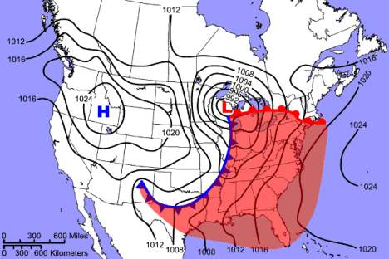
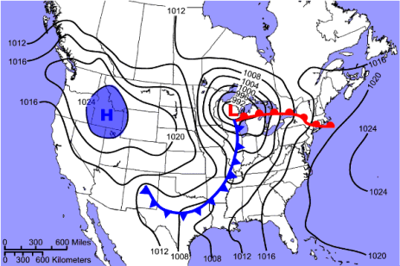

E
F

Answers:

F
The warmest temperatures are found in the warm air mass that lies behind the warm front and ahead of the cold front.

E
The highest atmospheric pressure is found at the center of a high pressure system, labeled with a capital H on a weather map.

C
Precipitation typically occurs along and ahead of the warm front, along and behind the cold front, and around the center of a low pressure system.

A
The lowest atmospheric pressure is found at the center of a low pressure system, labeled with a capital L on a weather map.

D
The coolest temperatures are found in the cold air mass that lies behind the cold front.

B
The highest wind speeds are found where the isobars on a weather map are spaced closest together.

Resources:

http://www.dnr.sc.gov/climate/sco/Education/wxmap/wxmap.php

