Work - Lifting
Purpose:
In this activity, students will investigate the scientific definition of work.

Objectives:
- Calculate how much work is being performed.

Materials:
- 3 Objects with different masses
- Spring Scale
- Meter Stick

Procedure:
1. Attach one of the objects to the spring scale.
2. Slowly lift or pull the object straight up. Record how much force you used to pull or lift the object (Newtons).
3. Use the meter stick to measure the distance you moved the object. Record the distance in meters.
4. Find out how much work you did by using the formula, W =F x D by the object moved. Record your answer.
5. Repeat steps 2-5 with the other objects.
Data:
Object | Force (N) | Distance (cm) | Work (J)
Conclusion:
- Which object did you put the most amount of work in lifting - the light or heavy one?
- Why did the heavy objects result in more work being performed?

Work – Ramp
Purpose:
In this activity, students will investigate the scientific definition of work when using ramps.

Objectives:
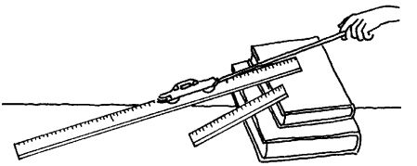
- Observe the variance in the force required to pull an object to a certain height when changing the angle of the ramp.

Materials:
- Block cubes
- Thin, loose rubber bands
- Tacks
- A long ramp and a short ramp with a smooth surface
- 2 textbooks

Procedure:
- Prop rulers of different lengths on a pile of books.
- Tack a rubber band to a block.
- Pull the object up the different ramps.
- Observe how the rubber band is stretched in each case.
- Pull the object straight up to the books, without using a ramp.
- Observe how the rubber band is stretched.

Conclusion:
Which ramp resulted in the least force to raise the block? How could you tell?

_____________________________________________________________________________
If friction is neglected, will it take approximately the same amount of work to raise the cart up to the same height?
_____________________________________________________________________________
_____________________________________________________________________________
_____________________________________________________________________________

