Download all Associated Files for this lesson from our Website
Let’s Break It Down

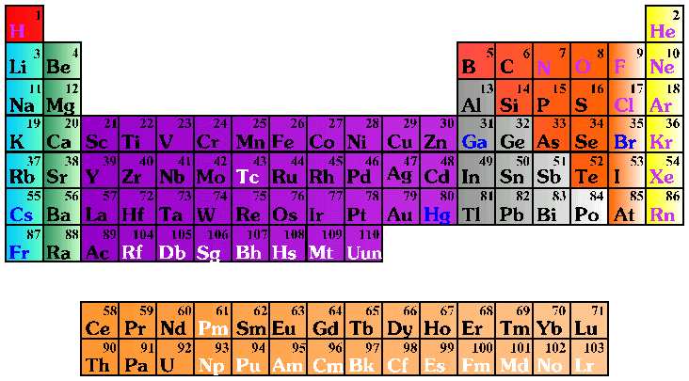

Legend
 | Solid |  | Liquid |  | Gas |  | Synthetic
 | Alkali metals |  | Alkali earth metals |  | Transition metals |  | Rare earth metals
 | Other metals |  | Noble gases |  | Halogens |  | Other nonmetals
http://www-tech.mit.edu/Chemicool/

Periodic Table
WHAT IS AN ELEMENT?

- An element is the most basic type of chemical substance. All the elements known to exist are listed in the periodic table. Some elements are naturally occurring (oxygen, for example), while others are synthetically produced (like einsteinium, named for Albert Einstein).

- If you were to split an element (like a block of silver) into smaller and smaller pieces, the smallest piece of that element that would still retain its unique characteristics would be an atom.

- Gold, silver, copper and many other metals are also elements. There are millions of atoms in a single gold ring!
NOW LET’S THINK ABOUT COMPOUNDS AND MIXTURES

- A compound is a substance made up of two or more elements connected by chemical bonds. For example:

This compound… …consists of
Water Hydrogen and oxygen
Baking soda Carbon, hydrogen, oxygen, sodium
Table salt Sodium and chlorine
Carbon dioxide Carbon and oxygen

- A mixture is a combination of two or more elements or compounds that are not chemically combined.

- Mixtures keep their physical properties and can be physically separated.

- An alloy is a mixture of two metals which, when heated to extremely high temperatures, actually dissolve into each other.

Objectives:

- Examine each sample closely. Take note of the samples’ color, texture, or other characteristics. DO NOT smell or taste the samples!

- Record your observations on your worksheet. If you think you know the identity of the sample, jot it down in the observation column.

- Decide whether each sample is a pure element, a compound, or a mixture. Mark your answer in the second column on your worksheet.

Name:____________________
Period:____________________

Record your observations of the Do you think the sample is an
following samples: element, compound, or mixture?
A.

B.

C.

D.

E.

F.

G.

Let’s break it down: Teachers’ notes

Prepare:
      - A tightly-sealed jar of colored water and oil
      - A tightly-sealed jar of water in which a tablespoon of table salt has been dissolved
      - A block of brass
      - A tightly-sealed jar of sugar cubes
      - A small bowl of sand
      - Aluminum foil*
      - A tightly-sealed jar of cola
*Aluminum foil designed for kitchen use are usually made of aluminum and <1% of other metals. Aluminum foil designed for medical or electrical use is often 100% pure aluminum. If you would like to use pure elemental aluminum but cannot find pure foil, pure aluminum wire is a good substitute. This could also be grounds for an interesting classroom discussion – how pure are “pure” elements? Most pure substances are susceptible to contamination, oxidation, etc.

Create seven stations around the classroom and place one of the above samples at each station. You can modify the difficulty of the exercise by choosing whether or not you wish to label each sample, some samples, or none at all.

Most samples should be fairly simple to identify, but a few more challenging ones demonstrate that differentiation between compounds, mixtures, and elements cannot always be accomplished simply by sight.

Students will visit each station and fill in their worksheets. After all (or most) students have completed the activity, discuss the correct answers.

Ask students how they might separate various mixtures. The salt water mixture could be separated by evaporating the water and recollecting it as it rose and cooled. When you open a bottle of cola, you allow carbon dioxide to escape from the mixture. You can separate heterogeneous mixtures, too. For example, you could separate rocks from sand by passing the mixture through a sifter.

Notes concerning each of the seven substances:
The colored water and oil sample: This sample is a mixture. Oil and water are two different compounds which do not chemically combine. Because the oil and water are not evenly distributed throughout the mixture, it is a heterogeneous mixture.
The salt water sample: This sample is a special type of homogenous mixture – a solution. A solution describes a mixture in which one compound is dissolved into another. The salt is the “solute” and the water is the “solvent.”
The brass sample: Brass is also a homogenous mixture. It may look like an element, but it is actually a mixture of two elements – zinc (Zn) and copper (Cu). The metals are heated to extremely high temperatures and actually dissolve into each other. This process makes a type of mixture we call an “alloy.” Brass, steel, and bronze are common alloys. Pennies, dimes, nickels, and quarters are all made of alloys.
The sugar sample: Table sugar, or sucrose, is a compound – C₁₂H₂₂O₁₁.
The sand sample: If the sample is pure sand, or silicon dioxide, it is considered a compound. However, much of the sand or dirt found outdoors is a mixture of substances such as sand, humus, leaves, bugs, and clay.
The aluminum foil: Aluminum is element #13. (Aluminum foils designed for kitchen use contain <1% of another metal, and thus are not purely elemental.)
The cola sample: Cola is a mixture of many compounds. Common ingredients include fructose and carbon dioxide.

