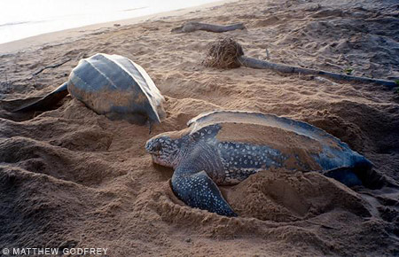
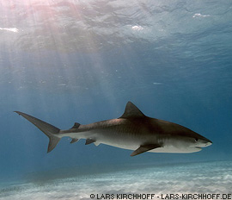
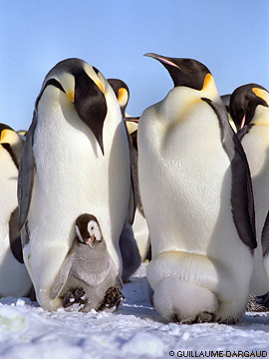

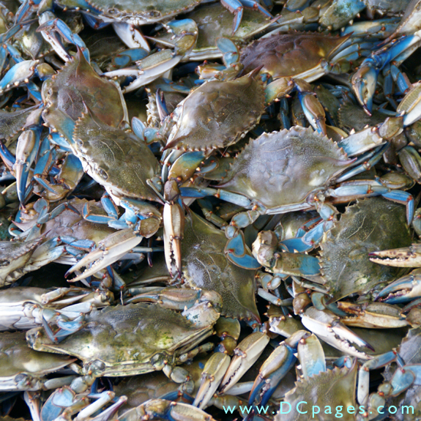
By Land or Sea — Comparative Anatomy

Summary:
This lesson begins with a demonstration describing adaptations of mammals to motivate the students to think about anatomy differences between humans and animals. The lesson features a video presentation that explains how a complex set of genes called homeotic genes have been found in all species of animals, including sea creatures, and are responsible for body segmentation in crustaceans, like lobsters, crabs and shrimp. In humans, this same family of genes is responsible for creating our segments, such as our spine and ribs. This video also addresses how these species have evolved over millions of years as nature finds new ways to use their genetic material. Students will explore comparative anatomy by understanding how nature has used the same genes to create diversity.
Keywords: anatomy, comparative, homologous, analogous, adaptation, diversity

Subject:
- Science:
7.12: Organisms and environments. The student knows that living systems at all levels of organization demonstrate the complementary nature of structure and function.
(A) Investigate and explain how internal structures of organisms have adaptations that allow specific functions such as gills in fish, hollow bones in birds, or xylem in plants.
(B) Identify the main functions of the systems of the human organism, including the circulatory, respiratory, skeletal, muscular, digestive, excretory, reproductive, integumentary, nervous, and endocrine systems.
(C) recognize levels of organization in plants and animals, including cells, tissues, organs, organ systems, and organisms
- Biology:
(7) Science concepts. The student knows evolutionary theory is a scientific explanation for the unity and diversity of life. The student is expected to:
(A) analyze and evaluate how evidence of common ancestry among groups is provided by the fossil record, biogeography, and homologies, including anatomical, molecular, and developmental
(E) analyze and evaluate the relationship of natural selection to adaptation and to the development of diversity in and among species

Grade Level:
- Target Grades: 7, 9
- Upper Bound: 12
- Lower Bound: 6
Learning Objectives:
- Understand how internal structures of organisms have adaptations that allow specific functions
- Identify the major functions of the body systems of the human organism and compare and contrast them to the systems of marine animals
- Make inferences about structure and function based on radiographic images
Time Required: 2 class periods
- One for introduction/motivation activities, video, and PowerPoint Presentation
- One for follow-up/assessment activities
Materials:
- PowerPoint: Comparative Anatomy - Marine
- Video: “By Land or By Sea – Comparative Anatomy” – approximately 7 minutes viewing time
Ward Television
Producer: Fran Victor
Featuring: Nipam Patel, Howard Hughes Medical institute at University of Chicago
There are three ways to access the video:
  - The video can be downloaded (http://www.pubinfo.vcu.edu/secretsofthesequence/showdetail.asp?id=29)
  - YouTube – many school districts block this site but with teacher access, you may be able to view the video without advertisements (http://www.youtube.com/watch?v=-jTIexNfw3Q)
  - Science Stage – you may have to watch an advertisement prior to viewing the video. This can be viewed before showing the class and then paused at the start of the actual video (http://sciencestage.com/v/17850/by-land-or-by-sea-comparative-anatomy.html)
- Rubber gloves
- Large bowl
- Water
- Ice
- Solid vegetable shortening
- Comparative anatomy activity sheet
- Radiographs, printed copies of radiographs, or radiograph PowerPoint

Reusable Activity Cost Per Group [in dollars]: $10.00
Expendable Activity Cost Per Group [in dollars]: $0.00

Background Information:
Comparative anatomy is the study of similarities and differences in the anatomy of different species. It indicates that various organisms share a common ancestor and assists scientists in classifying organisms based on similar characteristics of their anatomical structures. Two major concepts of comparative anatomy are:
- Homologous structures - structures (body parts/anatomy) which are similar in different species because the species have common descent (share a common ancestor).
- Analogous structures - structures are similar in different organisms because they evolved in a similar environment, rather than were inherited from a recent common ancestor. They usually serve the same or similar purposes.
Preview the video and make note of the locations at which you will later pause the video for discussion.
Lesson Introduction / Motivation:
Have students work in small groups or ask for a few volunteers to demonstrate the following activities. Students should be separated into “moving” and “observing” groups. These activities are designed to have students begin thinking about the relationship between structure and function and the differences in structures between species.
- Animal movements observations: Have the “moving” students walk, run, jump, or stand relaxed. Ask the “observing” students to carefully watch and record how the moving students’ legs, feet, arms, etc... function during these activities (you may even ask students to remove shoes and socks so that close observation of the feet can be made). Next, view videos of various species of animals, walking, running, eating, scratching, resting, and or playing. Have all students make observations about how the animal’s body parts function in each video. Then, have the “moving” students to attempt to mimic the movements of the animals. The “observing” students should record what they see. Students should record the similarities and differences they witnessed in the movements of humans versus animals. Ask students what allows or prevents them from moving like other species.

- Aquatic Animal Adaptation Demo: Prepare a large bowl of ice water (or several if working with student groups). Begin by asking the students how they think sea mammals like whales, seals and dolphins stay warm in cold water. Direct the students (or volunteer students) to take turns putting on a rubber glove and placing their gloved hand into the ice water for 10-20 seconds. Ask the students to describe out loud how his or her hand feels. Next, have the students take turns repeating the same procedure, this time with a thick coat of solid vegetable shortening on their hand before putting the glove on. Have each student again explain (either to the class or to their group) how his or her hand feels. Discuss and record how this experiment demonstrates the function of blubber in sea mammals. Make sure students know what blubber is—a thick layer of fat beneath the skin of sea mammals. Allow the students to wash their hands with soap and water after the demonstration.
Lesson Plan:
- PowerPoint Presentation: Comparative Anatomy- review the presentation ahead of time to make notes of discussion points. Allow ample time for students to take notes and ask questions.
- Video:
- Start the video.
- Pause the video (1.48 minutes into the video) after Nipam Patel says “We’re interested in the genes that allow them to specialize these different appendages to do different things.”

Ask: “Can you think of and list different ways these appendages (arms) are used in different organisms? How are these uses similar or different between organisms? Recall the movement activities you performed before the video”
Some uses include:
- Swimming
- Picking things up
- Feeding
- Defense mechanisms – break things, strike prey
- Walking

- Resume the video.
- Pause the video (6.37 minutes into the video) after the narrator says,”…so just like our cousins…” the human vertebra consists of 33 segments divided into 5 types.

State: “Let’s list the 5 types of human vertebrae described in the video and review what their functions are.”
- Cervical: designed to be flexible and strong in order to hold up the head
- Thoracic: designed to hold more weight and is attached to the ribs
- Lumbar: designed to hold up the majority of the body weight
- Sacral: segments are compressed and fused together for support
- Coccygeal: forms the tail-like bone at the base of the spine
5. Resume the video and play to the end.

Activity/Application:
- Comparative Anatomy Worksheet: This worksheet, provided by betterlesson.com, provides students the opportunity to identify, compare, and contrast the skeletal systems of humans and a variety of other species.

- These Bones Can Talk: Provide students radiographs (X-rays) and/or models of an unnamed species’ appendage to observe. Students will make inferences based on what they know of human anatomy to determine the corresponding human structure, function of the appendage, size of the animal, habitat in which it lives, and specific adaptations the animal has. They must provide evidence or rationale to support their claims. Students should then attempt to make a drawing of what they believe the animal’s external appearance would be based on the model or radiograph.

Lesson Closure:
- Review how evolution has resulted in increased specialization of appendages of crustaceans using the following examples shown in the video.
- Sea monkey (brine shrimp): this primitive crustacean shows that all appendages of the thorax are used for swimming
- Other crustaceans: some variation and evolution resulted in some appendages near the head becoming specialized for feeding
- Lobster: further evolution show appendages becoming specialized not only for feeding but also for snapping at something, tearing food and walking away all at the same time
- Stomatopod: shows further evolution with powerful appendages used for defense and attack

- How do the genes that create segments in arthropods correlate to humans?
Homeotic genes called HOX genes that are found in all species are identified with making different parts of the body different from other parts – this is called regionalization. These genes not only create segmentation in an arthropod but also have been directly linked with how the spine develops in humans. UBX or the ultra bi-thorax gene is one of these HOX genes that is found in all vertebrates but expressed at different levels depending on the evolution of that particular species.

Note: Remind students that crustaceans and humans are both animals. Often students have a misconception that humans are in their own kingdom.

- Extension: Students can use the data table and Venn Diagram to create Cladograms, a diagram showing the degree of relationship between different organisms. This website: http://www.education.txstate.edu/ci/faculty/dickinson/PBI/PBISpring07/AlienInvasion/Content/Making%20Cladograms.pdf provides an excellent lesson plan.

Additional Resources and References:
- Links to animal videos:
  - Giraffes, http://www.youtube.com/watch?v=6rZfERFa3yk begin video at :35
  - Cat jumping http://www.youtube.com/watch?v=Sc9CBXYeCAo
  - Foal scratching http://www.youtube.com/watch?v=c-dFQAapvLY begin video at :12
  - Chimpanzees http://www.youtube.com/watch?v=l0tAQcpLILQ begin at :40
- Comparative anatomy images and lessons for the Smartboard: http://exchange.smarttech.com/search.html?q=%22comparative%20anatomy%22
- http://betterlesson.com/lesson/2142/comparative-anatomy?from=search
- http://www.iacad.org/istj/34/3/anatomy.pdf
- http://www.education.txstate.edu/ci/faculty/dickinson/PBI/PBISpring07/AlienInvasion/Content/Making%20Cladograms.pdf
- www.vcu.edu/lifesci
Authors:
Undergraduate Fellow Name: Brittany Sanchez
Torri Whitaker Science Content Specialist
Please email us your comments on this lesson:
E-mail to ljohnson@cvm.tamu.edu
Please include the title of the lesson, whether you are a teacher, resident scientist or college faculty and what grade you used it for.

