CDs are Groovy

Activity Summary:
In this activity, students will investigate the properties of light, especially how small slits or grooves with dimensions comparable to the wavelength of light can split light into its component colors like a prism or like how water droplets in the sky would to create a rainbow.
Subject:
Science: Science as Inquiry, Science and Technology, Physical Science

Grade Level:
Target Grade: 8

Time Required: 30 minutes – 1 hour
Activity Team/Group Size: Conducted as a class or in small lab groups of 4-5 students
Materials (Reusable):
-Small Diffraction grating film panels or diffraction grating glasses. These can be found at various places online for under a dollar each including the links listed below, or perhaps a nearby high school physics department might have some that they would allow your school to borrow.
http://boreal.com/category.asp_Q_c_E_546471
http://shop.store.yahoo.com/rainbowsymphony/scienanded1.html
-CDs: These can be blank CDs which can be found for cheap most anywhere, or used CDs will work as well. This could be a nice opportunity to use those free internet CDs that seem so unwanted.
-Various light sources: these could include (but not limited to) a flashlight, a lamp with a 60 watt bulb, sunlight from a window (either through a small slit in a piece of cardboard or off of a reflection so that they don’t look directly at a sun), a candle, halogen lamp, Christmas lights (preferably single color strands, to be observed separately). If you have access to some lights which use different types of gases or metals such as neon, helium, sodium, etc, these would be extremely effective in illustrating the principles at work since they emit different colors of light. However, these can be quite expensive, so the best bet again might be to look into borrowing them for a high school physics department.
-For optional introduction activity: Large, shallow glass or plastic transparent pan; overhead projector and screen; modeling clay; ruler.
Authors:
Undergraduate Fellow: Ryan Newman
Graduate Fellow: Timothy Yu
Date Submitted: 3/14/05
Date Last Edited: 2/22/05
Parent Lesson Plan(s):
This activity is designed for use alongside the Three Rivers, Three Nations curriculum module produced by the PEER Program, but it could easily be conducted independently of the module.

Activity Introduction / Motivation:
The students should be given a brief introduction, explaining that visible light is only a small part of the electromagnetic spectrum, which includes other forms of energy such as radio waves, microwaves, infrared and ultraviolet light, and X-ray. The visible white light we see is made up of component colors, which can often be seen in the form of a rainbow or from devices like prisms. These component colors travel at different frequencies, allowing them to separate out as they slow down when they pass through different media such as the glass of a prism or water droplets in the air. Explain that in the activity, the students will investigate another way in which this diffraction phenomenon can be observed. One way is to use a ripple tank to see that water waves too, will diffract when they encounter a barrier or slit. A simple ripple tank can be made by placing a transparent pan filled partly with water on an overhead projector. Then, using a ruler, the instructor can generate parallel waves through the pan by repeatedly moving it up and down, in and out of the water at one end of the pan. Use modeling clay or cardboard to make a barrier with a gap in the middle (about the same width as the distance between the water waves) to simulate the diffraction slit. Viewing the waves on the overhead projection will make it much easier to see the pattern. Try using slits of different size to demonstrate that diffraction only occurs when the width of the slit is about equal to the size of the wave length or vice versa. However, it may be difficult to reproduce these results well without extensive testing, so we have included some links and photographs which can be used as a substitute for or as a supplement to an actual ripple tank:
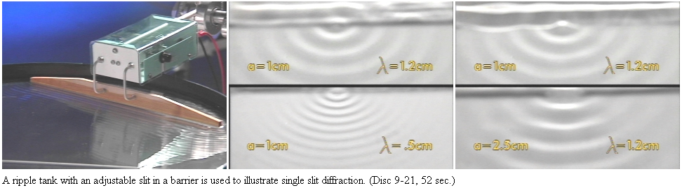
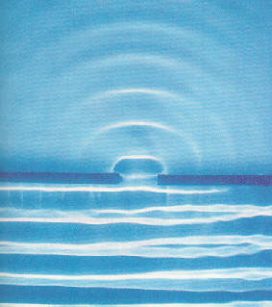
Here is a very nice java applet to simulate the ripple tank results: http://www.echalk.co.uk/Science/Physics/rippleTank/ripple.htm
Click on the first pull-down menu and choose “Setup: Single slit” to create a single slit diffraction pattern similar to the ripple tank. There are many options to choose from to observe other interesting wave behaviors and phenomena. The instructor should explain that light behaves similar to water near a diffraction slit, so we know that light has wave properties. Using what we know about wave properties can help us understand light better.

Activity Plan:
The activity is given in the form of a lab procedure, which is included with this document. You should feel free to modify this depending on the desired level of complication and time constraints. The activity should begin with the teacher going through the “Investigation” section of the activity with the students to teach them the concepts behind the activity. Emphasis should be placed on this section because the rest of the activity will make much more sense to the students and they will take much more from it if they understand the principles at work. Then, either working in small groups (preferred) or as an entire class with the teacher conducting, the students should go through the rest of the activity and discuss and write down their observations and calculations. The two calculations are both essentially the same. If they need some assistance, the spacing of the lines is equal to (1/(lines per cm)) × (1×10⁷). The conclusion could take the form of either a written paragraph to be turned in with the observations, or as a class discussion of the questions included and any more that may arise.

Assessment:
The main goal of this lab is to help the students to understand more about light and the visible spectrum, especially how we can see light acting as a wave through the diffraction of light. As long as the students have some grasp on these concepts, then the activity should be considered a success.

Learning Objectives:
8th Grade Science TEKS:
8.2 Scientific processes: The student uses scientific inquiry methods
8.7 (B) Recognize that waves are generated and travel through many substances

Vocabulary (illustrations included in lab sheet):
Wavelength - The distance between one peak or crest of a wave of light, heat, or other energy and the next corresponding peak or crest.
Diffraction - Change in the directions and intensities of a group of waves after passing by an obstacle or through an aperture whose size is approximately the same as the wavelength of the waves.
Interference - The variation of wave amplitude that occurs when waves of the same or different frequency come together

Activity Extensions:
If the students seem interested, there are many more activities concerning different aspects of light available on the internet. A common activity uses a double slit grating rather than the multiple slit gratings used in this activity. Aiming a laser at these slits and observing the resulting light pattern can further illustrate the concept of diffraction and introduce the property of constructive and destructive interference of light waves. A computer simulated version of this experiment can be found here: http://schools.matter.org.uk/Content/Interference/laserinterference.html
Multimedia Support and Attachments:
The Three Rivers, Three Nations curriculum module produced by the PEER Program gives excellent background information for this activity in slides 42-51 of the student version.

Safety Issues:
If candles or other potentially dangerous light sources are used in the activity, obviously fire safety should be considered. Take care not to aim any light source or laser directly at the eyes to avoid potential damage. Light bulbs are hot and will burn the skin on contact. Students should not directly handle light bulbs due to the danger of glass shards and heat. If the students will be creating their own ripple tanks, prepare goggles for use or ensure that only clean water will be used. Students should wash their hands thoroughly with soap and water after any laboratory activity.

Activity Scaling:
The activity could be modified for time, materials, or the students’ scientific maturity to only include a certain part of the investigation.

References:
http://micro.magnet.fsu.edu/optics/activities/students/properties.html
http://www.echalk.co.uk/Science/Physics/rippleTank/ripple.htm
http://www.physics.montana.edu/demonstrations/video/3_oscillationandwaves/demos/singleslitdiffractionofwaterwaves.html
http://www.ph.unimelb.edu.au/staffresources/lecdem/wa3b.htm
http://schools.matter.org.uk/Content/Interference/laserinterference.html
Definitions from http://www.dictionary.com

