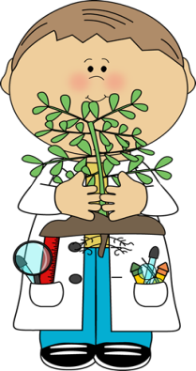
Plant Hormones
Fill in the blank spaces with the appropriate definition or description of each.
What is a plant HORMONE?
A naturally-occurring compound that causes change
in physiology, growth or development in the plant.

- ___AUXIN_____
Role of Hormone | Cell elongation (increase cell size)
Site of Production | Shoot Tips
Effect of Hormone | Growth of plant in response to the environment, production of roots.
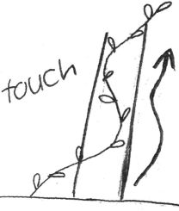
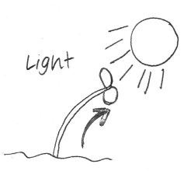
Define and draw some examples of TROPISM:
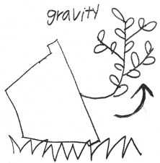
Tropism: a plant’s response to environment
Phototropism- response to light
Geotropism-response to gravity
Thigmotropism-response to touch

- ___CYTOKININ____
Role of Hormone | Cell division (increase cell quantity)
Site of Production | Root Tips
Effect of Hormone | Mitosis of new cells; stimulates seed germination and new shoot growth
Draw some examples of how this hormone works:

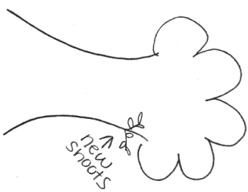
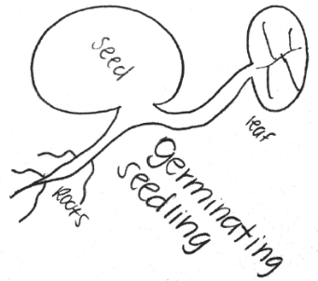

- ____GIBBERELLIN___
Role of Hormone | Internode elongation
Site of Production | Root and Shoot Tips
Effect of Hormone | Controls yearly cycles (flowering, seeding and dormancy exiting) rapid growth of stems and seeds.
Describe how PHOTOPERIOD helps gibberellin in the plant control yearly cycles:

Photoperiod: a plant’s recognition of daylight length in a 24 hour period
As daylight increases in the spring, the plant recognizes a longer photoperiod. Gibberellin triggers the plant to exit dormancy.

- ____ABSCISIC ACID______
Role of Hormone | Dormancy
Site of Production | Chloroplasts
Effect of Hormone | Enters dormancy: (leaves drop off of trees, seeds fall, stomatas close to reduce water loss)
Describe how abscisic acid, in the plant, enters dormancy during times of drought:

In times of water stress, the chloroplasts trigger stomatas to close to prevent loss of water during respiration.

- ____ETHYLENE_______
Role of Hormone | Ripening and death
Site of Production | Ripening fruit, aging flowers, germinating seeds and wounded tissues
Effect of Hormone | Stimulates fruits to ripen, flowers to enter senescence (to grow old and die)

Describe how ethylene can affect other plants:
Ethylene is in gas form and can diffuse and affect nearby plants.

