Activity 1-Brain Size

Use this image of the brains of several species to answer the questions on your worksheet.
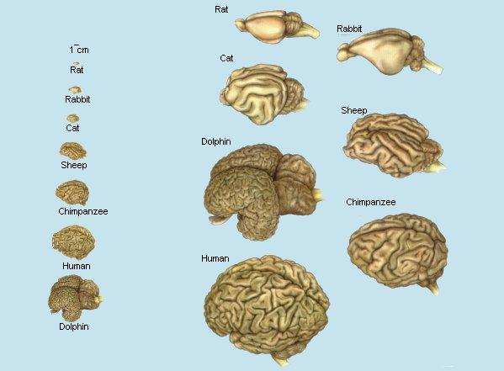

Name: ____________________________________________________ Date: _______________
Activity 1 – Brain Size

Look at the picture of brains of different species. The picture is drawn to scale. Using the picture, answer the following questions.

Question | Answer
- Which animal has the smallest brain? Which has the largest?

2. Do you think the size of the brain directly relates to the intelligence of the species? Why or why not?

3. The higher (more intelligent) species have more folds of tissue on the surface. Does this mean they might have more neurons on the surface (because there is more surface)?

4. The porpoise brain is almost as big as the human brain, and it has more folds. What do you think that this suggests?

5. The two small lobes at the left of the brain of the rat, rabbit, cat, and porpoise are "olfactory bulbs," used in processing odors. They are present, but much smaller relative to the rest of the brain, in the other species. What does this suggest about the role of odor in the animal's lifestyle?

