Activity 2 Questions | Student Name: ___________________________  Teacher: ________________________________  Date: ___________ Period: _________________

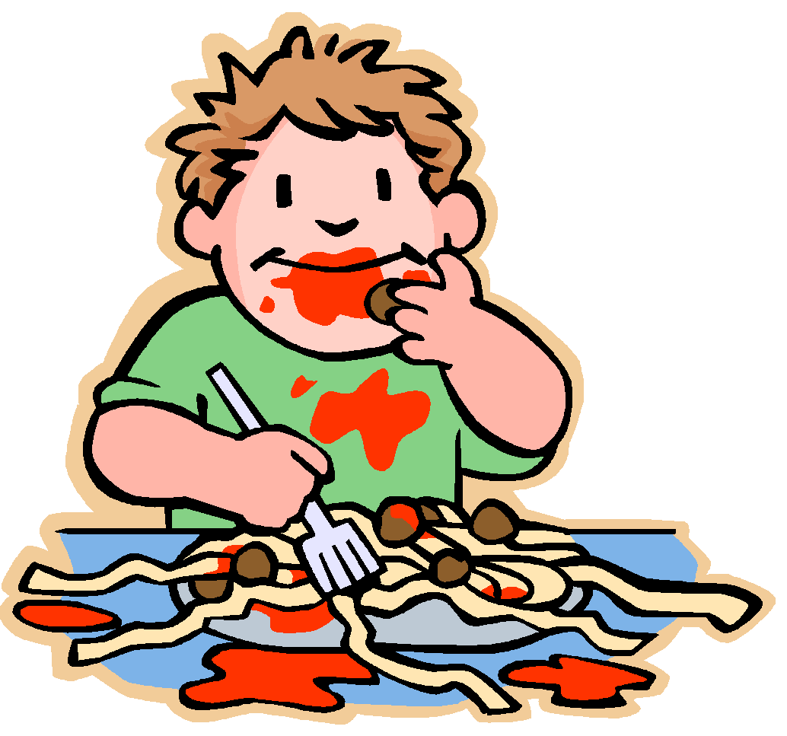
Let's Eat!

Today we are going to simulate digestion! Yum!!

1. Graham crackers were placed in a bag and pulverized. This simulates _____________________ and occurs in the _____________________.

2. Water was also added to the bag--where could the water come from?

3. Everything you eat mixes together in your ___________________.

4. This organ churns and also produces __________________ and ______________________to help digest the food.

5. Now the food is moving into the first nylon hose, what organ does the nylon hose represent?

6. The liquid coming out of the nylon represents _____________ and _________________ that would go _______________________.

7. The remaining food particles empty into the ____________________ (represented by the second nylon).

8. Food in the _______________ (represented by the second nylon) is destined for _________________.

