Navigating the Nervous System

- What are the functions of the nervous system?
  - Receives information from the sensory neurons
  - Processes information and makes decisions
  - Controls organs and muscles
  - Maintains homeostasis through control of body function such as heart rate, body temperature, and breathing.

- Define a neuron:
  - Nerve cells that carry information in the nervous system.

- Draw and label the three main parts of a neuron:
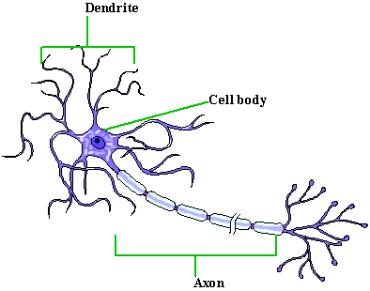
  - The three main parts of the neuron are the dendrite, cell body, and axon.

- How does a nerve impulse travel through a neuron?
  - A nerve impulse begins at the dendrite tip, travels through the cell body, and leaves the neuron through the axon tip.

- What is the role of the axon?
  - To send nerve impulse messages.

- What is the role of the dendrite?
  - To receive nerve impulse messages.

- What are the three types of neurons and what are the functions of each?
  - Motor- Connects the brain to different muscle groups.
  - Interneuron- Forms connections between other neurons that together perform thinking and memory functions.
  - Sensory- Originates from a sensory organ such as the tongue, eyes, nose, ears, or skin, to the brain.

- How does a nerve impulse travel between neurons?
  - A nerve impulse travels down the body of the axon, when it reaches the end the tip of the axon secretes a chemical.
  - The chemical secreted travels across the gap between the axon and the dendrite of the next neuron.
  - This gap is called a synapse. The chemical signal triggers a nerve impulse in the dendrite, which travels to the end of that neuron’s axon.

- Name and explain the two divisions of the nervous system:
  - Central Nervous System- Composed of the brain and spinal cord
  - Peripheral Nervous System- All motor and sensory neurons leaving the spinal cord. Functions to connect all body’s organs and muscles to the central nervous system. This way all organs and muscles can be controlled by the brain.

- How many pairs of neuron bundles are there in the Peripheral Nervous System?
  - There are 43 neuron bundles; they reach from the spinal cord to every part of the body.

- What are the somatic and autonomic nervous systems and what are the functions of each?
  - Somatic- The part of the peripheral nerves that controls the voluntary muscle movements.
  - Autonomic- The part of the peripheral nerves that controls the involuntary muscles and organs.

- Name the three parts of the brain and describe the function of each:
  - Cerebrum- controls all thinking, reasoning, memory functions, and voluntary muscle control. The left half of the cerebrum generally does the analytical work (math), and the right half does the creative thinking.
  - Cerebellum- controls the balance and movement of the body, using information from the eyes, ears, and signals from all muscles.
  - Brainstem- The brainstem controls the organs and involuntary muscles.

- How many neurons are located in the brain?
  - About 100 billion

- What is a spinal cord?
  - A bundle of sensory and motor neurons leading from the brain to the rest of the body. It is protected by the vertebra of the spine.

- What happens if the spinal cord is injured?
  - The spinal cord cannot repair itself if broken, and cannot be repaired by surgery. If it is damaged all muscles and sensory neurons below the cut will be unusable.

- What is a reflex?
  - A response to a stimulus without the brains’ involvement.

- How does a reflex work?
  - The pain nerve impulse travels along the along the spinal cord to an interneuron, where a motor neuron impulse is immediately sent back down to the muscles, telling those muscles to move away from the pain source. The brain receives the pain message a moment later, after the reflex has occurred.

